For My Mother

Who will, I trust, recall,
Instilling in her son a taste
For dreadful doggerel.

and thanks to my friends and family
for not laughing at my jokes.

CONTENTS

Dedication 5
Acknowledgements 6
Nocturne 9
Molluscotropism 10
Double Villanelle 1 l
The Limacon GT: Road Test 13
They’ve Nibbled The Leaves Of My Napalm Tree 14
Snail Christmas Carol 15
Irony 17
Snail Mail 18
Not The Fairway 19
Slugavad Gita 20
The Slug That Came To Camelot 21
Retreat 23
Two Snail Tanka 24
Resonance 25
Vigil, Witsands 26
Pebbles 27
Ephemeris 28
The Plover — Plettenberg Bay 29
Bird Watcher 30
A Few Haiku 31
Monday in Eden 32
The Myth Of Vicanis 33
The Sap Rising 34
Cyclops 35
Dallas Ditchwater 36
Riddle 37
Past Applegarth in Radiance 38
The Satori Story 39
Comerish 40
Starting From Scratch 41
Limerick 42
Liveware Blues 43
Limericks 44
Kamakazi 45
Spring 46
Energy Crisis 47
Glimlag 48

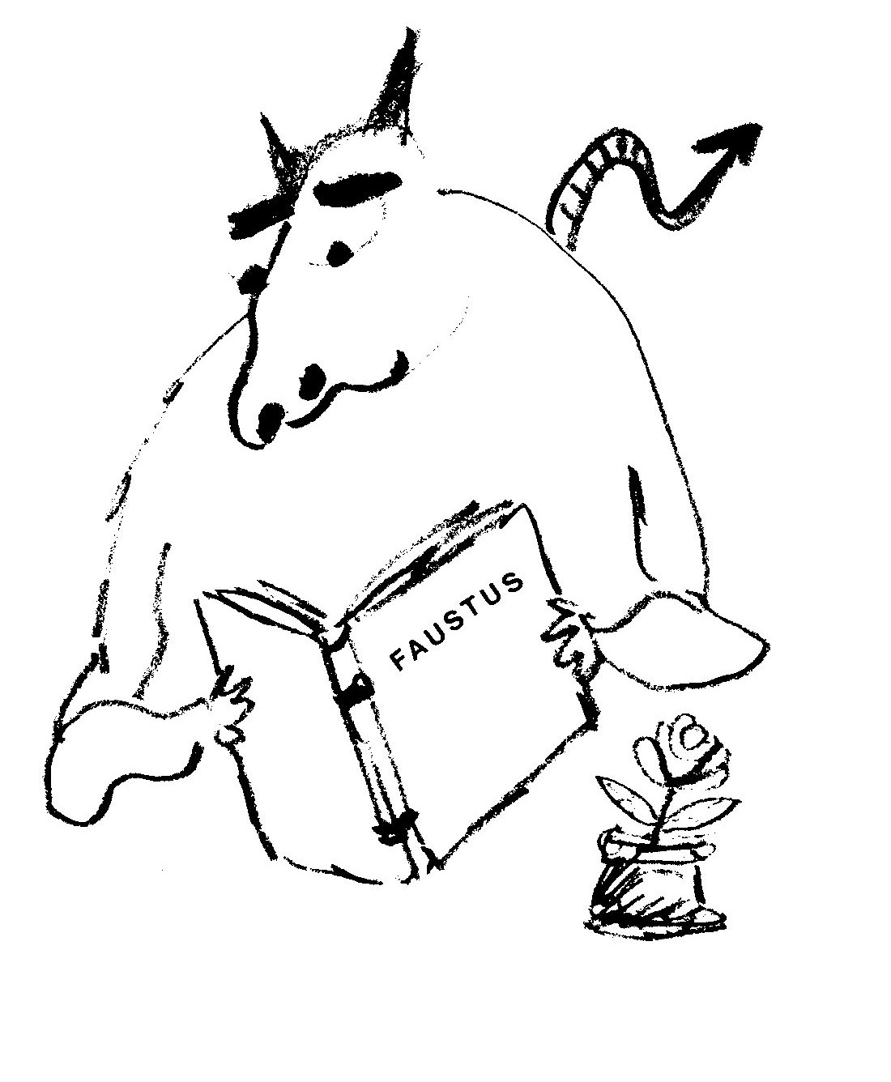

Nocturne

The sun has set. The orb of red
Is nestled in the West.
Awaken lazy slugabed
You’ve done your daily rest.

Uncurl that sleepy tentacle
And blink your purblind eye.
The muted wash of darkness will
Suffuse the evening sky.

The ﬂowers with fastened shutters droop
From supplicative stems.
Clandestine constellations group
To wink their stratagems.

Possess the Night! It is no crime
To seem to have things wrong:
To furl asleep at Matins time
And rise to Evensong.

Molluscotropism

A child with scientific bent
Can do this small experiment.
Performed with care it never fails.

THE AIM
To prove that plants need snails.

THE APPARATUS
All one needs
Are bell-jars, snails and legume seeds.

THE METHOD
Ensure both jars are clean.
Place each beside a growing bean.
A snail in one, its neighbour leave
As empty as an armless sleeve.

RESULT
The bean beside the vacant bell
Grows ramrod straight and vertical.
Its twin, the symbiotic bean,
In time towards the snail did lean.

CONCLUSION
Though snails hunt plants voraciously
The plants are happy.
Q.E.D.
Double Villanelle
I

The snail slides slow his burden slight,
His dappled dome of burnished gold,
Down darkened corridors of night.

Let lesser creatures curse the light
That softly fades as one gets old.
The snail slides slow his burden slight

And is no plaintiff ’gainst his plight
For grave and boundless space are cold.
Down darkened corridors of night

’Tis touch that surer is than sight
When twining lovers tend to hold.
The snail slides slow his burden slight

When if and but dissolve to might
And tales of trysting will be told
Down darkened corridors of night.

The days are long and far too bright
When twilight waxes, truths unfold;
Ihe snail slides slow his burden’s light
Down darkened corridors of night.

II

He ventures only out at night;
A predilection for the dark.
Inside his shell he has no light.

When black is there and rare is white
And desolate the dogs that bark
He ventures only out at night

When starshine shimmers silver-bright
And Moon’s a lantern in the park.
Inside his shell he has no light.

Avoiding every sun-drenched sight
He never hears the morning lark.
He ventures only out at night

When dearth of sunlight’s at its height
With crows of midnight screeching: “Kaark! ”
Inside his shell he has no light

Except, the gleam of smooth calcite;
The Sistine ceiling of his Ark.
He ventures only out at night
Inside his shell he has no light.
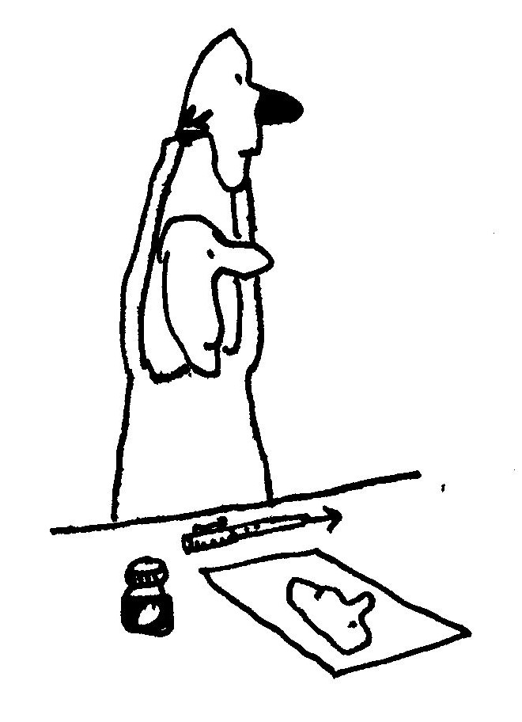

The Limacon GT: Road Test

for Mac

The traction’s great, the rubber grips
The road like pantihose hugs hips.

Suspension’s soft. I loved the ride,
An effortless and easy glide.

The headlights swivel and retract
They cannot shatter on impact.

The form is streamlined, sleek and low.
Designed for speed and yet, so slow?

The slug flat out with monstrous power
Does comma one ﬁve Ks an hour

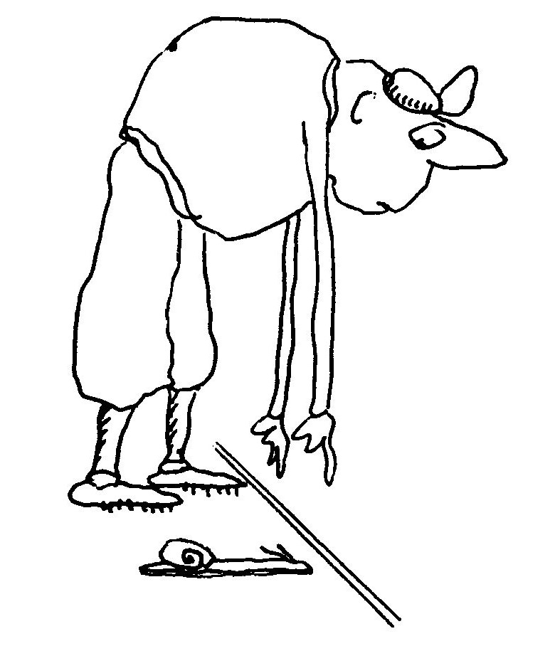

They’ve Nibbled the Leaves of my Napalm Tree

No snailophile would ever state
That gardening’s a Fascist trait
For gardeners must protect the ﬂowers
They’ve tended to for hours and hours.

But I feel sick each time I look
In any horticulture book
Which recommends for snailocide
That chemical: Metaldehyde.

Those gentle souls who talk to plants
Should surely give the snails a chance.

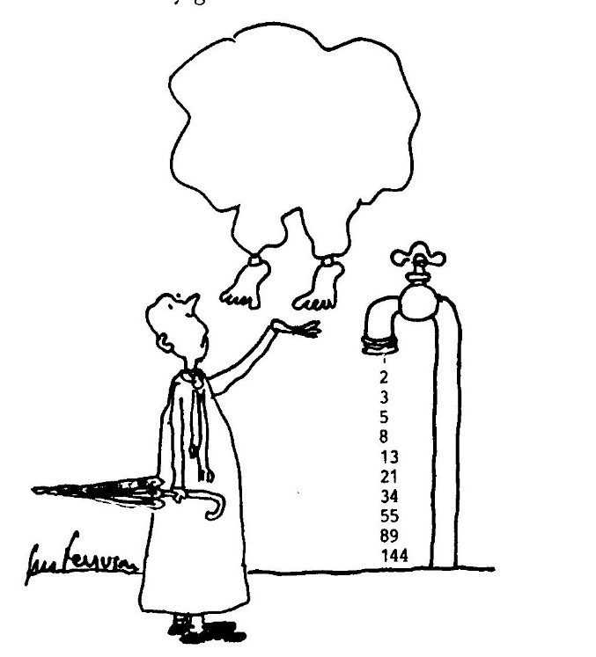

Snail Christmas Carol

While shepherds watched their ﬂocks by night
All seated on the ground
A humble snail came sliding by
And made a rasping sound.

“Desist!” cried he, for cruel intent
Had made them grasp their sticks
“Forewarning of great news I bring
To you unworthy hicks.

“When tomorrow night the evening star
Is just atop yon tree
An angel of the Lord will come
To prophesy to thee.”

A sudden streak. The snail was gone,
His trail an after-glow.
“A miracle!” one shepherd cried
“Methought the snail was slow.”

Tomorrow came and was today
Hie shepherds got cold feet
And arranged that another shift
The messenger would meet.

That is why the gospel speaks
About the “mighty dread”
For unprepared were the bunch
That watched that night instead.

The tidings told, the shepherds ran
Deserting they their sheep
Across the hills towards the Inn
Their witnessing to keep.

The sheep relaxed. The angel stood
Conversing with the snail:
“It seems to me, my little friend,
We planned to no avail.”

“For man forewarned is man alarmed
E’en glad news is a shock.
The shepherd that is born this day
Must tend a timid flock.”

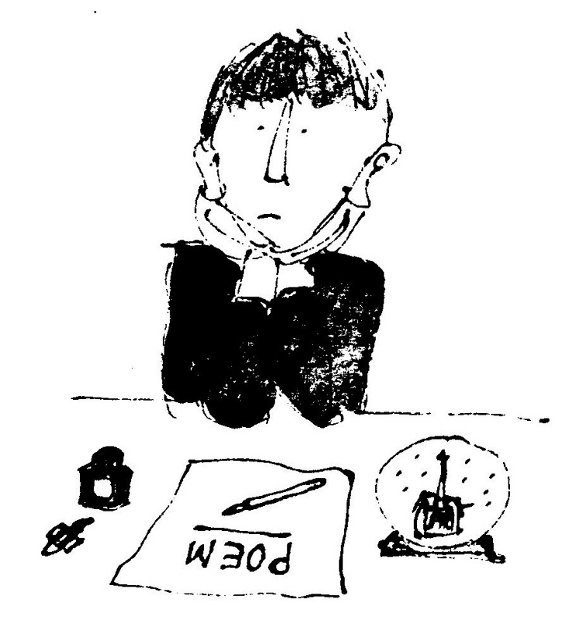

Irony

O poor, defenceless land-locked snail
Your dwelling’s dull, your casing’s frail

Your water cousin’s calcite shell
Protects his body very well,

But on the land I have a hunch
Men tramp on snails to hear the crunch

But even gardeners shudder: “Ugh!"
If they should step upon a slug.

Encumbered Knight enclosed in steel;
Your shield is your Achilles’ Heel!

Snail mail

In old Japan a border guard
With one wet horsehair wrote
In microscopic characters
His wife a poignant note.

He called his favourite carrier-snail
And pinned it to his shell
And said: “Oh steadfast Samurai
Depart for home. Go well!”

The message read: “Should I survive
Then disregard this brief
But if I die this missive will
Remind you of your grief.”

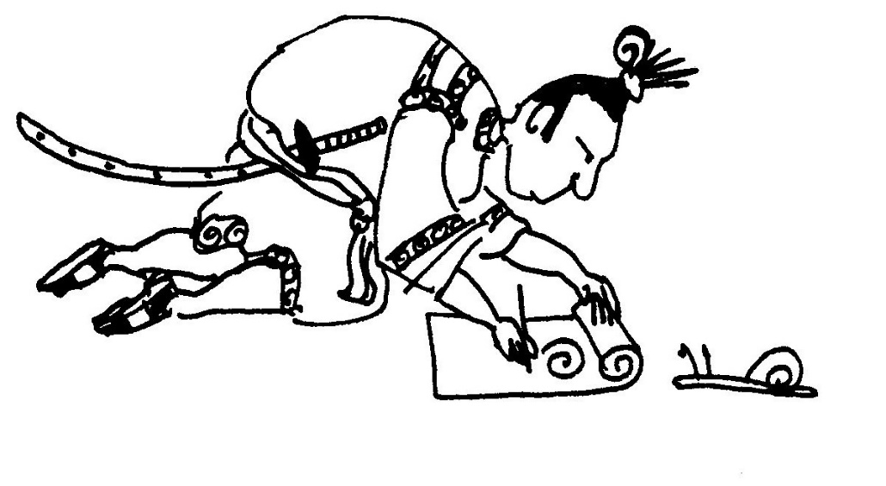

Not The Fairway

for Rupert

There was a golfer with the will
But not the skill to win,
It took on average twenty putts
For him to reach the pin.

He practised hard, read all the books,
Took lessons from the pros
But keenness is a handicap
As any player knows.

One day he ﬂung his golfbag down
Beside the seventh hole
And wept with rage. A passing snail
Took pity on his soul.

“Don’t cry,” he said in soothing voice
“You weep to no avail,
For don’t despair your help is here
I’ll be your caddy snail.”

From that day on his game improved
He soon was down to scratch.
With technique that was shocking
He was winning every match.

His awkward putts would wobble wide
And then would slowly stroll
With magical volition
Towards the empty hole!

But now the truth must be revealed
And I will tell it all:
His friend the snail was painted white
To emulate the ball.

Slugavad Gita

or Why the Snail is Slow

Lord Sri Krshna saw a snail
In contemplative trance.
It swayed upon a lotus leaf
In graceful tantric dance.

Krshna watched as time slid by;
The snail seemed unaware
Of the presence of Divinity
Or maybe didn’t care.

Then Krshna spoke: “O Svami Snail
Your strange aloofness might
In view of my attendance
Be construed as impolite.

“Yet my teachings tell: What seems to b
Is just an outer shell
And you resonate with purity
And vibrate like a bell.

“But I must hasten on my way
Although you’ll think it odd
That time is of the essence
To an omnipresent God.

“So I leave you benediction
But I reprimand you too:
Because you did not Hare me
I’l1 never Hurry you.”

The Slug that Came to Camelot

or How the Snail got its shell.

Antennae drooping with respect
He said: “O King, Divine Elect,
Though crept have I from very near
It took the best part of a year.
I live beneath a nettle thatch
Beside the castle cabbage patch
But stirring rumours of a Quest
Disturbed my dull, diurnal rest
And caused my sluggish blood to race
And doubled up my rippling pace.

I am mere slime. A speck of soot.
Unworthy, humble stomach-foot
But though I quiver I’ll not quail
When searching for the Holy Grail.

King Arthur smiled and Guinevere
Was seen to shed a single tear.

“Go on bold slug your heart is right.
Disdained creature of the night
I’ll wager that you are as able
As any Knight at my Round Table.”

The slug stretched up, dim eyes aﬂame
“O test me Sire. I won’t bring shame
To thee, O kind and gentle King
Whose rightful praises minstrels sing.”

King Arthur drew Excalibur
And said: ‘I dub thee, noble sir,
With all the might of Camelot.
Arise Sir Slug of Escargot.

Sir Slug was fashioned armaments
To fit his minute measurements.
His mail and chain was ﬁnely wrought
By silver-smiths at Arthur’s court.

A thimble size cuirass was built
And round its edge inlaid in gilt
The Motto: PERFICTE CRAS
IN TARDITATE VERITAS. *

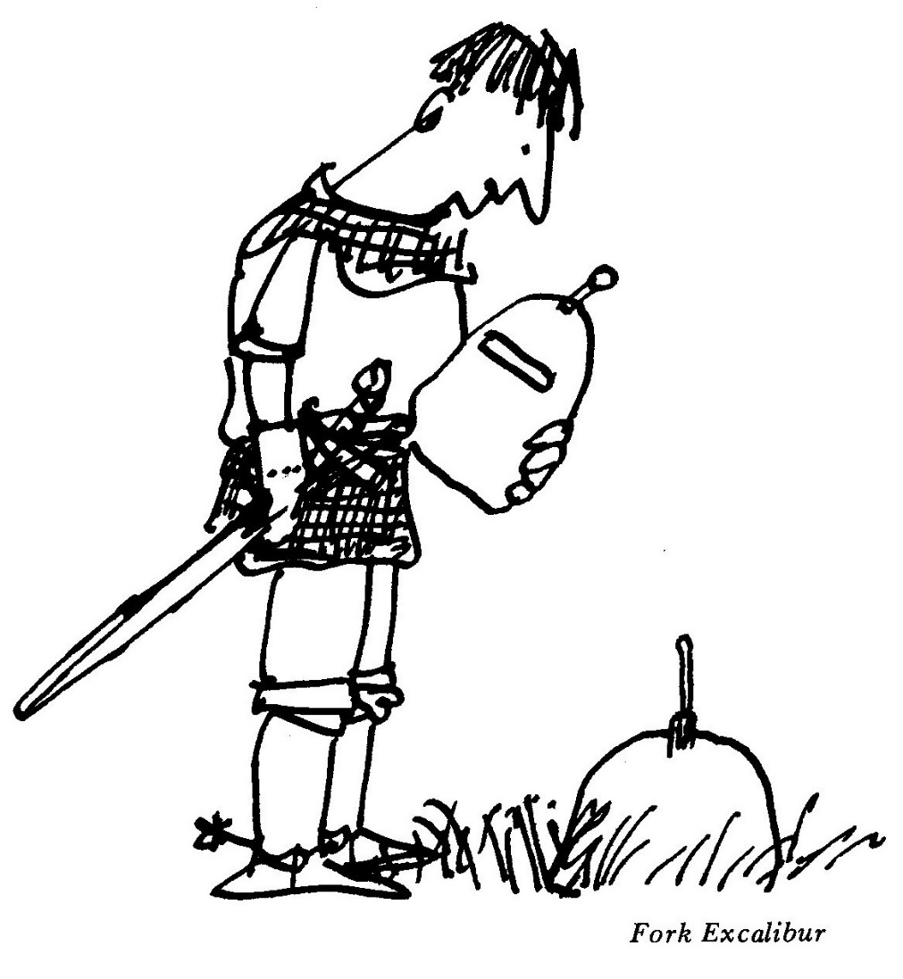

* PERFECTLY TOMORROW, TRUTH IN SLOWNESS
Retreat

for Nicky

Cloistered here for contemplation,
The only noise I choose to hear
From those that buzz and fret my ear
Is wind in trees. Soft crepitation.

By monastic meditation
My mind is still -— a limpid well
My inner self shucks off its shell.
Sudden freedom from fixation.

And thoughts of you, my love, prevail
(I must avoid this rhyme with snail).

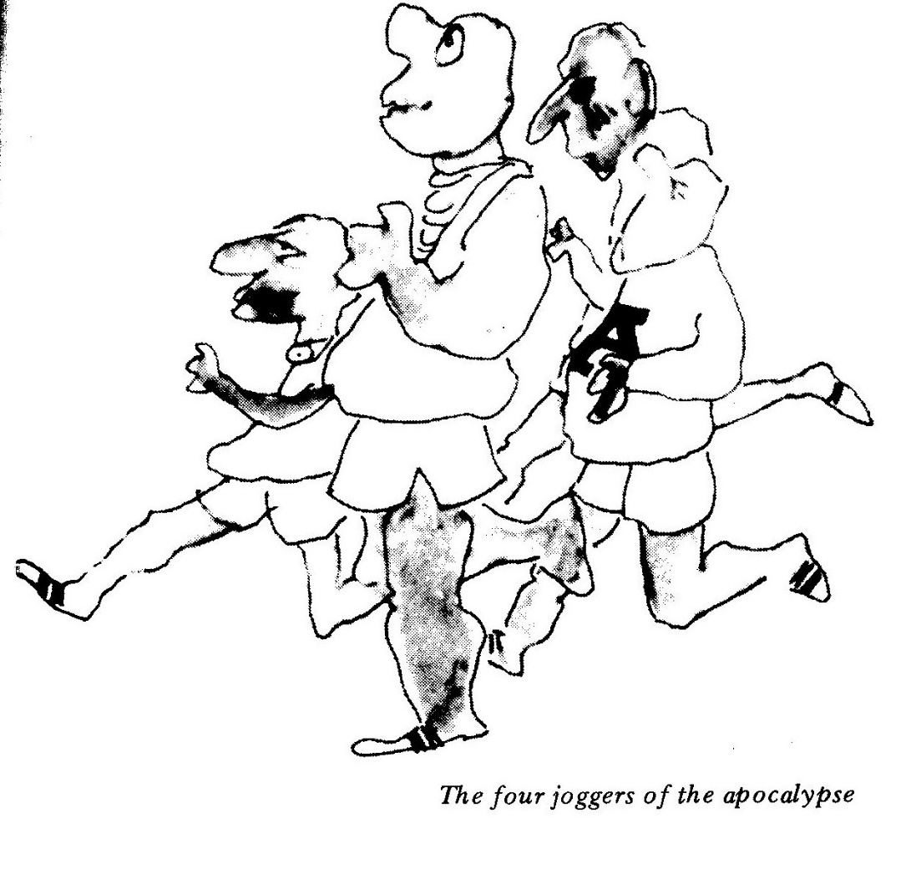

Two Snail Tanka

I

The snail, as twilight
Trims the sky, extends one eye.
A tentatively
Shy one, two, three, four, ﬁve, six,
seven, eight, nine tentacle.

II

Stuck in a traffic,
Jam: How pedagogical
To see a snail steam
Serene and placidly in
The opposite direction.

Resonance

I strolled along the lonely strand
With shells clamped to my ears.
I hoped to hear and understand
The Music of the Spheres.

I listened conchientiously
(Il suono blu e serio)
But all I heard, incessantly,
Was just the sea in stereo.

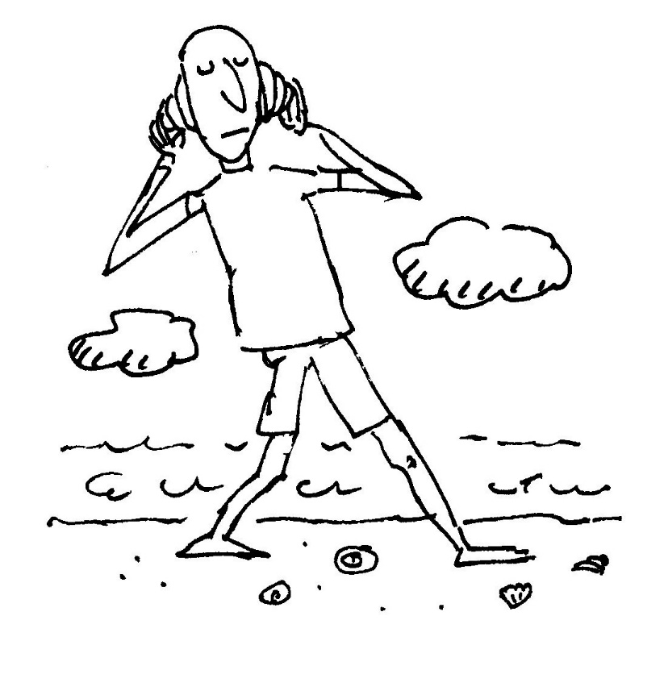

Vigil, Witsands

for Tom

The tide rolls in.
The headland steams
Beneath a pall of drifting cloud
Out to sea (or so it seems).

I wait at the window
(With bread and jam)
To wave goodbye
To Swellendam.

Pebbles

for Sandra

Impetuous, anarchic sea.
Untamed, implacable and free
Or monstrous calm, no ﬂurried fuss
You seem to us ambiguous,
For Time-trapped men can seldom guess
Your harassed lack of Timelessness.

With currents, backwash, Spring and Neap
Your schedule’s diﬁcult to keep
And Mistress Moon just loves to see
Her serfs enchained by fealty.
But at the strand we can observe
Some evidence of cracking nerve:

A ﬂustered tide that rolls and kneads
Its oceanic worry-beads.

Ephemeris

The Master’s calligraphic hand
With brush of wind and wash of sea
While limning changing constancy
Erases footnotes from the sand.

Each breaking wave, a slap of zen,
Repeats this lesson every sough:
The Transient is quite enough.
The foaming crest is hanging ten.

When tide is high the seabirds soar,
But dauntless in the tide’s retreat
Extending careful etchers’ feet,
Swoop, stop and drop upon the shore

To sprint or strut and, inter alia,
Imprint their ﬂeeting Marginalia.

The plover — Plettenberg Bay

for Gus Muller

I think the bird is called a plover
Who seems, frenetically, to hover
Above the shore in search of cover.

But needle eyes espy the feet,
The spindle shanks so deft and neat
That pirouette and sprint the beat

He plies between the sea and land
A crazy crisscross of the sand.
A hurried, frantic saraband.

At earth and water’s interface
With silent movie jerky pace
He lifts impatience to a state of grace.

Bird Watcher

Invisible to the casual eye,
Well camouﬂaged and very shy,
I spied it in its thicket nest.
The black “H” marking on its breast —
Front-jointed legs — grey dappled coat —
A lateral beak. I made a note
To add this species to my list:
An Urban Ornithologist!

A Few Haiku

1.

CHAMELEON

Cautious
With his delicate clawses.
Hesitates.
Before he pauses.

2.

Sporting springtime buds,
Logs trucking to the sawmill
Hopeless optimists!

3.

At night my neighbour’s
Cicada is this stridulating
Typewriter.

Monday in Eden

A gardening lady came to tea
And said, between her sipping:
“That lovely Monday-morning tree!
I’d like to take a clipping.”

Its foliage is fabulous
And varies with the clime.
To weather it’s impervious;
Like drought or wind or rime.

This paradigm to peach and fem,
So pleasing to the eye,
The seasons visit each in tum:
Our perennial Twirldry.

Now Adam bore one leaf of ﬁg
And Eve, I think, wore three.
They simply tweaked a clothespeg twig
And four fell from the tree.

This useful garden washing rack
Which decorates my premises
Can trace its antecedents back
To Chapter Three in Genesis.

The Myth of Vicarus

Upturned was every head to watch
Two leaf-green doves in ﬂight.
They soared above the cabbage patch_
The Cabbage Brothers Wright.

Transmogriﬁed from plant to bird
They tumbled through the blue
And every cabbage strained its roots
To get a better view.

“At last!” they cried “They’ve broken free
The fetters of the Ground.
If they can do it so can we!”
Then came a rushing sound;

On tiptoe every cabbage thrashed
Its leaves with fiendish force.
In vain, of course, some dust was raised
But none budged from its source.

But, the hurricane the effort caused
Surged upward through the air
Catching Icarus and Daedalus
Completely unaware.

Green wings were torn to tatters
Two hearts came crashing down
And all that really matters
Smashed senseless on the ground

The moral of this tragic tale
Is taught in every patch:
Ordained amongst us some must ﬂy
The rest are blessed to watch.

The Sap Rising

The insurrection in the breeze
Is whispered softly to the trees
Who agitate their green-gloved fists
Like apathetic anarchists.

Chameleons in camouﬂage,
Intent on subtle sabotage,
Advance on dialectic feet
To politicise branch elite.
The propaganda pigeons coo:
“Uhuru . . . Uhuru . . . Uhu . . .”

But all in vain. Suburban twigs
Are bourgeois, fascist, kulak pigs!

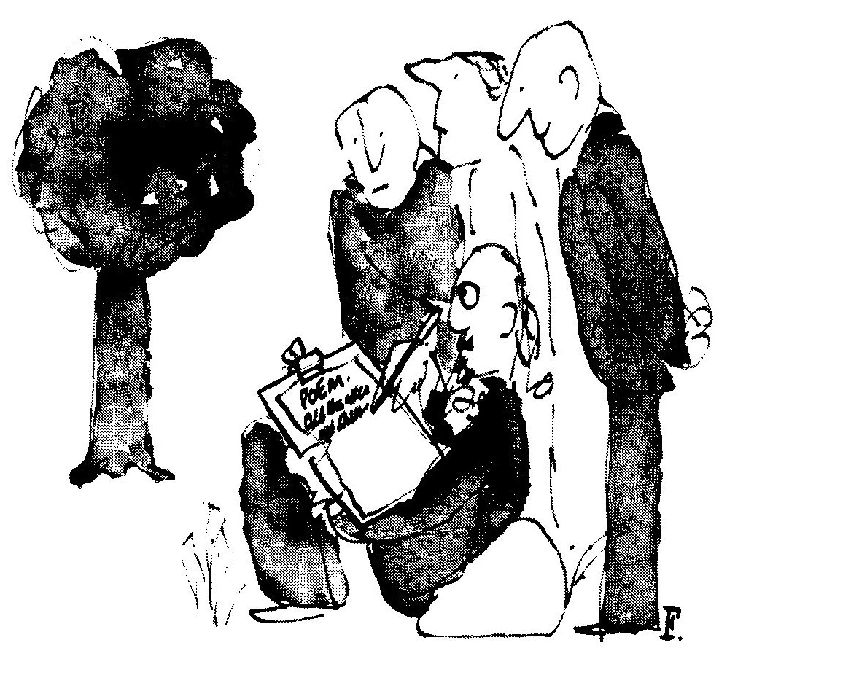
Cyclops

for Bruce

The dusk like gauze is falling
The day is fading fast
And homeward I am crawling
In hope that light will last.

As remnant shots of daylight
Are shuttled through night’s loom
I pedal apprehensive
Beneath the waxing gloom.

Myopic in the twilight
I peer from left to right
As cars from all directions
Scud blind towards the night.

Ecologists of the human race
List this amongst your theses:
That Cyclists of the Crepuscule
Are endangered as a species.

Dallas Ditchwater

I wonder what Miss Ellie, Jock
And all the rest are doing.
I will ﬁnd out on Tuesday night
It’s called: Compulsive Ewing.

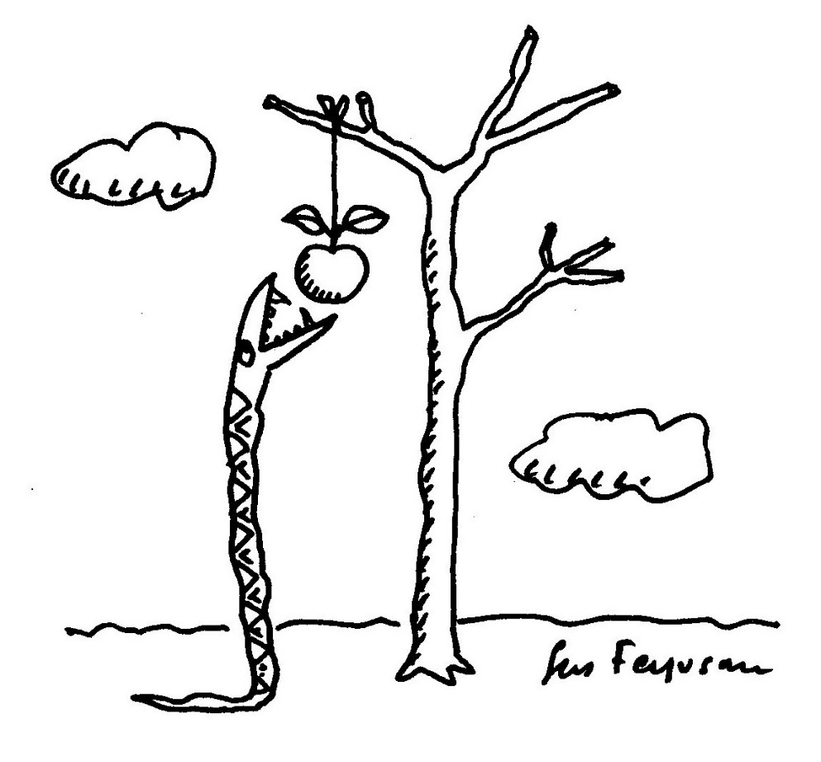

Riddle

My first is Inferno in one.
My second is nothing (a pun).
My third on a lady is velvet and gorse.
My last is an ovum minus the horse.

My whole you can’t buy for silver and gold
It tortures the young and comforts the old.

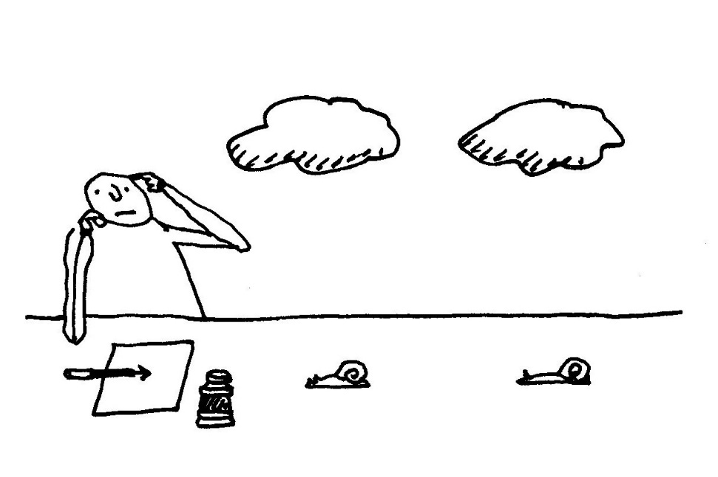

Past Applegarth in Radiance

My Sunday morning
Genuﬂections
Are made with bending knees
While sun spokes stroke
Across the road
And fire the fallen leaves.

My spinning chainwheel’s
Starred reflections
Whirr upward through the trees
And glinting from
My streaming cold:
The snailtrails on my sleeves.

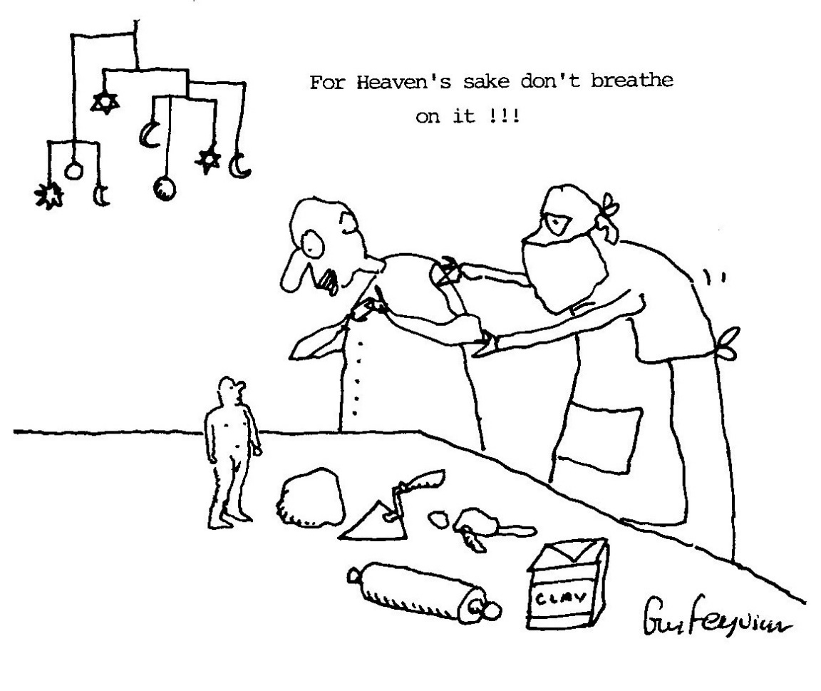

The Satori Story

A merchant on his way to Delhi
Toting his portentous belly
Stopped beneath a Bodi tree
To refresh himself with rice and ghee,
The shade was cool, the air was scented,
He fell asleep quite contented,
Until startled by an eager youth
Asking about Cosmic Truth:
“Master, can you tell me what
The Universe is all about?”
The merchant merely mumbled: “um”
And gazed intently at his tum,
In truth, to answer he was frightened,
But the boy cried out: “I’m enlightened.”
“You must be THE Gautama
Who opens portals to Nirvana.”

Disciples came in scores and throngs
With yellow robes and wooden thongs
And asked most obsequiously;
“What happened ’neath the Bodi‘ tree?”
The Buddha smiled: (Their thirst was slakened)
“Nothing much, I was awakened.”

Cornerish

In ancient Greece a baker man
Devised inventively to plan
Euclidian eclairs & symmetrical shapes
For sausage rolls or plane canapes.

His customers, it must be faced,
Lacked basic mathematic taste
Until he made, one day, a tasty
Quadrilateral pasty:

Pythagoras passing, stopped and stared,
“My Gosh!” he cried. “This pie are squared!”

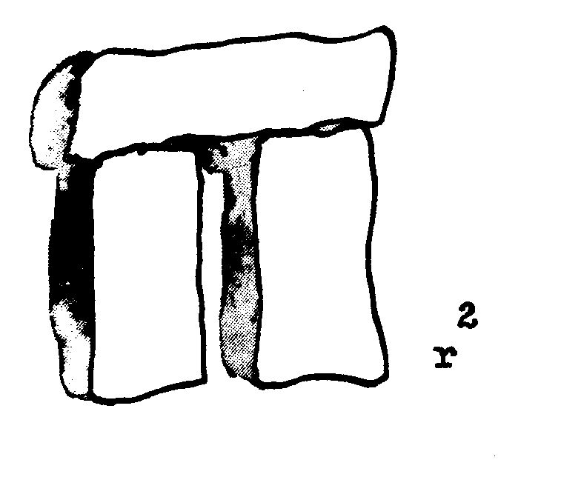
Starting from Scratch

Consider the case of the fortunate ﬂea
Who leapt from the bedclothes into my tea:
As aloof as a god I gazed from my height
As he frantically flailed with all his small might
And each desperate thrash in the tea made its wave.

Overcome by compassion I decided to save
Him. He sat on my finger and shook himself dry
And then bounded off in the wink of an eye.
So now when I bear the mark of the flea
I know I am victim to any but he.

My faith as I scratch at those itchy red bites
Is that I am Saint Androcles friend of the mites.

Limerick

There once was a fierce feminist
Who said to her man: I insist
As my conjugal right
Every Saturday night
To go out with the girls and get pissed
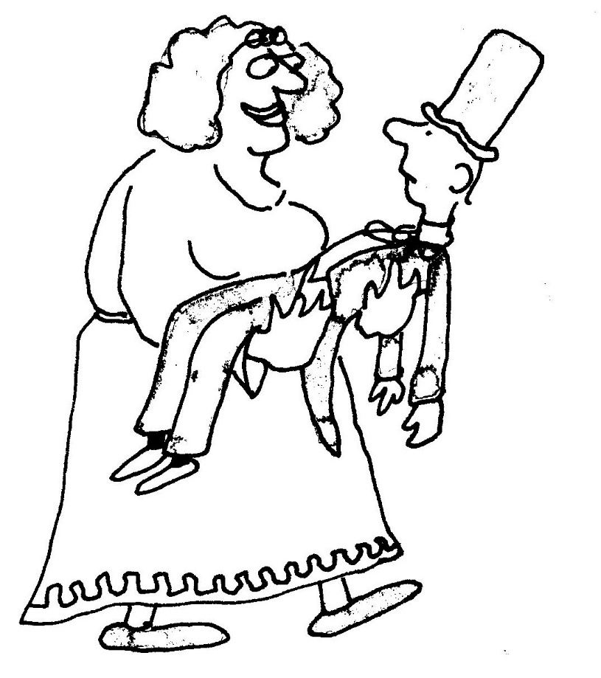

Liveware blues

Machine! You have not blood nor gland.
Your tongue no man can understand.
What Poem, Sonnet, Song or Ode
Can be expressed in Binary Code?
Pedestrian your rhythms run:
O one, o one, o one, o one.

We covet your complacent skill.
Those rapid circuits Digital,
Without remorse or grief or pain
Repeat-repeat each task again.
Your functional memory just wipes clean
The slightest trace of Doubt or Dream.

You’re never bored, but can’t regret
Not wanting what you cannot get.

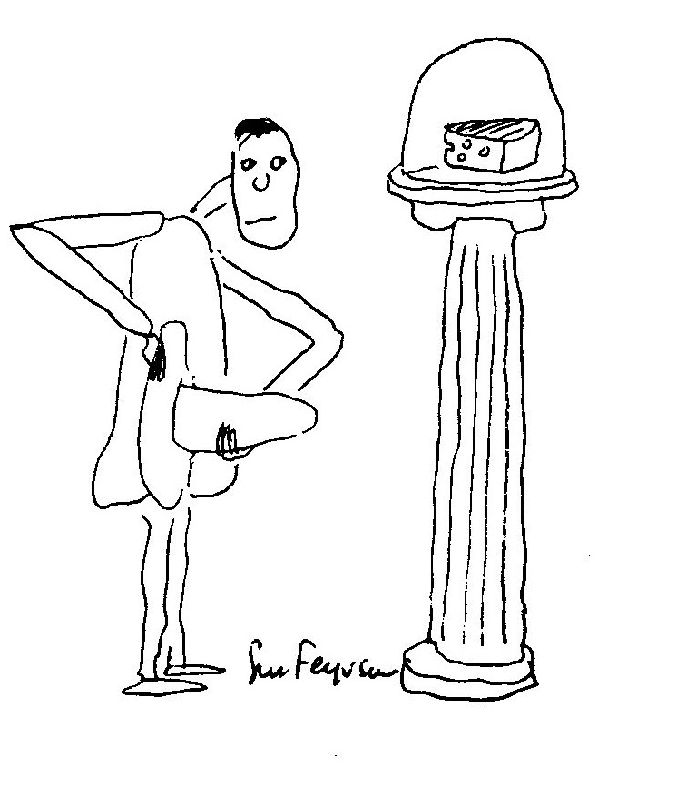
Homage to Fromage

Limericks

1.

There once was a jogger called Quail
Who trained with much pain and travail.
His doctor said: “Go
Exceedingly slow
And run round the block with a snail.”

2.

There was a sweet person called Pat
Who would talk to the flowers at her ﬂat
Said Pansy to Rose:
“She’s kind -I suppose
But I’d much prefer Compost to Chat.”

3.

THE BETTER PART OF VALOUR

When comes the revolution night
I’m sure that I will be alright.
I should survive the heat.
I have been quite discreet.
I’ve told no-one that I’m white.

Kamikaze

Like forty million crack dragoons
Stood battle trained spermatozoons.

The captain spoke in solemn voice:
“Although I know you have no choice
And little chance, you have permission
To volunteer for this emission.”

Not one comma hesitated:
“YES!” They all ejaculated.

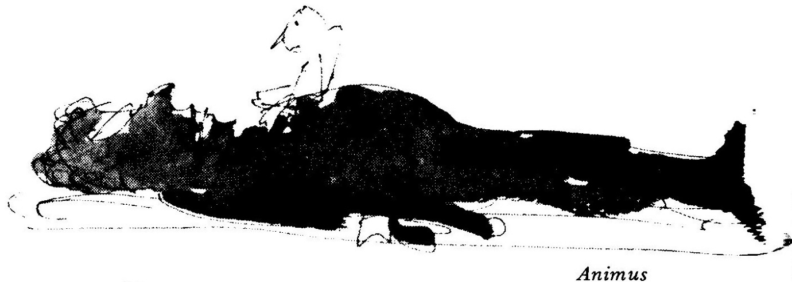
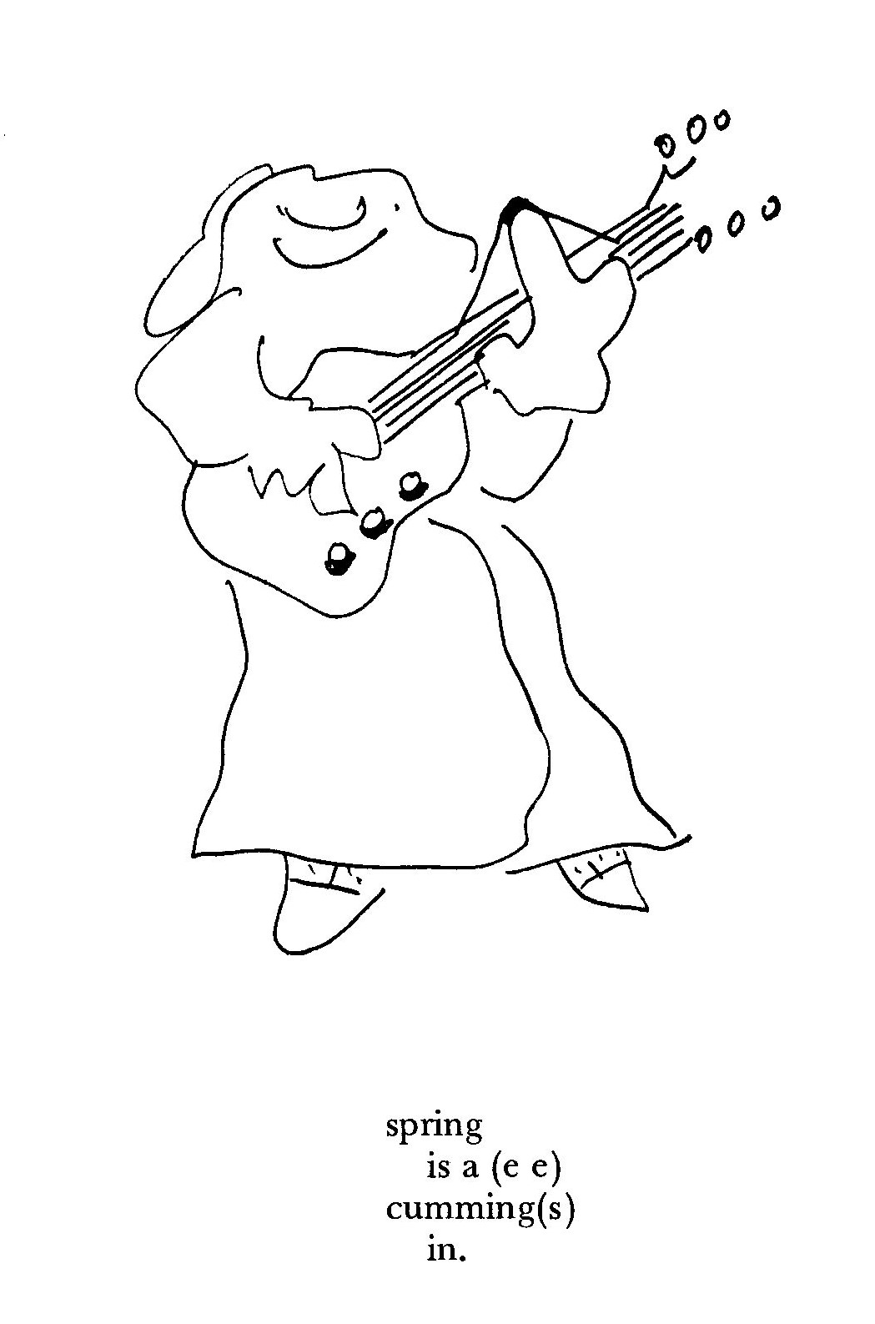

Energy Crisis

His demise was sudden
(Aortal constriction)
While watching a programme
On fuel restriction.

His cremation was cancelled
For a reason no worse
Than the ration on petrol
Applied to the hearse.

But all was not lost
Though the irony’s cruel.
His dried out old body
Made fine fossel fuel.

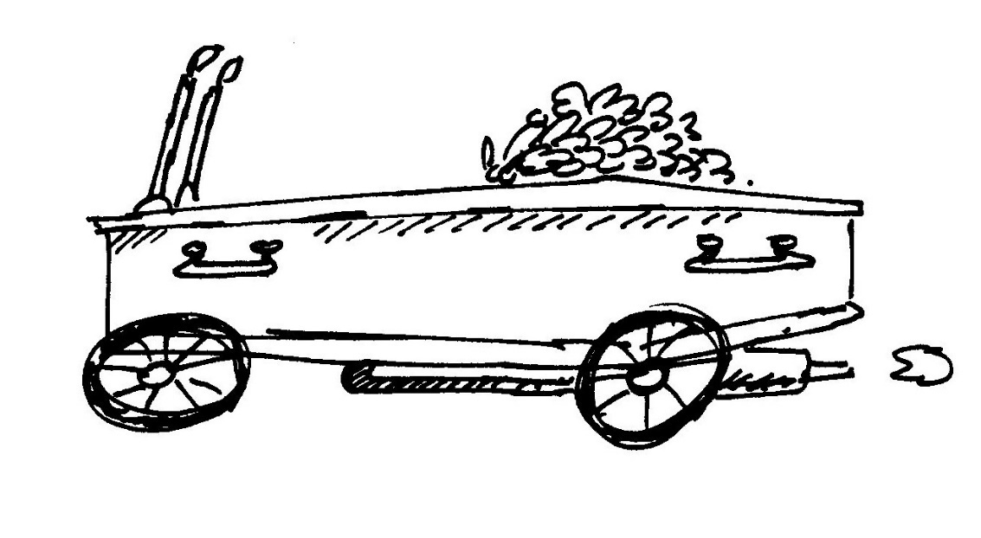

Glimlag 26/12/81

Came yesterday from outer space,
Nine ninety-one light years away
This message to the human race:
(In Hebrew, cognoscenti say)

“We’ve heard the news! We wish you joy!
Congratulations on a boy!”
