CONTENTS

THE BIRTHDAY: BOY NEW POEMS

The Start of the Quest
Trepanacea
The Problem with the Brain
Feminist Haiku
Riposte: a true story
From the Protocols of the Utopian Police
The Comedian Faces His Quietus
On Leaving Baltimore
Divorce
Domestic Remedy
Caveat
Who was Colin Dictor
The Geriatric on Looking at his 543 Emails
The Birthday Boy
Shrinking
Snailwail
Pilates
Found Poem
Disturbing
The Height of Monogamy
From The Ioys of Serial Monogamy
Living Among the Obsolete
Hippocrates is Alive and Well
Moving House
Transformation
Encoded
Culture Clash
Winter Bathos
Iumping the Queue
The Bright Morning
Dragged by His Dogs
Virginal
Suburban Ambiguity
In the Small Karoo
Humility in Action
When the Icelandic Geyser Burst
On ‘In a Station of the Metro’
Seeking Serendipity
Niente
Allergic
Caricaturismo
The Sound of a Distant Tom-Tom
Haikoids
Heraclitus (or Keeping Fit)
How Fair the Fairest Cape?
Stating the Obvious #7367
And the Birds are Tweeting
Endgame #76
A Shark’s Best Friend is His Chum
Two Lines for Finuala
At the Airport
Tending to Perfection
At Four a.m.
On Riding with Women on Bicycles
The Wind
Advice
Rise and Fall
Compassion
Ambition
More Haikoids
For David

CARPE DIEM: SELECTED POEMS

Vigil, Witsands
Liveware Blues
On the Death of an Old Computer
Snail Mail
Snail Love
Snail Christmas Carol
Snail Atman
Kamikaze
Ephemeris
Cosmick Carp
Carpe Diem
Haiku
Innocent Experience
Evidence?
Zoshi Said
Maslow Was Wrong
Reggae Rhymes for David
Poem for Nicky
Life Sentence
Good Theology, Bad Move
Book Club
Weather Report
Light Verse at the End of the Tunnel
The Metempsychosis of the Yak
Credo
The Elastic Life Formula
Limerick
Autophagy
Dyslexic
Epigram
Free Fall
Internet Senryu
Iustiﬁcation
Old Age
Self Pity
Love Among the Middle-Aged
More Love Among the Middle-Aged
Semper Helix
Two Tanka
If Only
Brief Selection: Ars Poetica
Brief Selection: Snapshots
Past Applegarth in Radiance
Grenade
Classiﬁed
The Cape Town Laureate Speaks
Found Poem
Writerk Block
With Occams Razor, Gerard Manley Hopkins Shaves
Iohn Donne on the N1
Wordsworth
Old Boys’ Club
Somewhere
Brief Selection
Poet
The Japanese Have a Word for It
Doggerel Dog
Thanks But No Thanks
Dorothy Parker
Confession of a Rough Beast
The Parable of the Generous Man
Syringa
By Foot the Apostles Travelled
Return to the Arms of Morpheus
Insomniac in Love
Simon’s Town Hell Run
Faminism
Advice to the Elderly
Synaesthesia Tanka
Yorvic
Spanish Sketches: Pilgrims’ Song
A Sad Sequel
In a Bookshop
Cloisters
Requieschatology
Southeaster Rising
Outage 1 Feb 2008
Questions Near Montagu
Flawed Survey
Endgame
Aubade
Alzheimer’s Freight
Toughened Up
Geriatric Plight
A Miscellany of Haikoids
Disengaged But Not Detached
Stressed, Unstressed
Rugby Injuries
Villanelle

AFTERWORD

A Word to the Aged

THE START OF THE QUEST
(banging on the tavern door)

My name is Gus.
His name is Tim.
We seek the ﬂaming
Terrapin.

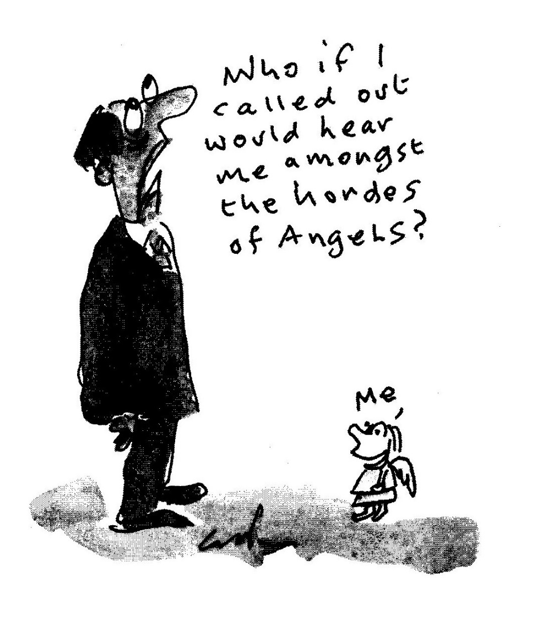

TREPANACEA

During the thirty six hours
it took to have
his brain serviced
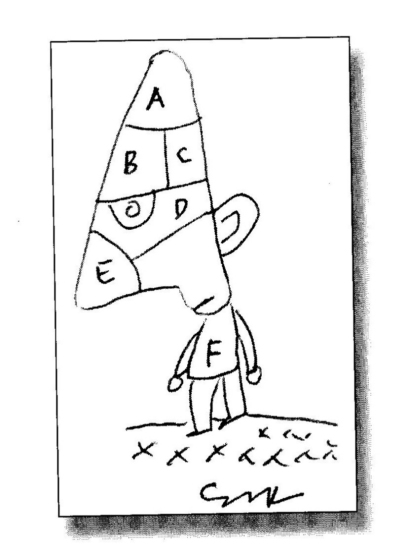
he sat, quite happily,
thinking of absolutely
nothing.

THE PROBLEM WITH THE BRAIN

The problem with the brain
Is that when you are over sixty
It seldom comes when called.
Instead it waits politely
To allow the gathering of wits.

FEMINIST HAIKU

Here’s my special gift to you:
it’s only my opinion

but any woman worth her salt
beats ten men in a minyan!

RIPOSTE: A TRUE STORY

At the till, I confessed to the cashier that this was my ﬁrst time in
a Wimpy She replied: I can’t believe it, sir, you look as if you were
here only yesterday.

FROM THE PROTOCOLS OF THE UTOPIAN POLICE

Should a suspect prove to be
recalcitrant with information
he is to be offered gingko biloba
to jog his memory.
THE COMEDIAN FACES HIS QUIETUS

He lies on his deathbed
in a most pleasant haze,
looking forward indeed
to posthumorous praise.

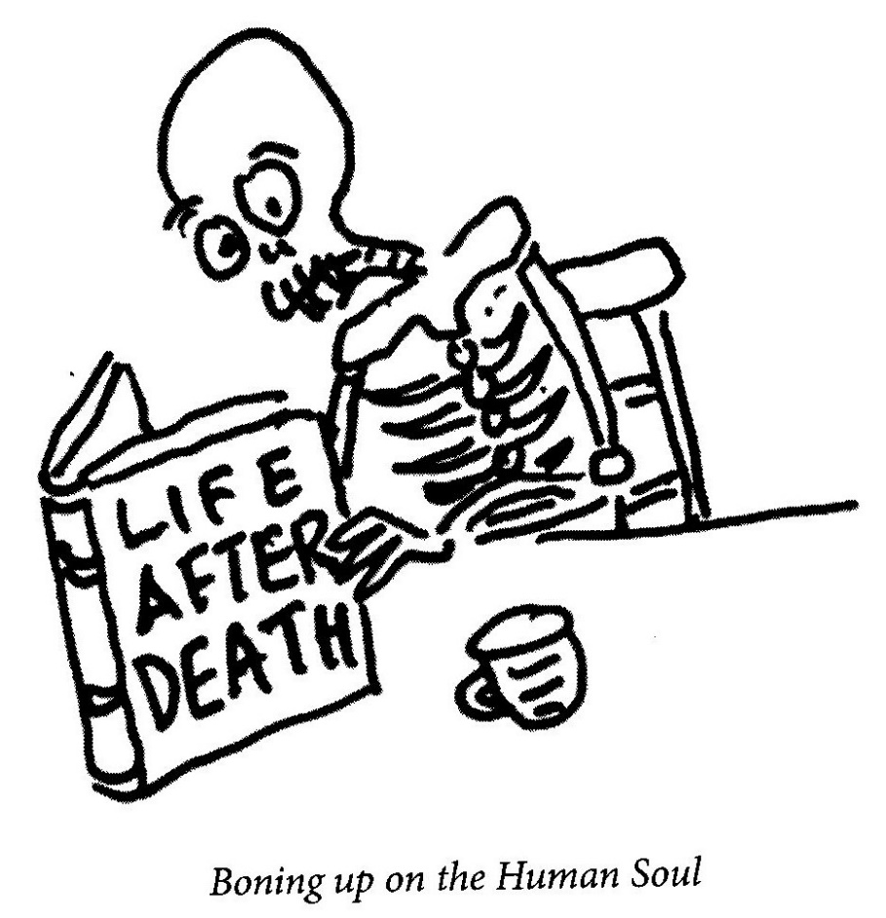

ON LEAVING BALTIMORE

Beside the phone that never rings
I pack, unpack, repack my things
preparing for the ﬁnal call-—
thc whistle of the oriole.
DIVORCE

Here we are, my love,
two hearts entwined,
entangled in a double blind.

To cut us loose,
to set us free,
call a surgeon
with a law degree.

DOMESTIC REMEDY

When his wife begins to mutter,
when complaining really starts,
he smiles and opens up his box
of acupuncture darts.
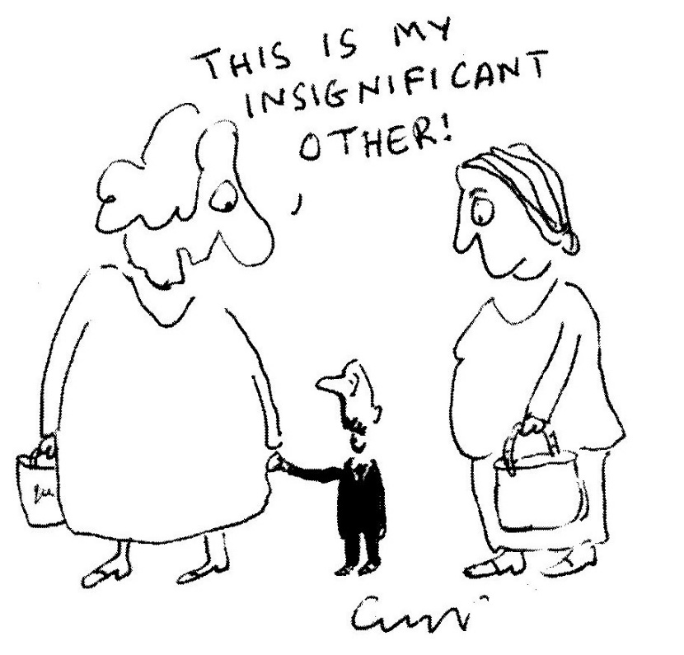
CAVEAT

It has come to our attention that supermarket malls all over the
civilised world have been secretly equipped with MRIs or cat
scans. The overnight installation of systems will be subtle and
painless and, best of all, anyone passing through the mall system
will be, automatically, healed of any disease or deformity. A grand
announcement will follow as soon as the valetudinarian prototype
is ﬁnally up and moaning.

WHO WAS COLIN DICTOR?

Today, I rode past a man at the side of the road offering a ﬁfties
answering machine destined to be a collectable in two thousand
and ﬁfteen, fully restored but not taking calls.

THE GERIATRIC ON LOOKING AT HIS 543 EMAILS

I must learn the art of deletion.
Although, mind you, my brain
with its ailing secretion
is doing an excellent job.

THE BIRTHDAY BOY

The birthday boy
Left standing in the rain
Making room for the guests

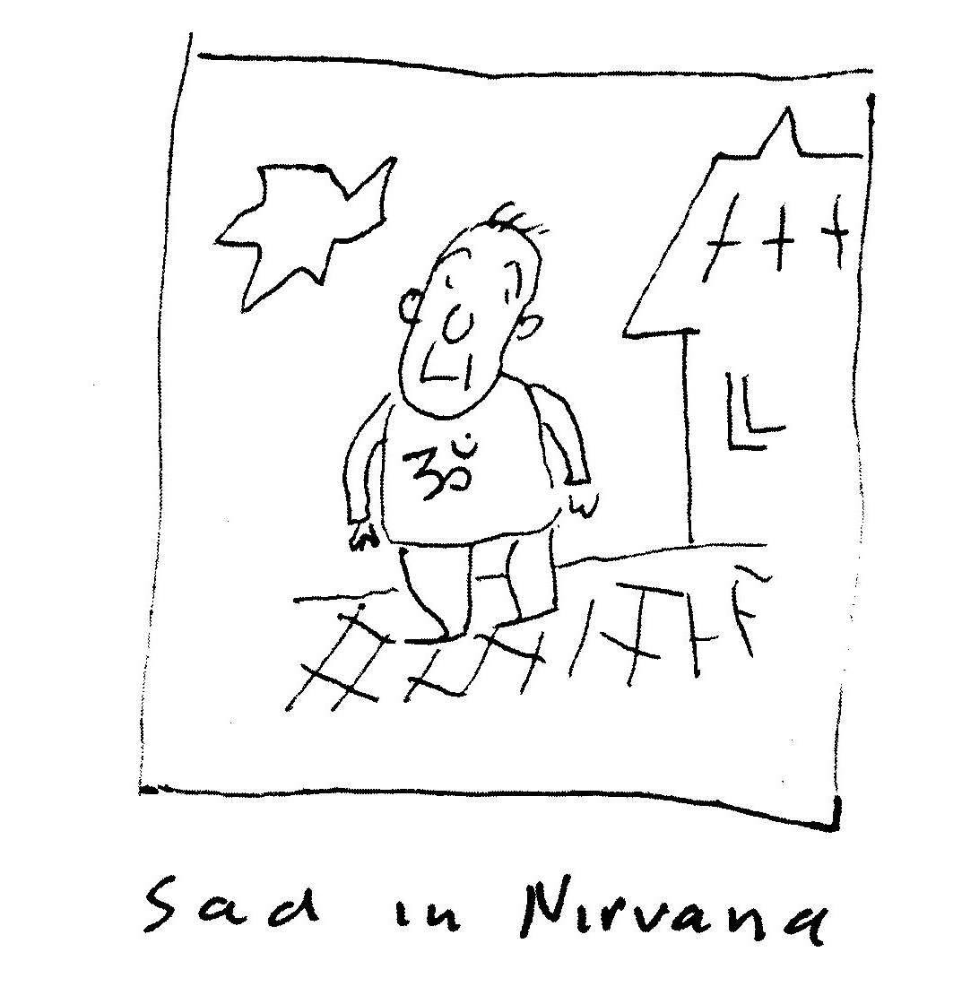

SHRINKING

I tried to write a villanelle
but gave it up—what the hell—
and fell upon my unmade bed
and wrote a clerihew instead.

SNAILWAIL

Our plight
is not to travel light
but slow
with more, not less, cargo.

PILATES

I don’t understand,
surely the efforts of old age
should keep you ﬁt?

FOUND POEM

Attention!
Will all male patients
return to their beds
Immediately!

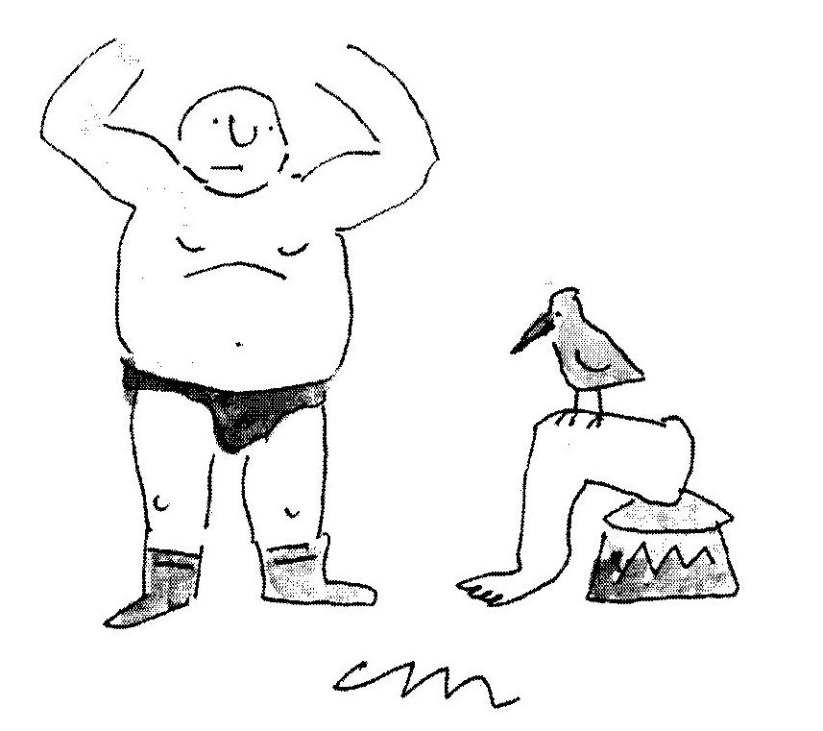
DISTURBING

Listening to my somniloquist,
I tapped her lightly on the wrist;
the spell was broken,
the sleeper woken
and was, believe me, pretty pissed.

THE HEIGHT OF MONOGAMY

His libido is too low
to get excited about
girls he doesn’t love.

FROM THE JOYS OF SERIAL MONOGAMY

Before his second marriage
he had his vasectomy reversed——
effectively untying the knot.

LIVING AMONG THE OBSOLETE

The last living stenographer
still writes
all her letters
in shorthand.

HIPPOCRATES IS ALIVE AND WELL

I had a little roundworm
he was my special friend
he led me up the colon
round each and every bend.

He showed me all the sphincters
he knows them, every one,
and revels in his element.
(He’s never seen the sun.)

He helps with colon problems
the doctors ﬁnd it funny
that despite his contribution
he never asks for money.

MOVING HOUSE

—-for Ingrid de Kok

The hermit crab was forced to move
From one shell to another.
A hellish task but which, when done,
Was truly worth the bother.

TRANSFORMATION

Auden, whose poetry
thunders and tinkles,
is now better known
for his wonderful wrinkles.

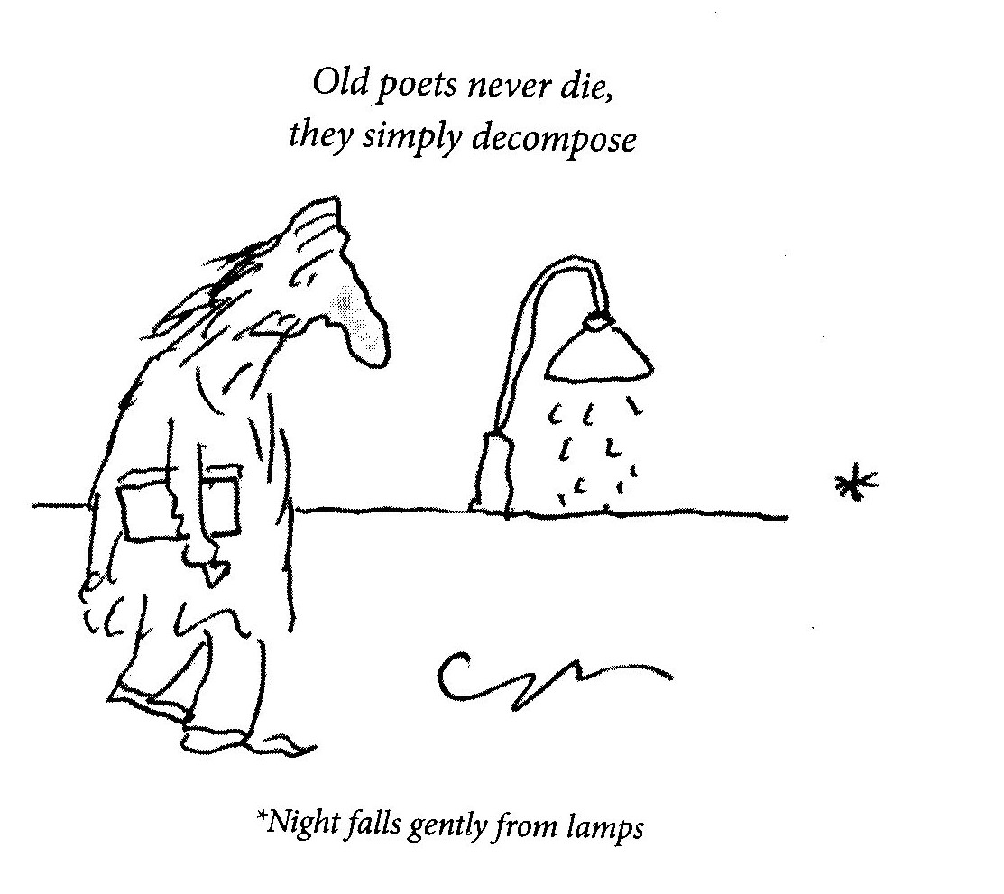

ENCODED

The profusion of mobile phones
reminds us that we are
old enough to remember
the rattling sound of Morse-code tapping

CULTURE CLASH

The one thing that I truly fear,
Which brings me out in hives:
Will the cricket interfere
With Days of our Lives?

WINTER BATHOS

Thrashing trees.
In the distance,
the ominous echoing
and rattling thunder
of dislocated
garbage cans.

JUMPING THE QUEUE

It takes a leap of courage
from both timorous and bold
to leap across the elderly
and join the very old!

THIS BRIGHT MORNING

The world so grandly sublime
That I'm quietly inclined

To consider this world
As intelligent design.

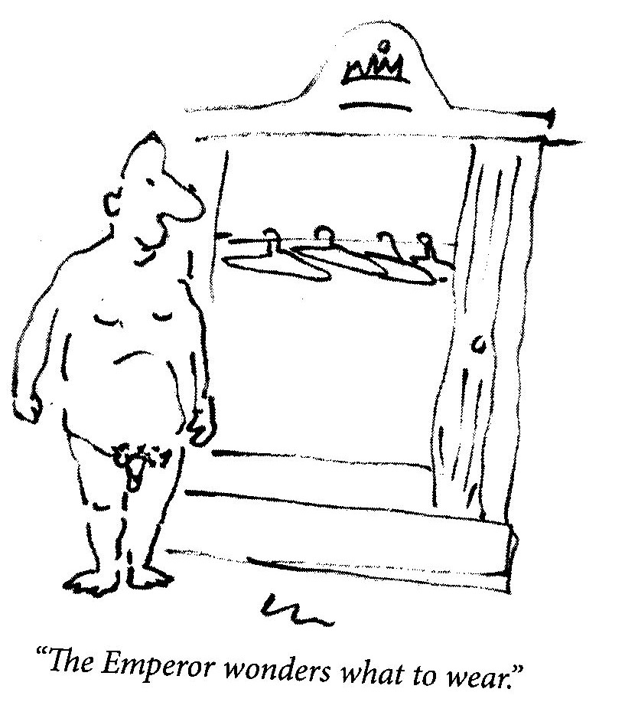
DRAGGED BY HIS DOGS

on a morning walk,
our neighbour,
the polar explorer.

VIRGINAL

Unsold, unread,
with early indications of foxing
The bookseller weeps.
SUBURBAN AMBIGUITY

Our security fence
has the same number of frets
as a guitar left in the wind—-
and the whole night singing

IN THE SMALL KAROO

But still,
in the distance,
the tick-ticking
of a metronome.

HUMILITY IN ACTION

Leonardo’s apprentice, Stefano,
drew the perfect circle, and then,
embarrassed, wiped it out.

WHEN THE ICELANDIC GEYSER BURST

Did Nostradamus not predict it?
Was it not in a million charts?
And the oracles and the diviners,

the clairvoyants and seers?
What were they doing?
Reading palms? Throwing bones?

Poring over the Tibetan Book of the Dead.
Not warning the endangered and vulnerable.
Were they, perhaps, some of them, not embarrassed

to be found stranded at the airport amongst
the ignorant and unsighted,
the grounded and bewildered?

ON ‘IN A STATION OF THE METRO’

Ezra Pound! Now there was a man—
he even wrote haiku that didn’t scan!

SEEKING SERENDIPITY

He stares and stares at one blank page:
his daily meditation. The page stares back,
it will not yield the slightest inclination
of what and where and why and when.
Except that this has naught to do with Zen.

NIENTE

Nothing to report
except the slightly
irritating clatter
of wind against
the bamboo blind.

ALLERGIC

When contemplating
the geology of France,
always remember
the layers of impacted
croissant crumbs
some ﬁfty metres deep.

CARICATURISMO

Unable to draw from life,
he drew thousands

of faces hoping
to match one to each subject.

On his death, his drawings
were hung in a vast gallery

with people arriving in numbers
desperately hoping to ﬁnd themselves

THE SOUND OF A DISTANT TOM-TOM

In acts of expiation
we return, at last,

to the ancient art
of running the dunes.

Ignoring ancestors,
we are insouciant in the belief

that angels in the cloud,
have little else to do

but track our each and every move
to mitigate our past.

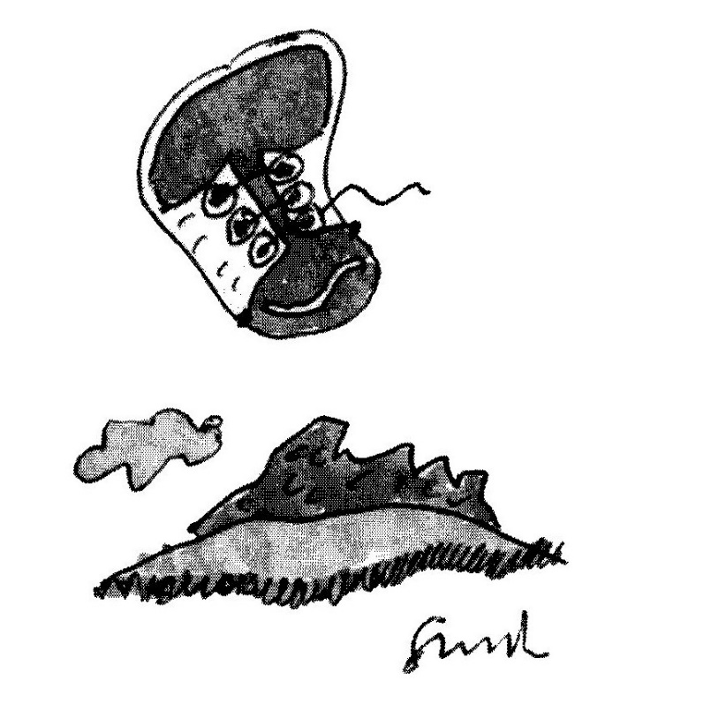
HAIKOIDS

Living in the moment
is great
until you’re in it.

His Muse has gone,
though now and then he calls
to collect his washing.

She stole my heart—
yet another case
of cardiac arrest!

Old men
struggle to pee.
Tam? pis!

He shaves ineptly
to allow his wife some
unexpected pricks.

According to Heraclitus
you can’t put your foot
in Touws River twice.

HERACLITUS (on KEEPING PIT)

He bought a pedometer
to gauge the number
of kilometres
he walks every day
looking for his spectacles.

HOW FAIR THE FAIREST CAPE?

Not much because, to be unkind,
both Hottentot and Dutch
did their utter best
to rob each other blind.

STATING THE OBVIOUS # 7367
Birds only ﬂy,
the sage said sadly,
because, you see,
they walk so badly.
AND THE BIRDS ARE TWEETING

There is something wrong,
the dog staggering on the lawn
scratching for crumbs in the sand.

In an ornithological nightmare
birds imitate klaxons, sirens, mobiles,
bleepers and each other.

In efforts to respond, eggs are unlaid,
genders get confused, nesting patterns muddled
and ancient roles reversed until

eventually birds fall silent, the dog
barks thrice, whines, turns again
and, disconsolately, falls asleep.

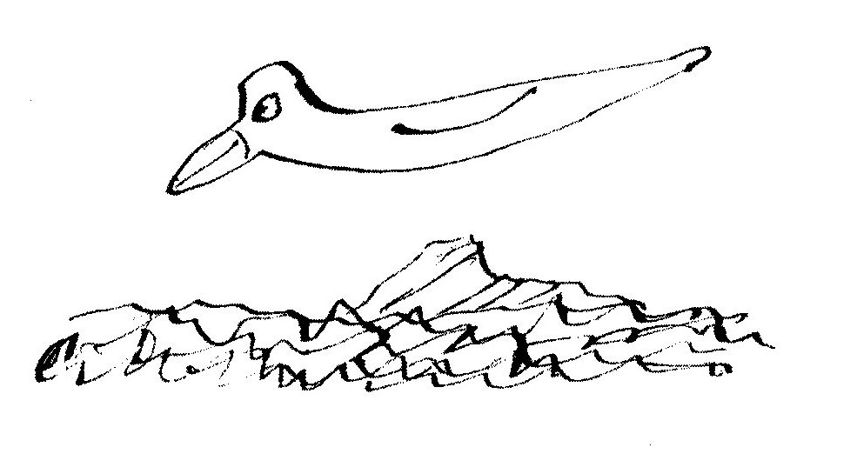

ENDGAME #76

As a ﬁnal grand gesture
he took his Hilton Nel plates
to a wild Greek party.

A SHARK’S BEST FRIEND IS HIS CHUM

When sharks are gliding through the sea
It’s not the place you want to be.
Sharks will eat you on a whim
Or just remove a dangling limb
So please be careful where you swim.

But why’s their bite worse than their bark?
Why do they sulk in the murky dark?
The answer is this, simple and stark:
They deeply resent being banned from the ark
But what about ﬁsh, or dolphin, or skate?

That, of course, is another debate.
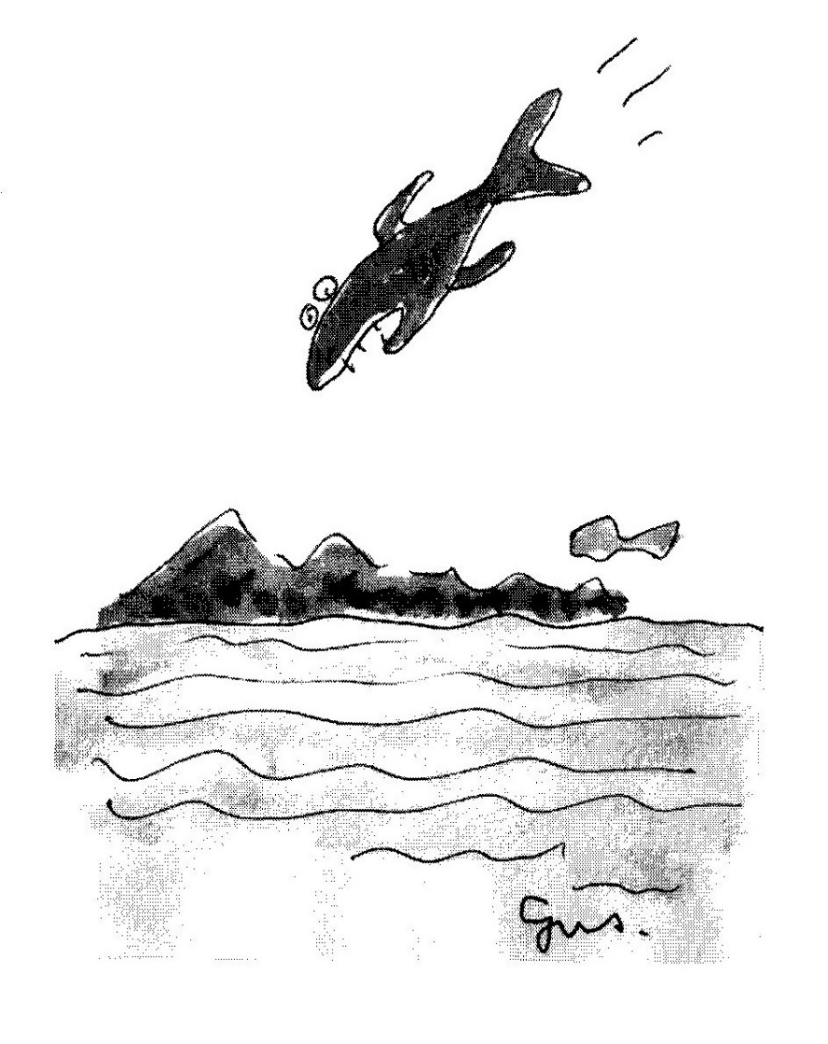

TWO LINES FOR FINUALA

Left in the grill
the toast was toast.

AT THE AIRPORT

So many men
but none of them Daddy.

TENDING TO PERFECTION

He always leaves
room for complaint.

AT FOUR A.M.

What really keeps me awake
and nocturnally losing the plot
is how many franchises
has the Lord of the Universe got?—

none ten billion some uncountable
lots stacks myriads thirty-two forty-
one seven inﬁnite spans et al inﬁnitum
never plench enough three nil nulla

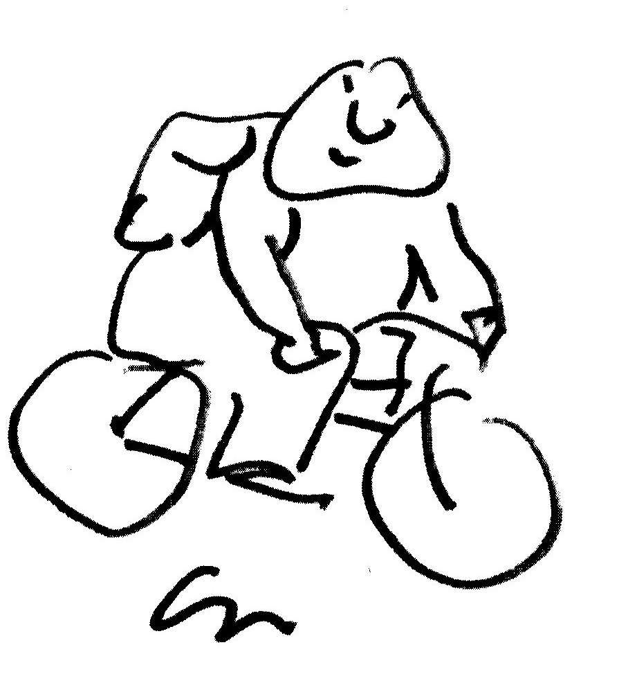

ON RIDING WITH WOMEN ON BICYCLES

I ride behind. My thoughts are pure.
But, still I’m viewed as envoyeur.

I ride ahead, the wind pumps hard.
They fall behind, I’m avant-garde.

In pelotons, I never ride,
Once ignored! I have my pride!

Yet, I’m content, I study Zen.
But from next week, I ride with men.

THE WIND

The wind sweeps away the clutter
then dumps it somewhere else.

ADVICE

Don’t wear yourself out—
It’s the only one you’ve got.

RISE AND FALL

With bursting hearts
and aching knees
we labour up
the Pyrenees

then down again
the other side
at hurtling speed!
We’re terriﬁed.

But when it’s over
and it’s all done,
we grin and say:
Well, that was fun!

COMPASSION

Said St Francis of Assisi,
In more or less these very words
Loving people isn’t easy
And charity is for the birds.

AMBITION

I’m sitting
in the boss’s chair,
relaxed and ready to roll.

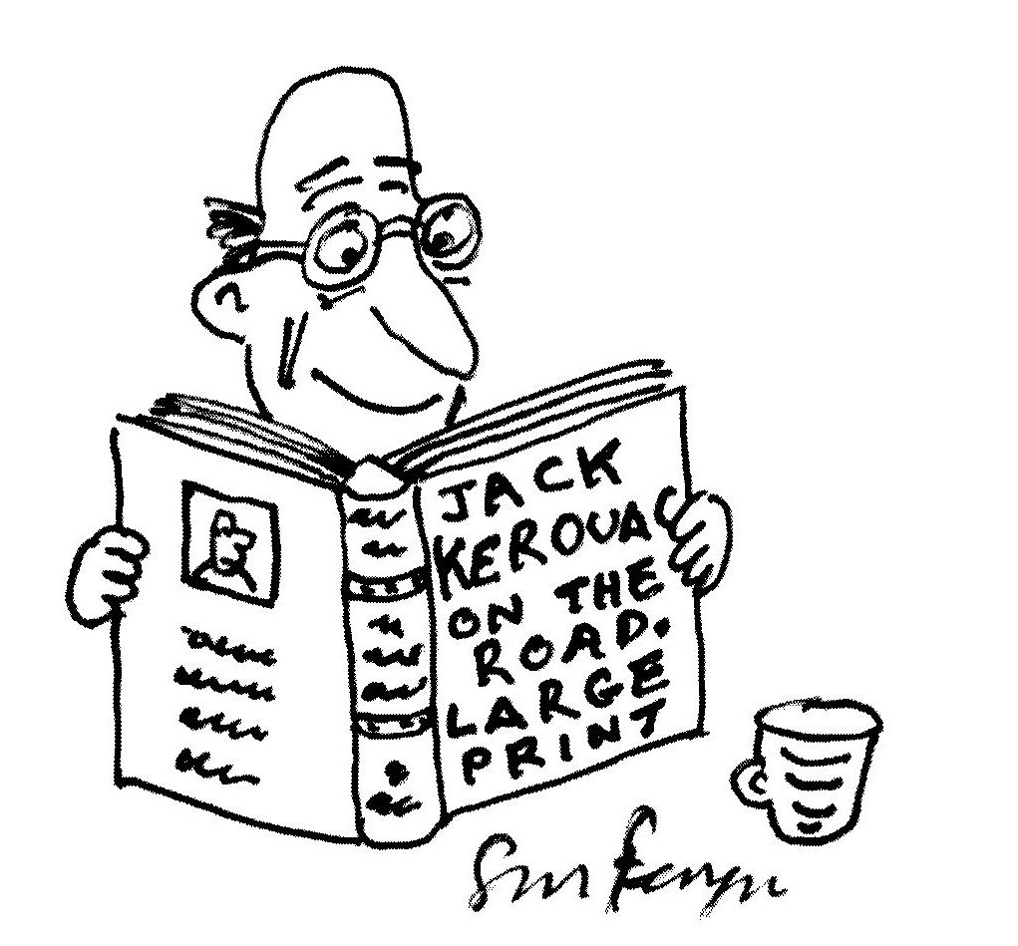

MORE HAIKOIDS
At the booksellers party
her friends all rave
about their Kindles.

I’ve only been in purgatory
for two weeks
and it’s been hell.

I owe my life to the fact
that my parents had
unprotected sex.

I’m not saying no
but I’m inundated with work
and unindated with time.

Off to the restaurant
hoping to be mildly
disappointed.

She comes to the pharmacy
for a pregnancy test
and a packet of chips.

FOR DAVID

April is the coolest month,
The wind don’t blow, yo!
The waves don’t squall, ya’1l.

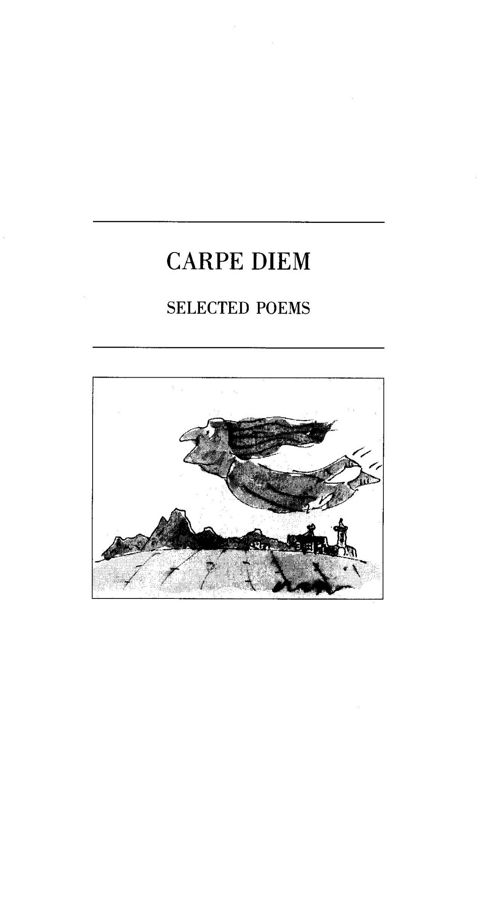
VIGIL, WITSAND

—for Tom

The tide rolls in.
The headland steams
Beneath a pall of drifting clouds
Out to sea (or so it seems).
I wait at the window
(With bread and jam)
To wave goodbye
To Swellendam.

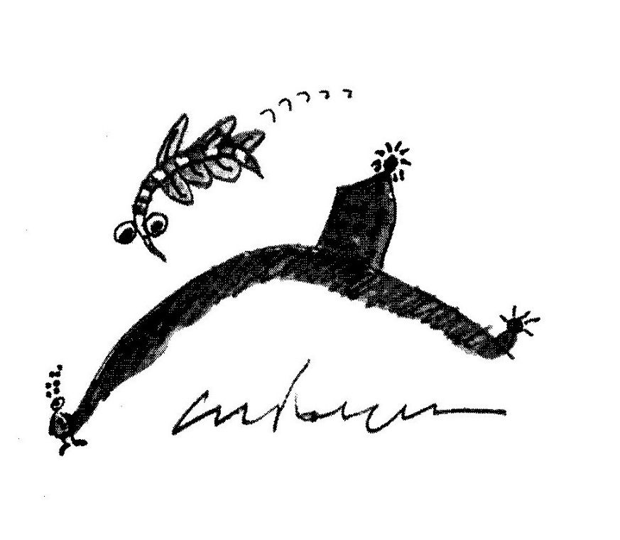

LIVEWARE BLUES

Machine! You have not blood nor gland.
Your tongue no man can understand.
What Poem, Song, Sonnet or Ode
Can be expressed in Binary Code?
Pedestrian your rhythms run:
O one, o one, o one, o one.

We covet your complacent skill.
Those rapid circuits Digital,
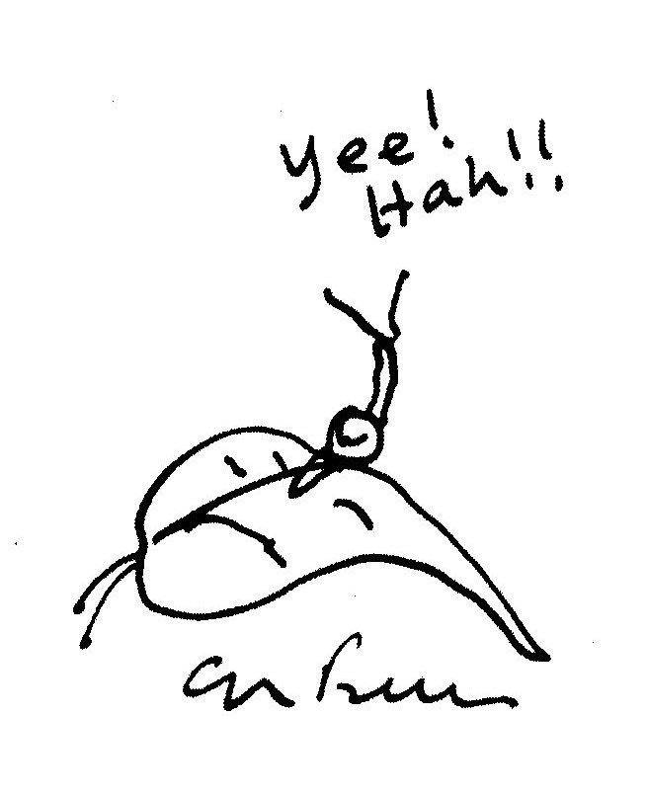
Without remorse or grief or pain
Repeat-repeat each task again.
Your functional memory just wipes clean
The slightest trace of Doubt or Dream.

You’re never bored, but can’t regret
Not wanting what you cannot get.

ON THE DEATH OF AN OLD COMPUTER

Ascii to Ascii,
Dos to Dos.

SNAIL MAIL

In old Japan a border guard
With one wet horsehair wrote
In microscopic characters
His wife a poignant note.

He called his favourite carrier-snail
And pinned it to his shell
And said: “Oh steadfast Samurai,
Depart for home. Go well!”

The message read: “Should I survive
Then disregard this brief;
But if I die, this missive will
Remind you of your grief.”

SNAIL LOVE

How lovely is this
sensual land
beyond the sexual peak:

Where slow and languid
ﬂows each gland
and foreplay takes a week.

SNAIL CHRISTMAS CAROL

While shepherds watched their ﬂocks by night
All seated on the ground
A humble snail came sliding by
And made a rasping sound.

“Desist!” cried he, for cruel intent
Had made them grasp their sticks;
“Forewarning of great news I bring
To you unworthy hicks.”

“When tomorrow night the evening star
Is just atop yon tree,
An angel of the Lord will come
To prophesy to thee.”

A sudden streak. The snail was gone,
His trail an after-glow.
“A miracle!” one shepherd cried;
“Methought the snail was slow.”

Tomorrow came and was today,
The shepherds got cold feet
And arranged it that another shift
The messenger would meet.

"lhat is why the gospel speaks
About the ‘mighty dread’
For unpreparéd were the bunch
That watched that night instead.

The tidings told, the shepherds ran,
Deserting they their sheep,
Across the hills towards the Inn
Their witnessing to keep.

The sheep relaxed. The angel stood
Conversing with the snail:
“It seems to me, my little friend,
We planned to no avail.”

“For man forewarned is man alarme
Even glad news is a shock.
The shepherd that is born this day
Must tend his timid ﬂock.”
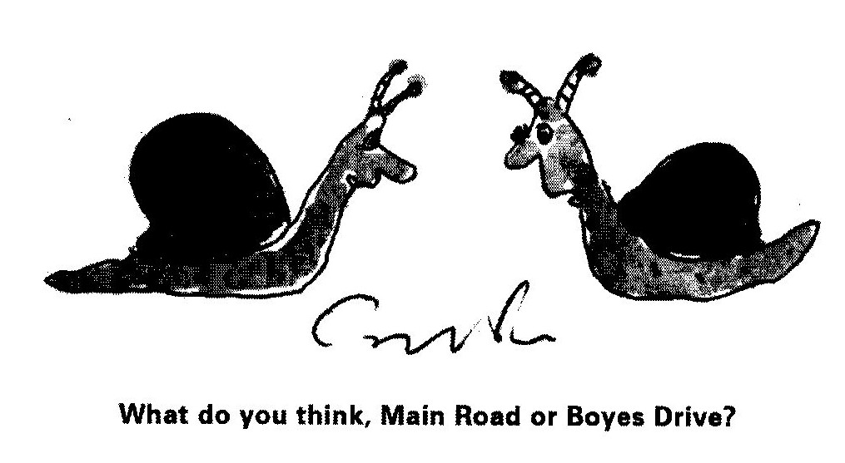

SNAIL ATMAN

O simple snail upon yon leaf,
Eschewing joy, eschewing grief:

The karmic round of mortal men,
Of birth and death and birth again,
Does not, I think, apply to thee
Who art beyond mortality.

O transcendental monoped
Why, you are neither quick nor dead

KAMIKAZE

Like forty million crack dragoons
Stood battle-trained spermatozoons.

The captain spoke in solemn voice:
“Although I know you have no choice
And little chance, you have permission
To volunteer for this emission.”

Not one comma hesitated:
“YES!” They all ejaculated.

EPHEMERIS

The Master’s calligraphic hand
With brush of wind and wash of sea
While limning changing constancy
Erases footnotes from the sand.

Each breaking wave, a slap of Zen,
Repeats this lesson every sough:
The Transient is quite enough.
The foaming crest is hanging ten.

When tide is high the seabirds soar,
But dauntless in the tide’s retreat
Extending careful etcher’s feet,
Swoop, stop and drop upon the shore

To sprint or strut and, inter alia,
Imprint their ﬂeeting marginalia.

COSMICK CARP

—A paradox as parable

Adrift in timeless nothingness—
A darkness sparked with light~—
We meet our subject, Cosmick Carp,
And recognise his plight.

The Universe, it has no sides,
Circumference or rim
But Cosmick’s consciousness of this
Is really rather dim.

His world is vast and boundless,
Lacks limits; is uncurbed
And yet, with all his liberty,
Our hero is perturbed.

Although twelve billion trillion miles
He ﬂoats with ﬂick of ﬁn,
Inﬁnity describes his cage—
A gaol is what he’s in.

He harbours secret fantasies
For tether, stake and lock,
For door and fence and recompense
Of calendar and clock.

But in a way, he's just like us
Though freedom is our goal.
We know that Cosmick really wants
A tiny goldﬁsh bowl.

CARPE DIEM

—for Lionel Abrahams

A goldﬁsh in a goldﬁsh bowl
Surveyed the world outside
And felt completely in control
Of everything he spied.

Thought he: “I’m in my element,
My glass, a faithful lens
That shows a foggy ﬁrmament
That wobbles and distends.

“An ever—shifting universe
Of ectoplasmic forms
Beyond all known parameters
Of ﬁnite, ﬁshy norms.

“And yet, this mystic interplay
Does serve me with such love
That I am blessed every day
With manna from above.”

HAIKU

—A DIALOGUE PROVING GOD’s EXISTENCE

“Look how perfectly
That small chameleon there
Is camouﬂaged!” “Where?”

The rain, when it pours,
Beats through the trees like discreet
Japanese applause.

—FROM MATTHEW
Lots of people in
Plumstead, Dad, play pianos
At night——it’s lank sad.

—ASTIGMATISM
How wonderful to
Age: Two moons and a double
Plenitude of stars.

—PANIC
Eight o’ clock, the cars-
How urgently they rush to
Reach the traﬂic jam.

—JOBURG
On cold crystal nights
A galaxy of grounded stars—
The city lights.

—CELESTIAL MOTION
From the bus window
the trees ﬂy by. But the moon,
it travels with us.

—HERMENEUTICS
Just the briefest glimpse,
then all eternity for
interpretation.

INNOCENT EXPERIENCE

—for Don Maclennan

An ageing sheep
Who was quite deep
Read Blake and cried:
“For goodness sake!

“If Christ is shepherd
And Christ is lamb
Then half-divine
Is what I am.”

And then she sighed:
“Not true, because
Half-divine
Is what I was!”

EVIDENCE?

After the ﬂood, when
The waters subsided,
God said to Noah:

“Come out of the ark.”
And all the wild beasts
And all kinds of cattle

And all of the birds
And all of the creatures
That crawl on the earth

Disembarked from the ark.
Excepting, of course,
The wood-borer beetles.

ZOSHI SAID

The Piet-My-Vrou
Talks Afrikaans,
Don’t you know?

MASLOW WAS WRONG

Along an early-morning lane
Between the forest and the sea
A hundred iridescent webs
Are laid like nets upon the lea.

Roughspun, they look like gossamer rags
Or even gleaming dinner plates.
And at each rim, alert, polite,
A bright attendant spider waits.

The threads, though tacky to the touch,
Remain quite empty through the day,
Except for shimmering drops of dew.
A clue? Perhaps the spiders’ prey

Is not small creatures dead or wrapped
But starlight, luminously trapped?

REGGAE RHYMES FOR DAVID

1
O elegantly rasta palm
Skanking in the air
Tossing in the north-west wind
Your natty dreadlocked hair.

2
O little star aster far
I wonder at your sheen
Changing like a traffic light
From red to yellow to green.

O little star aster far
I wonder if you are the
Celestial resting place
Of Robert Nesta Marley.

POEM FOR NICKY

Will my soul have memory of me
when it returns as chimp
or chartered accountant?

Will it, by my death,
have been liberated
or abandoned?

Might it, at least, feel
an ephemeral yearning
for you, your fragrance
and wonderful laugh.

LIFE SENTENCE

Jonathan Plaatjies
Who was born in the remote Cape hamlet of
Omdraaispad which is known for a statue
Of one of its postmasters Ian de Klerk
Representing him holding a limp ﬁsh
In an outstretched palm which was erected
In Nineteen-nineteen in his memory
By his eccentric wife Tamara who
Later scandalised Genadendal by
Living in sin with the Persian painter
Omar Barry (there were some who said he
Was not Persian) who invented Karoo
Cubism by meditating on
The rock formations in the Bamboesbergen
Died today.

GOOD THEOLOGY, BAD MOVE

—Ascension Day 1991

The sad, incarcerated carp
Who reasons perfectly:
“Could I but smash this bowl of glass,
My spirit would be free.”
BOOK CLUB

BOOK CLUB

My tame, domesticated wife
Tugs slightly at the strings of life
When, once a month, she ﬂies the coop
To join a book discussion group.

No men allowed! This silly rule
I think is chauvinist and cruel.
“Who needs,” I shrug in my defence,
“Their gossip laced with Lit Pretence?”

But when it is her time to host
It’s then it irritates the most.
Ignored! My fragile ego scarred!
A writer scorned! A poet barred!

I prowl the house, aloof and numb
But furtively, each time, succumb.
Against the door I lay an ear
And don a patronising sneer.

The moral is: What men deride
Is that of which they are outside.

WEATHER REPORT

FORE-WARNED

Knowing from the television
That a cold front was coming,
The trees of Signal
Hill, blurred in the mist,
Are more mysterious still.

GALE WARNING

The papaya tree
Flaps in the wind, taps windows
And rattles the eaves:

Flags for the deaf and
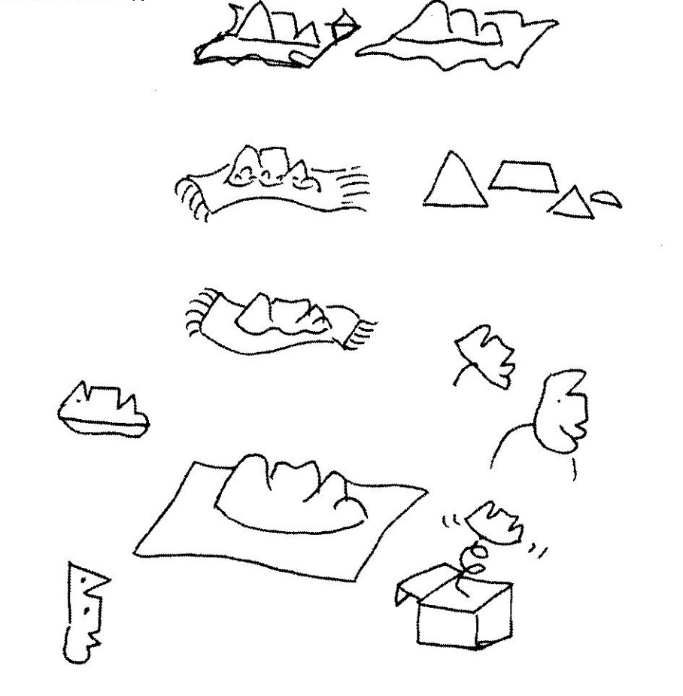
Morse for the blind, it signals
With snail-tattered leaves.

LIGHT VERSE AT THE END OP THE TUNNEL

The perfect poet lies in bed,
In vain he tries to sleep;
He counts the sheep inside his head
In syllables, not sheep.

His haiku all have seventeen,
His tankas thirty-one;
His prosody has always been
More regular than Donne.

With fourteen lines and seven rhymes
His sonnets are precise—
How cleverly the music chimes,
How literally nice!
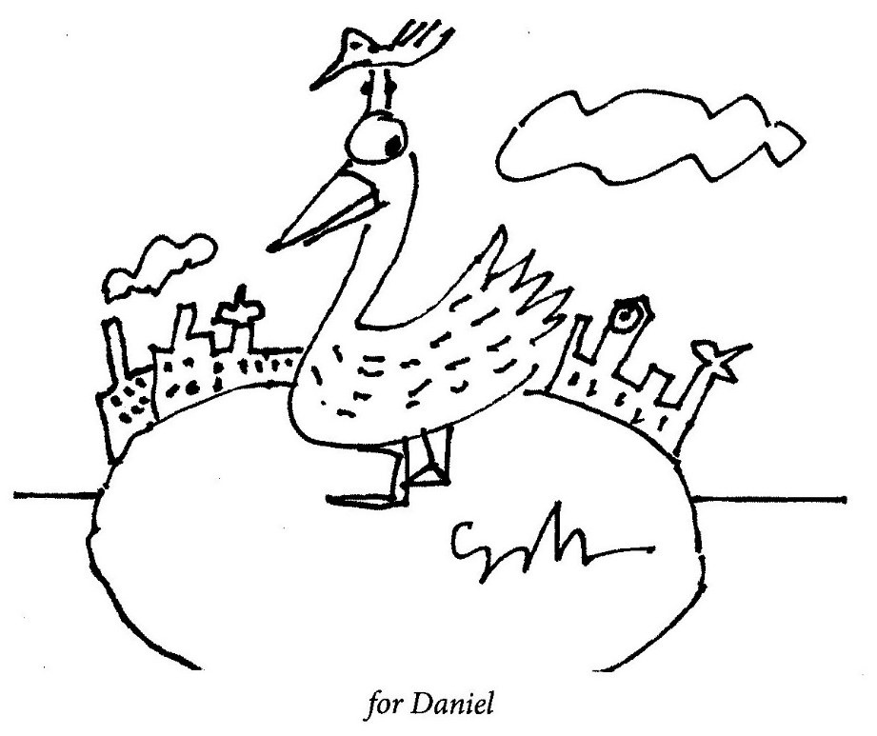
Archaic forms he knows them well:
The ode and virelay,
He likes to write a villanelle
And loves the triolet.

His every pulse is metrical,
Mechanical and neat.
His heart ﬂub-dubs iambical
And never skips a beat.

His ECG scans perfectly
De dum de dum de dum
And measures ineluctably
Each moment’s tedium.

His heart’s a clock inside a box
That ticks each beat and rhyme,
And only Death can spring the lock
To break the spell of time.

But Death does not this poem end
(Of that I can’t be surer),
It is, as mystics all contend,
An ultimate caesura.

THE METEMPSYCHOSIS OF THE YAK

He has no house, he has no shack,
lust shaggy hair upon his back
That hangs from cranium to hoof—
An absolutely perfect roof
To shelter him from winter chills
Amongst the Himalayan hills.

Tibetans ride upon the backs
Of generous and gentle yaks
Who offer milk, their hair for rope,
Their ﬂesh for meat, their fat for soap,
And listen as the valley swells
In irony to temple bells

That toll that karmic law decrees
They will return as Red Chinese.

CREDO

I do believe the world to be
the product of deep reverie—-
a dream that’s boundless and uncurbed
but oh so easily disturbed!

THE ELASTIC LIFE FORMULA

Hormones control every aspect of our lives. They hold sway over
mood and personality, size, bulk, bone-length, shape, gender and
even sexual orientation. W'hen delicate hormonal balances are
tampered with, bones lengthen, skin thickens, water is retained
and metabolism speeds up or slows down. The human condition
is rendered elastic.
With this in mind, coupled with the success of menopausal
hormone replacement therapy, the Universal Medical Insurance
Group is designing a cost-eifective hormone package for the
elderly.
The UMIG regimen, tentatively titled ELF (Elastic Life
Formula), is to be marketed for people of 60 and over who are
living on ﬁxed incomes. The burgeoning senior citizen tragedy
is that well-deserved pensions are withering away; living costs,
including food, shelter, transport and medicine are subject to
corroding inﬂation and seniors are become a major proportion
of the urban poor, unemployable, an increasing burden on family
and State, the innocent victims of creeping poverty.
The ELF polyhormonal package is formulated to reduce human
size and mass gradually without signiﬁcantly altering shape. It’s
rationale is: the smaller you get, the less you need.
Dosage can be linked to inﬂation and the pensioners on ELF
therapy will ﬁnd their cost of living dropping in direct proportion
to the inﬂation rate.
Based on 15% annual inﬂation, a 75 kg 60-year-old will weigh
15kg at 70 and 7kg at 75. At 80, they will have shrunk to the size
of a six-month-old baby.
Old-age homes (which will have to be redesigned) will easily
accommodate 10 times the number of residents, most of whom
will be around 60 cms tall.
Pensioners will be as lovable as pets. Although, on the down-
side, they could be snatched by cats and birds, and, if suffering
from senile dementia, could easily get lost or trampled underfoot.
However, on the upside, endangered seniors could easily hide
from burglars and scamper away from muggers.
Childhood perspectives would be restored, facilitating the
psychotherapy so necessary for the completion of unﬁnished
business.

Everything will be cheaper: food, clothing, blankets, transport,
make-up and even, ultimately, the cofﬁn and crematorium costs.
For instance, 187 80-year-olds could be packed into a minibus and
at least four jet-setting geriatrics could snuggle on one aeroplane
seat.
60-year-old giants will be seen shambling across retirement
village landscapes with dozens of hamster-sized nonagenarians
peeping from pockets, collars and turn-ups. One banana will
feed a dozen, a bottle of beer could ﬁre a bacchanalian orgy and
a pocket handkerchief would do as a tablecloth, tent or tarpaulin.
What is still unpredictable is the long-term effect of ELF on
longevity. Trials using rats have indicated that side-effects might
be uncontrolled promiscuity and premature ageing.

LIMERICK

—-According to an article printed in The Independent on 6 July 1994, research
into the mating habits of the Praying Mantis, where the female was fed before
copulation, proved that no well-fed female ate any one of her mates but only
one male survived an encounter with a starved female. With apologies to
other ‘Skinner/dinner/ in her’ limericks.

Said a cautious young mantis called Skinner:
I take all my ladies to dinner.
It’s not that I’m kind,
It’s just that I ﬁnd
I feel much more secure when I’m in her.

AUTOPHAGY

Amongst cannibals
The phrase ‘battered wife’ assumes
Another meaning.

DYSLEXIC

She signs her letter:
‘Lost and lost of love.’

EPIGRAM
(Source: Patricia Davison)

Lost in the hills at the end of the day
We burned the map to light the way.

FREE FALL

The Women’s Movement
Began, I believe,
With Adamant Eve.

INTERNET SENRYU

I believed that G-d
Encrypted the Universe
For fear of hackers.

JUSTIFICATION

Life is but a gift of time
Spent in gathering evidence
Against the summons for the crime
Of wasting that inheritance

OLD AGE

Your life-support system
Is coin-operated.
The Matron has change.

SELF PITY

My life in action replay:
Fifty perfect goals
And me the goalie.

LOVE AMONG THE MIDDLE-AGED

—SLEEPING MATES

A 1995 survey of more than 5000 frequent ﬂyers revealed some
startling facts and has led to the development of a fascinating
new travel service. 72 per cent of the travellers interviewed by
Marketpro were males aged 40-60, mainly in middle and upper
management, who were away from home 3-6 days a month.
The survey further showed that by far the majority were
heterosexual and married or in stable, more or less monogamous
relationships. A parallel probe by the marketing company of
escort agencies and massage parlours in major cities indicated
similar opinion. Most of the clients were middle-aged and most
were on business trips. Information on the marital status was, for
some reason, unreliable.
On investigating individual cases using psychologists, it was
discovered that the majority of the clients were not seeking sex,
but comfort.
Three nights away from home was reported to be unsettling.
Despite the luxury of the hotel rooms, sleep was shallow and
disturbed. Also, many of the interviewees had bad or worrisome
dreams. Post-Business-Trip-Trauma studies revealed an alarming
increase in paranoia and acute depression.
As a result of this research, the hotel group that commissioned
the survey has just introduced a pilot programme called Sleeping-
Mate. The service is offered discreetly to businessmen who can, for
an additional fee billed as extra room service, hire a middle-aged
woman who comes with a full kit of ﬂannel nightie, comfortable
pillows, Horlicks and ﬂuffy slippers.
Sex is not offered as an option and so far, in the pilot study,
has never been negotiated. Results have been phenomenally
interesting.
The businessmen report a tremendous elevation of mood,
causing mild euphoria during business meetings and sharper
concentration.

SEMPER HELIX

In duplicate beside the pond
The mirrored fern unfurls its frond.

The twisting leaf escapes the tree
And ﬂutters downward spirally.

All things expire. The spring of Time
Uncurls with tick and tock and chime

That knells the universal end
When knots unravel, curves unbend.

The straight line on the cardiograph:
A spirit-level epitaph.

So let us praise while yet we may
Those things that take the tortuous way,

Which twist and turn spontaneously
To stem the trend to entropy.

TWO TANKA

AUTUMN

God is present in
the stillness of twigs,
the trembling of leaves,
in perception and
surreptitious
counting of syllables.

FROM THE AIR

Like the length of string
dropped on an unmade bed
the road meanders in the mountains
leaving a sense of
pointlessness and comfort.

IF ONLY

Driven by a hunch that James Ioyce was dyslexic, Herman Charles
Englewald, poet, translator and remedial teacher, ran a computer
spell-check on Finnegans Wake and produced a novel of such
lucidity and popular appeal that the Bloomsbury Press sold six
hundred thousand copies in sixteen months.
Released by royalties from the travails of prose, Engelwald’s
current passion is to punctuate the poems of e e cummings.

BRIEF SELECTION: ARS POETICA

A defence against plagiarism:
Ensure your art is boring.

Today I took books
to the pulpers but sadly,
they don’t do poetry.

I hereby apply
for funding, sufﬁcient to
ﬁnish this haiku

BRIEF SELECTION: SNAPSHOTS

A gale-force southeaster:
birds surrender but grass, like
Samurai, ﬁghts on.

Before they left,
the aliens wrote
a brief, explanatory note.

Cycling past a kiewiet’s nest,
he stops to check his chain.

Notice in a Cafda bookshop:
Your jigsaw puzzle
is welcome
missing pieces or not.

PAST APPLEGARTH IN RADIANCE
—for Lee

My Sunday morning
Genuﬂections
Are made with bending knees
While sun spokes stroke
Across the road
And ﬁre the fallen leaves.

My spinning chainwheel’s
Starred reﬂections
Whirr upward through the trees
And glinting from
My streaming cold:
The snailtrails on my sleeves.

GRENADE

What a condition to ﬁnd ourselves in!
With just enough strength to pull out the pin
But not, I’m afraid, to hurl the grenade.

CLASSIFIED

The city lights-
a bed of glowing embers.
We dread the kindling wind.

THE CAPE TOWN LAUREATE SPEAKS

Too much is made of the mountain,
The wine, the crime, the sea,
The Waterfront and the Island,
But not enough of me.

FOUND POEM:
SHAKESPEARE IMPROVED
(]ohn Qwelane, Radio 702, 9/5/96)

A rose by any other name
Would smell the same.

WRITER’S BLOCK

The Poet-in-Residence sat on his bed
his computer cursor beating.
Blank is the screen. Empty the head.
The Muse is fast retreating.

He peers at a book. He ﬁlls up a glass,
sips coffee and pale green tea.
He beats his breast and cries, “Alas!
Why must this happen to me?

“The well is dry. The sump has leaked.
My inspiration’s vanished.
I’m over the hill. I must have peaked.
I’m under arrest or banished!”

He went to the Co]lege’s Admin. Block
and knocked on the Dean’s grey door.
“Come in!” cried the Dean, unclicking the lock,
“And what can I do you for?”

“I’m done,” sighed the poet, “a fraud and a farce,
my muse has stolen away!”
“Oh! Crap!” said the Dean, “Don’t be an arse,
for this is a fortunate day.

“As a poet you were a drone and a bore
and a drain on our ﬁscal resources,
but now that you know you can’t write anymore
you can workshop our poetry courses.”

WITH OCCAM’S RAZOR,
GERARD MANLEY HOPKINS SHAVES

Those springing rhythms, riding, creaking, wrecked my rest.
The dapple-dawn-drawn bathroom steams, the mirror mists.
With sweeping, squealing palm I wipe it clean, and fraught
In dreary day’s dominion, meditate my liturgy of lists.
And then, with strokes of contemplation awaken to the thought
I’ve caught this morning morning’s palimpsest.

JOHN DONNE ON THE N1

And therefore never
send to know
for whom the road’s tolled;
it’s tolled for thee.

WORDSWORTH

In hesitant, subjunctive mood,
emboldened by my solitude,
I wonder if—I doubt I should—
‘Daffodils’ is any good?

OLD BOYS’ CLUB

Roy Campbell went to Durban High,
when he was but a pup.
Now that is pure biography:
the rest he just made up.

Pessoa went to Durban High,
was miserable and sad,
went back again to Portugal
where things were just as bad.

Charles Ortlepp* went to Durban High,
he boarded there for years,
and grew up strong and resolute,
admired among his peers.

I also went to Durban High,
I left in standard eight.
(This poem serves to demonstrate
the vagaries of fate.)

‘A prominent Cape Town pharmacist

SOMEWHERE

Somewhere in the vast possibility of eternity, Alice B Toklas met
J Alfred Prufrock. They spent the night together, their conversation
unrecorded as James Boswell was ﬂirting with Gertrude Stein.

BRIEF SELECTION

—INTERNATIONAL POET
Such bad luck! To be
Assigned an interpreter
\/Vho contradicts him!

—PUBLISH OR BE DAMNED
Our struggle will end
when each white participant
has written a book.

-AT THE READING’S END
Relief, mimicking
enthusiasm, was heard
as a call for more!

—UNENTITLED
Disregarded at home
but abroad, a sensation:
her poems, it seems,
improve in translation.

POET

My poems are the means by which
I send my thoughts to you.
You’ll ﬁnd them sensitive and rich,
Original and true.

They’re erudite and full of wit
With subtle traps and lures
And, quickly while I think of it,
Please don’t send me yours.

THE JAPANESE HAVE A WORD FOR IT

that simultaneous, brief,
conﬂation of joy and grief,
the rising sun, the falling leaf.

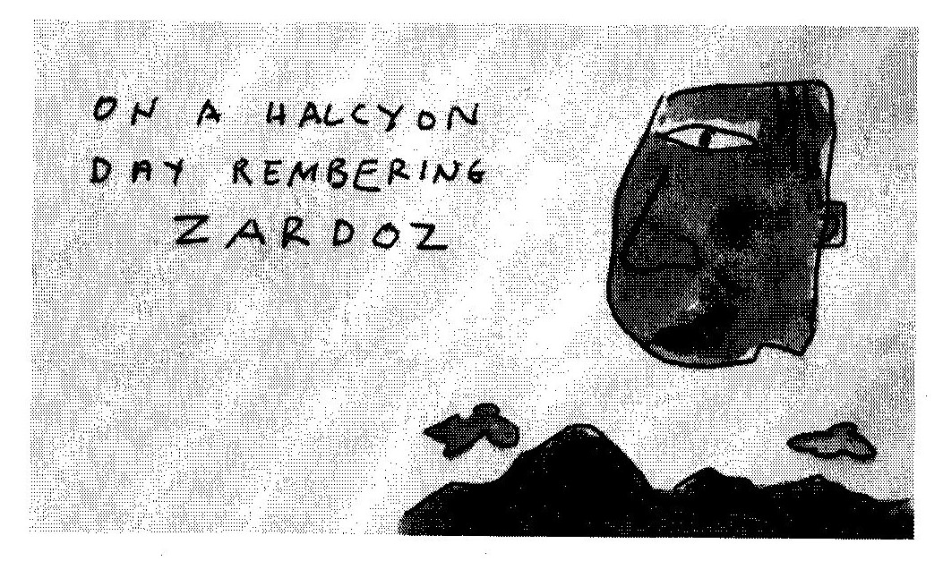

DOGGEREL DOG

Doggerel Dog crosses the street
tripping on iambic feet.

Down darkened alleys hear him whine
while snufﬂing for some scraps sublime

An empty dustbin’s hollow clang,
he swings around and bears a fang.

Night will ﬁnd him all too soon
howling at a paper moon.

THANKS BUT NO THANKS

Presenting a manuscript,
he maligned the publishers

of his other books as rank
incompetents and crooks.

Not wishing to join their ranks,
I gratefully declined, with thanks.

DOROTHY PARKER

She dipped her pen
In blood, not ink;
She made us laugh,
She made us think.

CONFESSION OF A ROUGH BEAST

One day, slouching along,
I came to a fork in the road.

One way went to Bethlehem,
the other to Pilates.

I took the one less travelled.

THE PARABLE OF THE GENEROUS MAN

I tend to lend the things I like,
my CDs, books, my precious bike,

my glasses, tablecloths, my plates;
I press them on my lucky mates.

So what is left, it dawns too late,
are all the things I really hate.

And as we’re judged by what we own
and by the stuff we have on loan

then here’s my fate, it’s really sad:
my friends look good and I look bad.

The moral drawn from all this sorrow?
It’s bad to lend, it’s good to borrow.

SYRINGA

shifting in the wind
alien and rooted,
and the wind,
just passing through

BY FOOT THE APOSTLES TRAVELLED

During the washing of feet,
it was rumoured that all ingrown toenails,
bunions and corns were also cured.

RETURN TO THE ARMS OF MORPHEUS

By far the most
delightful sound
when tired
of Argus training:

That pitter-patter
on that roof
that signiﬁes
it’s raining.

INSOMNIAC IN LOVE

Amongst the pleasures
I have know in a long
and worried life

is to lie awake
and listen to
a gently snoring wife.

SIMON’S TOWN HELL RUN

Suddenly atheists and secular humanists
are everywhere. On yesterdays train
to Simon’s Town our carriage was stunned

into evasive silence by an evangelist hammering
us with terrifying quotations from Richard Dawkins
(evidently there is no afterlife, heaven or even hell).

Reaching our destination was such a relief
that the entire congregation burst into ecstatic
ululation, hallelujah and amen!

FAMINISM

Their tummies ﬂat,
their ﬁgures neat,
they never have
enough to eat,
but if they had,
then here’s their fate:
they’d put on weight.

ADVICE TO THE ELDERLY

Avoid confusion
as eyesight dims:

Don’t buy glasses
that don’t have rims.

SYNAESTHESIA TANKA

Blindfolded, he sniﬂed,
rolled it around his palate,
pondered and pronounced:

“Charlie Parker—Bird at the
High Hat, 1953.”

YORVIC

The Vikings who invaded York
to live in squat and village,
were vile to girls and ploughed the earth,
combining rape and tillage.

SPANISH SKETCHES: PILGRIMS’ SONG

We were lost on the Camino,
we worried and we prayed:

why are there no refugios
for pilgrims who have strayed?

A SAD SEQUEL

After D’Artagnan
left the Musketeers
the new recruit, Bathos,
was a bit of a disappointment.

IN A BOOKSHOP

A couple called Gladys and Rex
were suddenly keen to have sex
(such urgency’s slightly perverted),

“But where can we do it?” cried she
“The poetry section,” said he,
“I’ve noticed it’s always deserted.”

CLOISTERS

We meander through
antique furniture stores
with exactly the same
whispered reverence
we once felt visiting
church or cathedral.

REQUIESCHATOLOGY

Were I to believe in the soul
with all of the problems it poses

I’d dread not only my death
but also my metempsychosis.

SOUTHEASTER RISING

The long grass has its
ears pinned back and the
trees are mercilessly thrashed

while the stars and the
lights of the town are
astigmatically blurred.

OUTAGE 1 FEB 2008

—after Albert Camus

As he ranted on
about the blackout she
was ravished by the stars.

QUESTIONS NEAR MONTAGU

Which of these hills
has a name?

And which are knowable
only by number?

And what of the others,
anonymous, hunched

in deep, unclassiﬁed,
slumber.

FLAWED SURVEY

Diogenes, when not in his tub,
went prowling the night
with his lantern light
in search of one honest man

amongst
Cassandras
night crawlers
cutthroats
insomniacs
muggers
pimps
prostitutes
footpads
cutpurses
doomsayers
debauchers
and skullduggers

while decent folk were safe in bed

ENDGAME

With modern medicine
doctors can ﬁnd something
wrong with everybody,

while new age healers can
cure anything you haven’t got.

AUBADE

On a cosy Sunday morning,
in bed with book and tea,
the church bells in our suburb toll
for everyone but me.

ALZHEIMER’S FREIGHT

Those things you wish to remember
are never lost or forgotten
but only packed, sent on ahead.

TOUGHENED UP

If I’d felt at sixteen
as I do every morning
at sixty ﬁve, my mother
would have kept me in bed.

GERIATRIC PLIGHT

Oh, let us all give
copious thanks:

that we are each other’s
memory banks.

A MISCELLANY OF HAIKOIDS

Unable to make
a living as a real writer
he turned to crime.

The poor critic,
rising to leave, got trapped
in a standing ovation.

Although I know he’s
bleak and gloomy, give me
Borges over Rumi.

Tidy the house!
Granny’s Skyping
in half an hour.

His T-shirt says: Fuck Fear.
He looks anxious.
Umbrage might be taken.

It is thus ordained:
we arrive and leave
without memory.

As the morning cold begins to lift
the evening chill is closing in.

Burglar wishes to meet
nice people with lots of stuff.
No chancers.

A ditherer? Not at all,
he lives his life
serendipitously.

While his wife’s away
he does what any robust
male would do—he mopes.

When he moves towards her
with amorous intent—
the dog barks.

Man at the side of the road:
feet in the gutter he sits
hopefully holding his spirit level

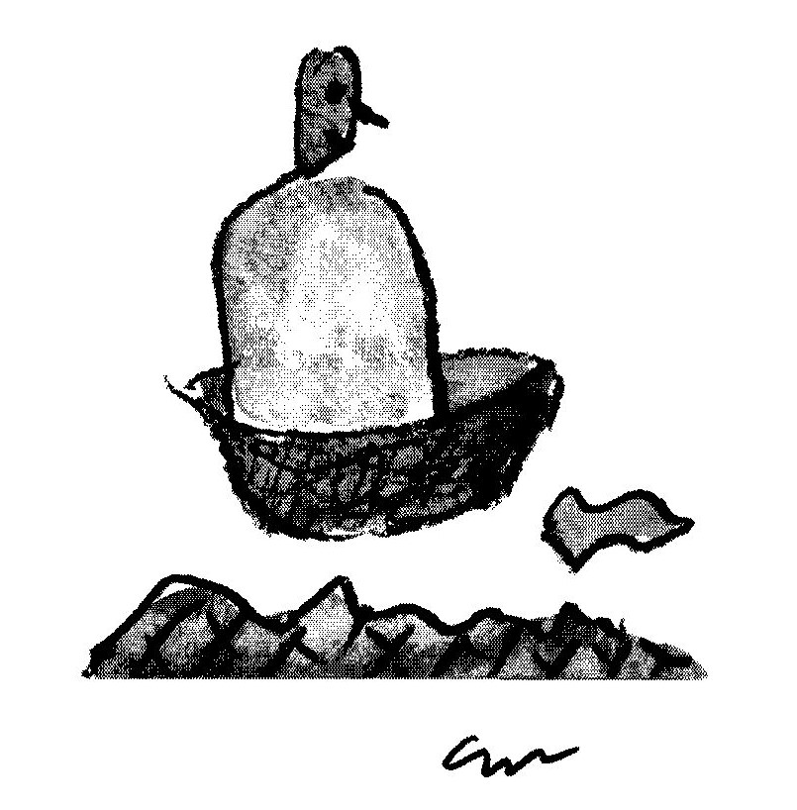

DISENGAGED BUT NOT DETACHED

Amongst the pleasures I have known
from joy to mild elation,
none compare, I have to own,
with those of cancellation.

The technique is: accept a date,
the more delight you show the better,
then later on, but not too late
conﬁrm by telephone or letter.

Then on the evening or the day
apologise for lissom lies
designed in each and every way
to make the hostess sympathise.

There is no spite in what I do,
(I tell my nagging conscience ‘hush!’)
I only do it, so should you,
to get that serotonin rush,

that wild tsunami of relief
that comes with each postponed event,
a happiness that’s close to grief,
a respite that is heaven sent.

But why the rush and why relief?
What drives this mindless process on?
Perhaps some undeclared belief
that even Death can be reneged upon.

STRESSED, UNSTRESSED

—-from the diary of a minor poet

Invited to talk to a Writers’ Club
on the role, in modern society,
of prosody, which, of course
has more feet than a centipede,

I worked for a week on
The Virtues of Verse to speak
for twenty minutes.
There were no questions.

Travelling home, afterwards,
my thank-you gift of hazel nuts
bustled and rattled in their box.
The sound of mild applause.

RUGBY INJURIES

He hurt each and every time
he wasn’t chosen for the team.

VILLANELLE

What was it that we tried
to remember (when was it?)
that it slipped from focus.

It was redolent of love,
and the after-taste of crocus?
Why can’t we remember

to remember to remember?
Or make a note to note
that elusive lover’s name

that comes one hour too late?
And, of course, that perfect,
inaccessible quote!

And the title of that movie,
the one we’ll never forget? And the name
of the thing that squeaks on the gate?

Let’s rather abandon to random,
memory, it is excessively kind,
and revel in those lovely things
that, unexpectedly, spring to mind.
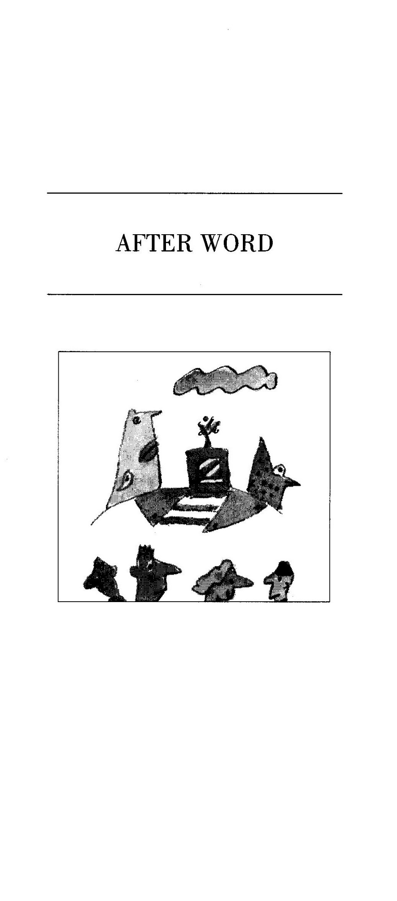
A WORD TO THE AGED

When ageing brains deteriorate
and memories get short

it’s difﬁcult to separate
within an addled head

those lovely things that one has thought
from those that one has read.

