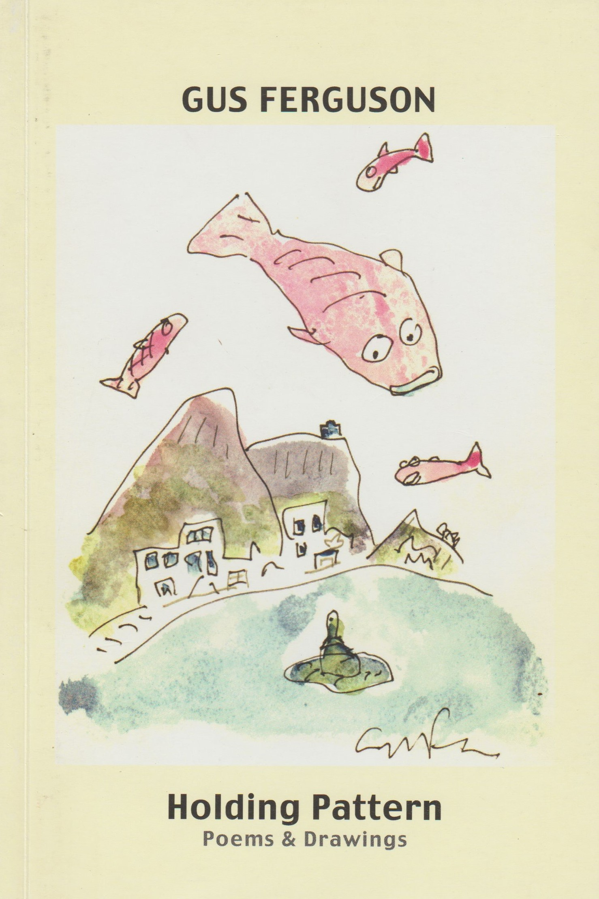
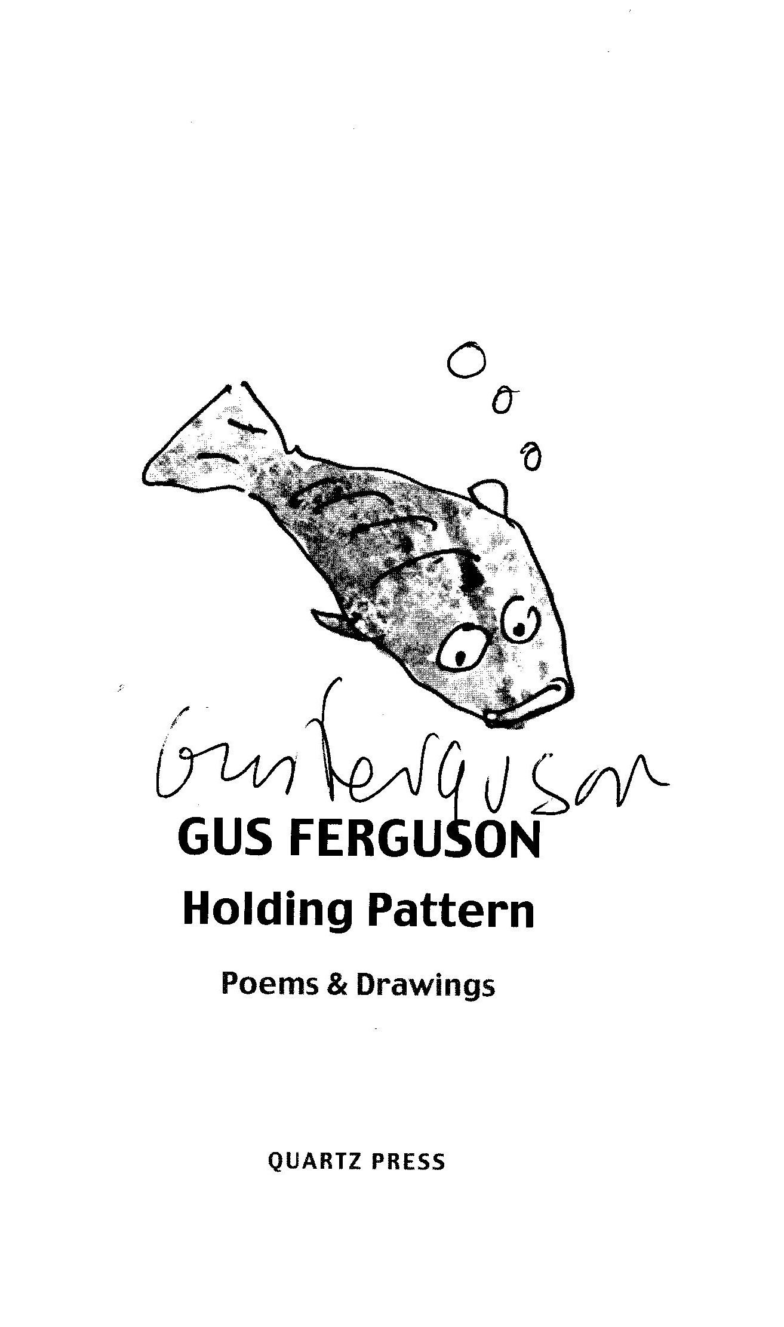

for Julian Solomon
and Susan Rivera

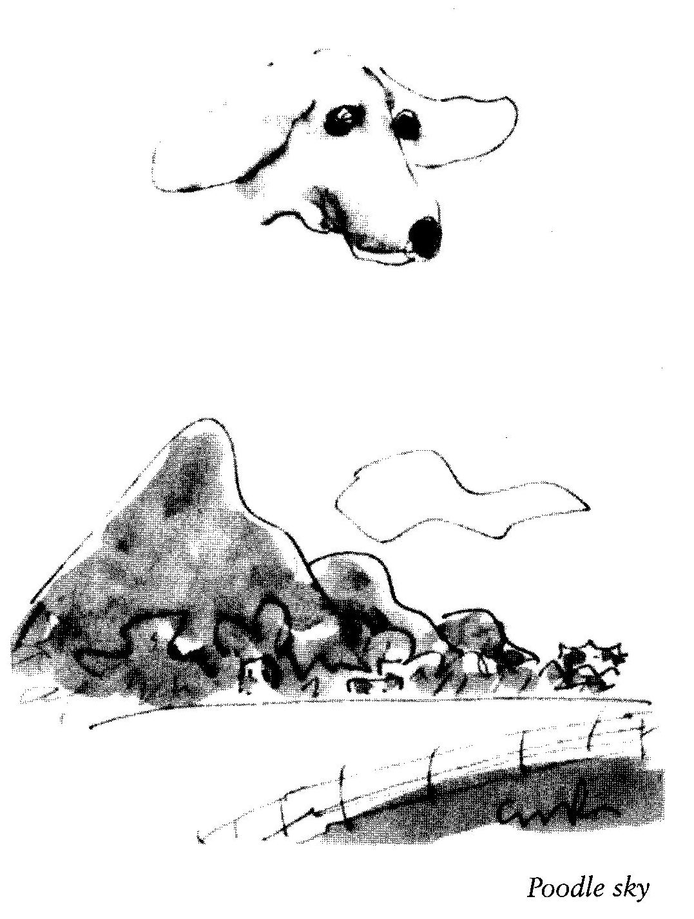

Contents

If it rings a bell, is it a villanelle?
Perhaps
Syringa
Doggerel Dog
The spiteful gene
Limericks
The parable of the generous man
Thanks but no thanks
Dorothy Parker
Confession of a rough beast
By foot the Apostles travelled
Tanka
Return to the arms of Morpheus
Samsara
Sisyphus returns to Gattis
Franschhoek crepuscule
Insomniac in love
Changeling
Uqbar previsited
Chiaroscura
Faminism
Advice to the elderly
Sonnet
Suburban epiphany
Simon’s Town Hell Run
Synaesthesia Tanka
Somewhere
Yorvic
A sad sequel
Plagiarism
What does the fashion-conscious locomotive say?
Eaud to an open bottle of water
In a bookshop
Requieschatology
Southeaster rising
Outage 1 Feb 2008
Questions near Montagu
Klein Karoo
Near Swartberg
Flawed survey
Little twitcher
Setting standards
Sponsorship
Endgame
On first reading Tatamkhulu Afrika’s
Night Bucket
Regret beyond the grave
Stressed, unstressed
Rugby injuries
Bicicletta
A Miscellany of Haikoids
Disengaged but not detached

The Japanese have a word for it

that simultaneous, brief,
conﬂation of joy and grief,
the rising sun, the falling leaf.

If it rings a bell, is it a villanelle?

What was it that We tried
to remember (when was it?)
that it slipped from focus?

It was redolent of love,
and the after-taste of crocus?
Why can’t we remember

to remember to remember?
Or make a note to note
that elusive lover’s name

that comes one hour too late?
And, of course, that perfect,
inaccessible quote!

And the title of that movie,
the one we’ll never forget? And the name
of the thing that squeaks on the gate?

Let’s rather abandon to random,
memory, it is excessively kind,
and revel in those lovely things
that, unexpectedly, spring to mind.

Perhaps

Could sap rising
through the phloem perhaps inspire
a little poem?

Well depending on
your new of what a poem is,
perhaps it has.

Syringa

Shifting in the wind
alien and rooted
and the wind
just passing through

Doggerel Dog

Doggerel Dog crosses the street
tripping on iambic feet.

Down darkened alleys hear him whine
While truffling for some scraps sublime

An empty dustbin’s hollow clang,
he swings around and bears a fang.

Night will find him all too soon
howling at a paper moon.

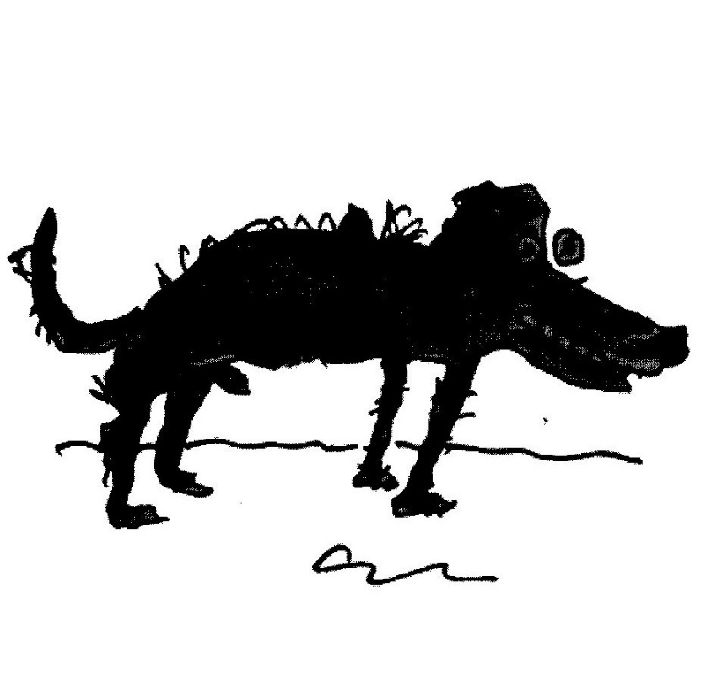

The spiteful gene

The glum suburban melancholic,
he doesn’t dance, he doesn’t frolic

Although not clinically depressed
he very seldom leaves the nest.

He has no friends, he lives alone.
His call’s a ghastly stiﬂed moan.

Yet oddly. he desires to mate,
his progeny will share his fate.

Limericks

1

Edmund Clerihew Bentley
Made jokes, but ever so gently,
Unlike Lenny Bruce
Who favoured abuse
Which he spewed completely intently.

2

Remember the great Qgden Nash
Who wrote with such flair and panache?
Scholars avoid him
It seems he annoyed ’em
By making a fortune in cash.

3

A delightful young lady called Cora
Was incredibly keen on the Torah.
Matters ]udaic,
New and archaic,
Have her laughing and dancing the Hora

The parable of the generous man

I tend to lend the things I like
my CDs. books, my precious bike,

my glasses, tablecloths, my plates;
I press them on my lucky mates.

So what is left, it dawns too late,
are all the things I really hate.

And as we’re judged by what we own
and by the sniff we have on loan

then here’s my fate, it’s really sad:
my friends look great and I look bad.

The moral drawn from all this sorrow
Its bad to lend, it’s good to borrow.

Thanks but no thanks

Presenting a manuscript,
he maligned the publishers

of his other books as rank
incompetents and crooks.

Not wishing to join their ranks,
I gratefully declined.

Dorothy Parker

She dipped her pen
In blood, not ink,
She made us laugh,
She made us think.

Confession of a rough beast

One day, slouching along,
I came to a fork in the road.

One way went to Bethlehem,
the other to Pilates.

I took the one less travelled.

By foot the Apostles travelled

During the washing of the feet,
it was rumoured that all ingrown toenails,
bunions and corns were cured.

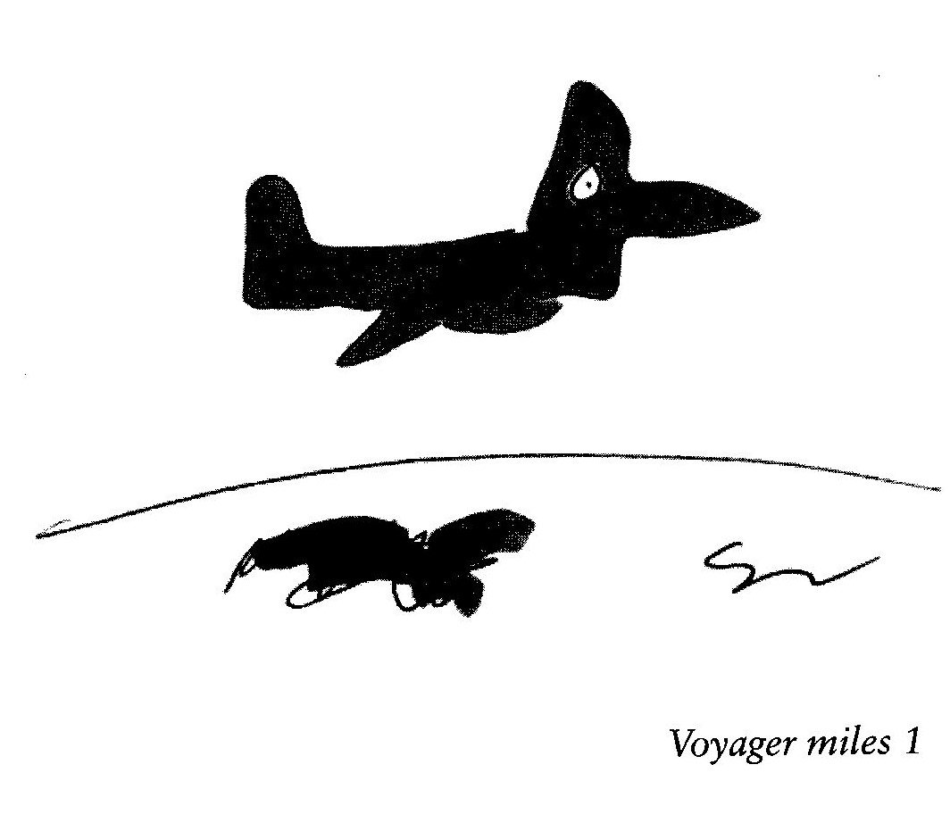

Tanka

Have you ever noticed
that artists who draw bicycles
always leave essential bits
to the imagination?

just like poets.

Return to the arms of Morpheus

By far the most
delightful sound
when tired
of Argus-training:

That pitter patter
on the roof
that signifies
it's raining.

Samsara

For over thirty years
I’ve ridden, I’ve raced

and, at least once,
replaced

every part,
including the frame,

but nevertheless
it remains the same,

it’s still my bike
and still it’s whole.

A metaphor, if you like,
for the transcendent human soul

Sisyphus returns to Gattis

Such pathos in the sight
of an ice-cream vendor

heaving his creaking
tricycle in the heat

uphill against
the south-east wind.

And all the while
the lollies melting.

Franschhoek crepuscule

Was it a conceit
or not — a congregation
of haute cuisine chefs

seated at a bench
outside the church, drinking beer,
eating ﬁsh and chips.

Insomniac in love

Amongst the pleasures
I have known in a long
and worried life

is to lie awake
and listen to
a gently snoring wife.

Changeling

Her fish pond is alchemical
a pleasure to behold —
the morning brings a miracle —
a dark fish turned to gold.

Uqbar previsited

In Portugal, in eighteen seventy seven,
1 cabal of writers: Alvaro de Campos,
Alberto Caeiro and Ricardo Reis,

met, secretly, with the express purpose
of inventing the poet, Fernando Pessoa
who had, as everyone knows, his revenge

Chiaroscura

The cat, with her back to me,
watches the play of light and shadow
by the window and curtain
on the white wardrobe door.
In a suburban morning setting
she re-enacts the Parable of the Cave.

Faminism

Their tummies ﬂat,
their figures neat,
they never have
enough to eat,
but if they had,
then here’s their fate
they’d put on weight

Advice to the elderly

Avoid confusion
as eye-sight dims:

Don’t buy glasses
that don’t have rims.

Sonnet

Serote, Clark, Cullinan, Crane,
Mahola, Cope, Van Wyk Louw, Blake,
O what’s his name, for goodness sake,
that Durban boy who fought in Spain?

Fitzgerald, Frost, Traherne, Joubert,
De Lange, Hambidge, Pound, De Kok,
De Vos, Verlaine, Couzyn, Belloc,
Sepamla, Watson, Baudelaire,

MacCaig, Blomérus, Byron, Raine,
MacDiarmid, Conn, O’Driscoll, Gunn,
Cafaw, Hughes, Seferis, Donne,
Symborska, Livingstone, Kozain.

The list above deserves acclaim
lid. Royston Campbell. That’s his name!

Suburban epiphany

This morning, while bending
to gather dog poo in a garden

moist with summer mist,
I noticed, in sudden focus,

a full-sail ﬂeet of snails
tacking across the grass.

Like ships they lift and dip
and topple through the waves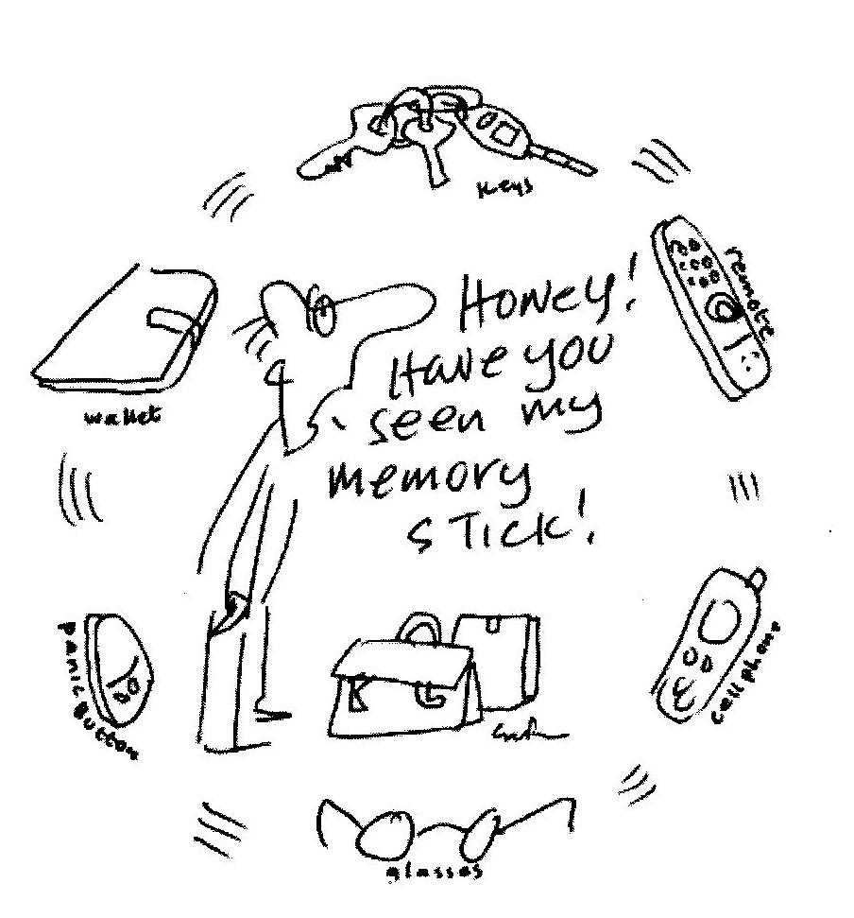
Simon’s Town Hell Run

Suddenly atheists and secular humanists
are everywhere. On yesterday’s train
to Simon’s Town our carriage was stunned

into evasive silence by an evangelist hammering
us with terrifying quotations from Richard Dawkins
(evidently there is no afterlife, heaven or even hell?)

Reaching our destination was such a relief
that the entire congregation burst into ecstatic
ululation, hallelujah and amen!

Synaesthesia Tanka

Blindfolded, he sniffed,
rolled it around his palate,
pondered and pronounced:

‘Charlie Parker — Bird at the
High Hat, nineteen fifty-three.’

Somewhere

Somewhere in the vast
possibility of eternity
Alice B. Toklas
met]. Alfred Prufrock.

They spent the night together.
Their conversation unrecorded
as James Boswell was flirting
with Gertrude Stein.

Yorvic

The Vikings who invaded York
to live in squat and village,
were vile to girls and ploughed the earth,
combining rape and tillage.

A sad sequel

After D’Artagnan
left the Musketeers
the new recruit, Bathos,
was a bit of a disappointment.

Plagiarism

Manque see,
manque do

What does the fashion-conscious locomotive say?

Jimmy Choo Jimmy Choo ]immy Choo Choo shoes
Jimmy Choo Jimmy Choo jimmy Choo Choo shoes

Eaud to an open bottle of water

Are you still
sparkling?

In a bookshop

A couple called Gladys and Rex
were suddenly keen to have sex
(such urgency’s slightly perverted),

‘But where can We do it?’ cried she
‘The poetry section!’ said he
‘I’ve noticed it’s always deserted.’

Requieschatology

Were I to believe in the soul
with all of the problems it poses

l’d dread not only my death
but also my metempsychosis.

Southeaster rising

The long grass has its
ears pinned back and the
trees are mercilessly thrashed

while the stars and the
lights of the town are
astigmatically blurred.

Outage 1 Feb 2008
after Albert Camus

As he ranted on
about the blackout she
was ravished by the stars.

Questions near Montagu

Which of these hills
has a name.

And which are knowable
only by number?

And what of the others,
anonymous, hunched,

in deep, unclassified,
slumber.

Klein Karoo

Unpredictable
the countryside

As we cycle
through the grass

First a flock
of tall blue crane

And then a field
of ass

Near Swartberg

Travelling in the back
of a speeding bakkie

my long hair
streaming in the wind

my thoughts turn
to Isadora Duncan.

Flawed Survey

Diogenes, when not in his tub,
went prowling the night
with his lantern light
in search of one honest man
amongst
cassandras
night crawlers
cut throats
insomniacs
muggers
pimps
prostitutes
foot pads
cut purses
doom sayers
debauchers
and skullduggers

while decent folk were safely in bed.

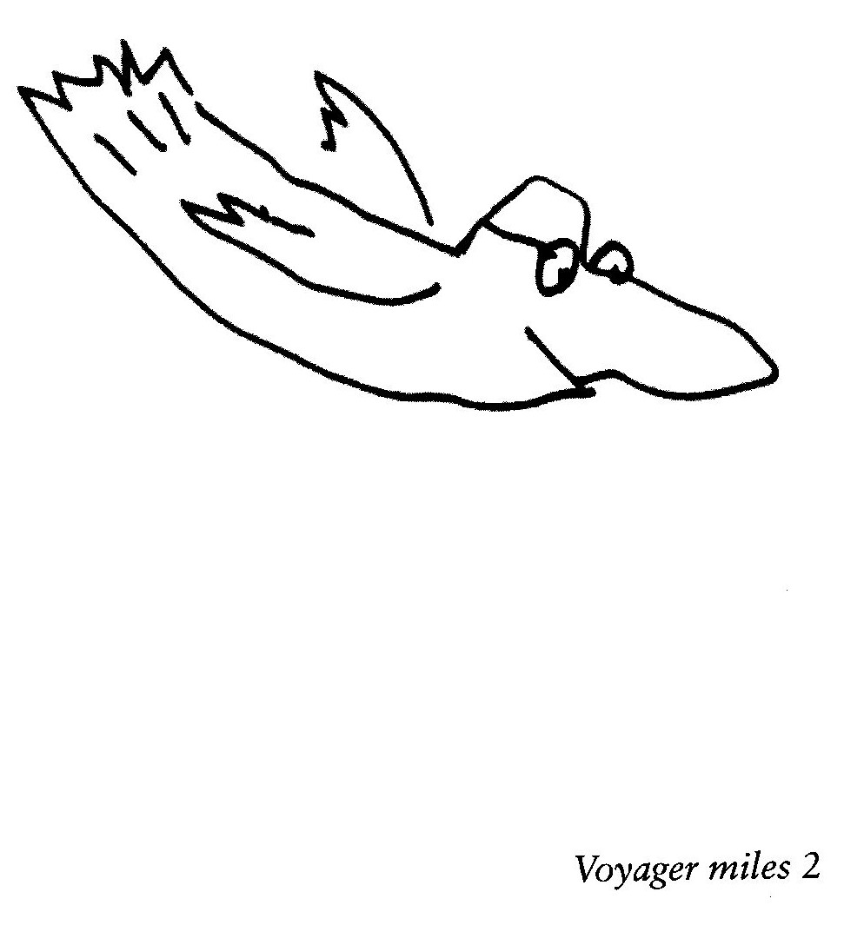

Little twitcher

At the fourth-floor window
of the dullest building

in the whole of Pretoria
our deliberations

were fiercely interrupted
by a flustered crested-barbet,

his beak’s panicked staccato
rattling the window.

But, as none of us
had morse-decoders

on our blackberries,
the warning went unheeded.

Setting Standards

for Jo-Anne who is both

The publisher sighs
with a glint in his eye:

no more, I do swear,
will I publish a thing

that hasn’t a lilt
or a hint of a swing,

that isn’t amusing,
confusing or deep,

making the typesetter smile
or the proofreader weep.

Sponsorship

When broadband was still young
it was so quick that messages
would zip past the domains of the rich
missing the dishes of the poor.

Now we wait for them to limp home
exhausted and burdened with trash.

Endgame

With modern medicine
doctors can find something
wrong with everybody,

while new age healers can
cure anything you haven’t got

On first reading Tatamkhulu Afrika’s Night Bucket

How can the Music of the Spheres
compete with the sound
(under swirling constellations)
of urine tinkling in a bucket.

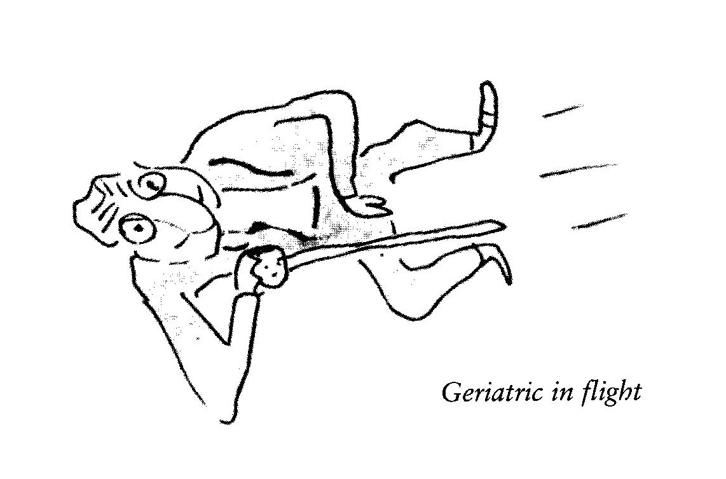

Regret beyond the grave

If I had known it was like this
I would, of that I’m sure,
have worried less and laughed a lot
and sinned a great deal more.

Stressed, Unstressed

from the diary of a minor poet

Invited to talk to a Writers Club
on the role, in modern society,
of prosody, Which, of course
has more feet than a centipede,
I worked for a week on
The Virtues of Verse to speak
for twenty minutes.

There were no questions.

Travelling home, afterwards,
my thank-you gift of hazel nuts
bustled and rattled in their box.

The sound of mild applause.

Rugby injuries

He was hurt each and every time
he wasn’t chosen for the team.

Bicicletta

Battling against the south east wind
my pump tugged by a gust from the frame
fell to the ground with exactly the sound
as the name of this shaken quatrain.

A Miscellany of Haikoids

Unable to make
a living as a real writer
he turned to crime.

Publisher in love:
He loves me and he hasn’t
even got a manuscript!

The poor critic,
rising to leave, got trapped
in a standing ovation.

When their books don’t sell
poets should apologise
to their publishers.

Although I know he’s
bleak and gloomy, give me
Borges over Rumi.

When the aliens split
they left a brief,
explanatory note.

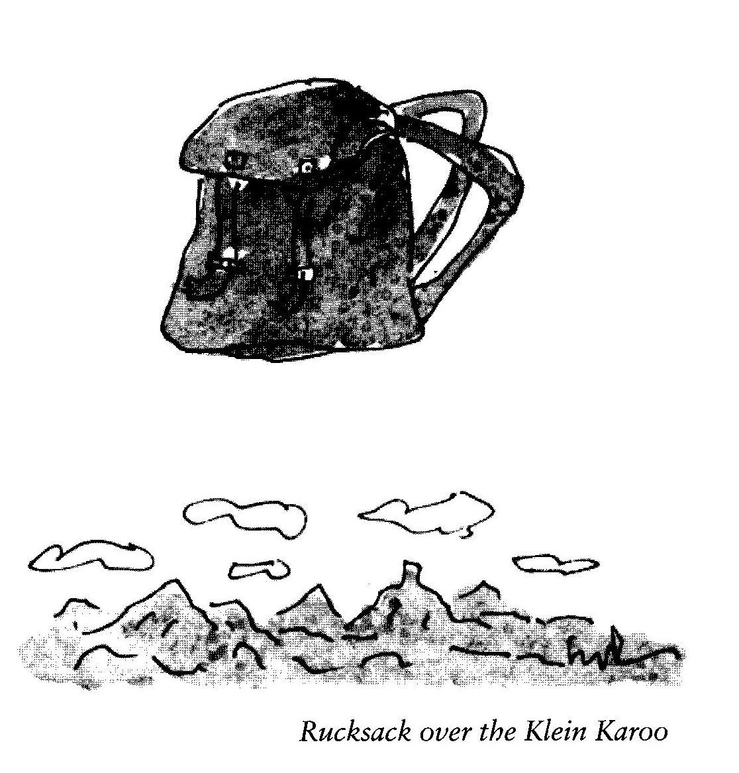

Tidy the house!
Granny’s skyping
in half an hour.

His T-shirt says: Fuck Fear.
He looks anxious.
Umbrage might be taken.

It is thus ordained:
We arrive and leave
without memory.

As the morning cold begins to lift,
the evening chill
is closing in.

Burglar Wishes to meet
nice people with lots of stuff.
No chancers!

A perfect match of
science and faith:
a prayer-mat with a compass.

A ditherer? Not at all,
he lives his life
serendipitously.

While his wife’s away
he does what any robust
male would do — he mopes.

As the plane lands
and comes to a stop —
a sudden chorus of birds.

When he moves towards her
with amorous intent —
the dog barks.

Found poem: I have
reached an age when I can
remember history.
(Sandra MacDonald in conversation.)

Man at the side of the road:
feet in the gutter he sits
hopefully holding his spirit level.

Disengaged but not detached

Amongst the pleasures I have known
from joy to mild elation,
none compare, I have to own,
with those of cancellation.

The technique is: accept a date,
the more delight you show the better,
then later on, but not too late
confirm by telephone or letter.

Then on the evening or the day
apologise with lissom lies
designed in each and every way
to make the hostess sympathise.

There is no spite in what I do,
(I tell my nagging conscience ‘hush!’)
I only do it, so should you,
to get that serotonin rush,

that wild tsunami of relief
that comes with each postponed event,
a happiness that’s close to grief,
a respite that is heaven sent.

But why the rush and why relief?
What drives this mindless process on?
Perhaps some undeclared belief
that even Death can be reneged upon.

