ACKNOWLEDGEMENTS
Most of the poems in this collection have been published before.
For those not previously collected, acknowledgements to the Editors
of Electric Juice, EAR, New Contrast and Scrutiny 2.
First published 2000 by David Philip Publishers Pty (Ltd), 208
Werdmuﬂer Centre, Newry Street, Clarernont, 7708, South Africa
© Gus Ferguson 2000
ISBN O-86486-358-6
All rights reserved

Edited and designed by comPress
Printed by Clyson Printers
Contents
Go to the Snail, thou Sluggard 1
Shellancolia 2
Go Well, Go Shell 3
They’ve Nibbled the Leaves of my Napalm Tree 4
Molluscotropism 5
Riddle 6
Cosmick Carp 7
Only One Life He Croaked 8
Kamikaze 9
The Myth of Vicarus 10
Sailing Alone Around the World 11
Semper Helix 12
Andante’s Paradiso 13
Snail Christmas Poem 14
In His Own Image He Created Them 14
Nocturne 15
Innocent Experience 16
Evidence? 17
The Metempsychosis of the Yak 18
M C Koei 19
Narcissus 20
Snail Stripper 21
Elitist 22
The Sap Rising 22
Quarry Pond Samsara 23
The Amoeba is Immortal 24
Maslow was Wrong 25
Carpe Diem 26
Weather Report 27
Pebbles 28
Snail Mail 29
Plumstead Sky 30
Fugue for Rhythm and Wind 31
The Plover — Plettenberg Bay 32
Two Tanka 33
Love Amongst the Middle-Aged 34
Brief Selection: Getting On 35
The Walls of Redwing 37
Cyclops 38
Past Applegarth in Radiance 39
Light Verse at the End of the Tunnel 40
Liveware Blues 42
Arachnidophobia 43
Poet 44
The Start of Something Big 45
Who Put the M in Creation? 46
If Only Scott had a Laptop 47
With Occam’s Razor Gerard Manley Hopkins Shaves 48
Brief Selection: Ars Poetica 49
On First Creeping into a Poem by Dylan Thomas 50
Two Snail Tanka 51
Snail Atman 52
The Limacon GT: Road Test 53
Slugavad Gita 54
Resonance 55
Book Club 56
Brief Selection: Snapshots 57
Brief Selection: Foundlings 60
Primal Shriek Sonnet 62
Ephemeris 63
That Sort of Poem 64

Notes to the Poems 66

To
Nicky
and
fellow Sestigers
John, Tony and David

Like this, poor girl, is under a sad Weather
W H. Auden, Letters from Ireland

Go to the Snail, thou Sluggard

The snail, most people think a pest,
It spins no web nor weaves a nest.
Its morals make the prudes uptight:
Low, languid lust! Hermaphrodite!
It bears no fang nor tooth not tusk,
Lacks backbone! Cowardly mollusc!

And yet, I rather love the snail:
Whom thrush and humans seldom fail
To crush to eat or disembowel
With vicious beak or garden trowel.

It totes around with stoic grace
A sylvan, spiral carapace.
With leaden ballast, sailing slow,
Go carefully my escargot.

Shellancolia

The shell that humans all admire:
Its vaulted hall, its dreaming spire,

Is nothing but a limestone
The Alcatraz of every snail.

Enclosed, inadequately roomed,
Incarcerated and entombed,

We’re cast to play a prison role,
A lifetime stretch with no parole.

There’s heavy irony as well:
Each convict is a mobile shell.

Escape is out. We’re doomed to crawl
And drag about the prison wall.

But after lives of hopeless toil
We shufﬂe off the mortal coil.

Our souls to weightless realms depart —
The drudging dray transcends the cart —

Released from graft and gravity
To timeless bliss and levity.

Let poets praise the cloister shell
That spiral, existential Hell!

Go Well, Go Shell

Magician’s ﬁngers move too quick
For human sight to snap the trick.
All sudden things both ﬂeet and ﬂy
Amaze the dilatory eye.
But sharp-eyed sceptics also strain
To catch the snail’s legerdemain.

I stoop with stop-Watch in my ﬁst
To clock the slow perambulist.
‘No? Yes!’ An indecisive thrill.
‘It’s definitely moving still.’

Inexorably the snail does mime
The crawling minute hand of Time.

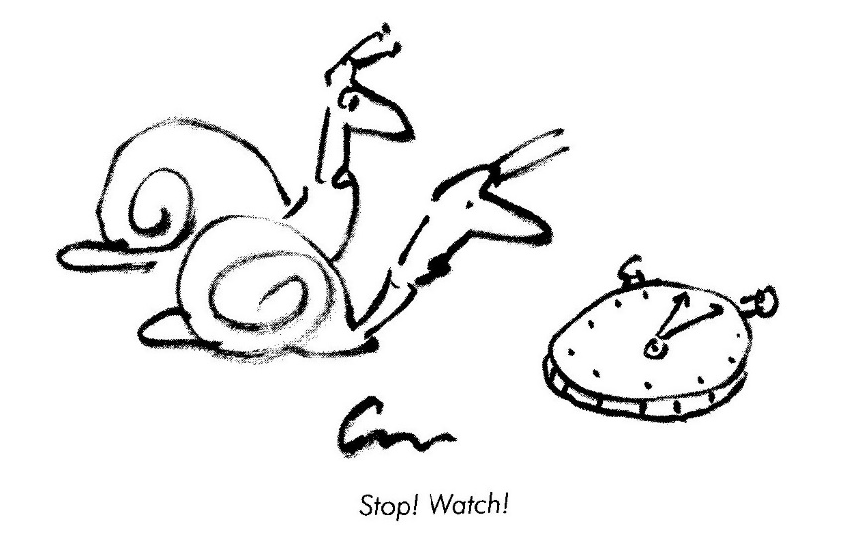

They’ve Nibbled the Leaves of my Napalm Tree

No snailophile would ever state
That gardening’s a Fascist trait
For gardeners must protect the ﬂowers
They’ve tended to for hours and hours.

But I feel sick each time I look
In any horticulture book
Which recommends for snailocide
That chemical: Metaldehyde.

Those gentle souls who talk to plants
Should surely give the snails a chance.
Molluscotropism

A child with scientiﬁc bent
Can do this small experiment.
Performed with care it never fails.

Aim:
To prove that plants need snails.

Apparatus:
All one needs
Are bell-jars, snails and legume seeds.

Method:
Ensure both jars are clean.
Place each beside a growing bean.
A snail in one, its neighbour leave
As empty as an armless sleeve.

Result:
The bean beside the vacant bell
Grew ramrod straight and vertical.
Its twin, the symbiotic bean,
In time towards the snail did lean.

Conclusion:
Though snails hunt plants voraciously
The plants are happy.
Q.E.D.

Riddle

My ﬁrst is Inferno in one.
My second is nothing or none.
My third on a lady is velvet and gorse.
My last is an ovum minus the horse.

My Whole you can’t buy for silver and gold
It tortures the young and comforts the old.

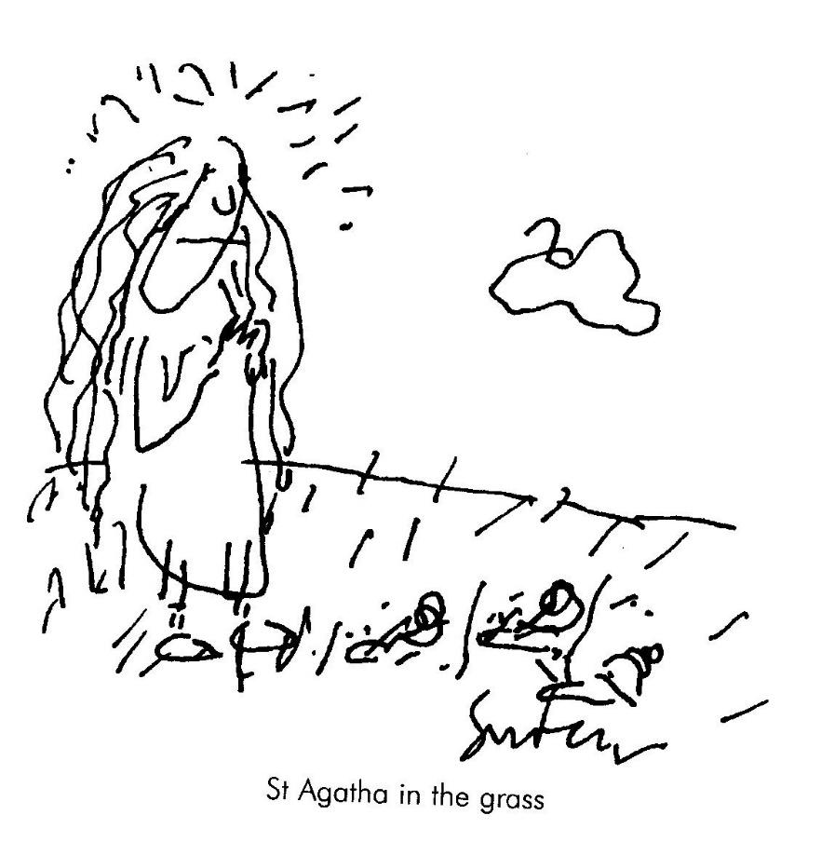
Cosmick Carp
A paradox as parable

Adrift in timeless nothingness —
A darkness sparked with light —
We meet our subject, Cosmick Carp,
And recognise his plight.

The Universe it has no sides,
Circumference or rim
But Cosmick’s Consciousness of this
Is really rather dim.

His world is vast and boundless,
Lacks limits; is uncurbed
And yet, with all his liberty
Our hero is perturbed.

Although twelve billion trillion miles
He ﬂoats with ﬂick of ﬁn:
Inﬁnity describes his cage —
A gaol is what he’s in.

He harbours secret fantasies
For tether, stake and lock,
For door and fence and recompense
Of calendar and clock.

But in a way he’s just like us
Though freedom is our goal.
We know that Cosmick really wants
A tiny, goldﬁsh bowl.

Only One Life He Croaked

‘Actually,’ he sighed, his knotted
Tongue lolling behind his lips, ‘the
Spectrum of my experience
Should be much, much broader than yours,
Being amphibian, I am
At home in water and on land.

But the sad truth of the matter
Is a deadeningly humdrum
Diet of ﬂying arthropods
(How I hate the flittering and
Frantic scrabbling in the larynx).
The monotonous perfection
Of this paradisal pond sucks.
My real options are: Bog or log.

Add to all this my morbid
Fear of humans, especially
The large pink ones that wallow
In water and ﬂing stones and, Quel
Horreur! amputate our long, lithe
Legs to titillate the palate.

Had I options, I would pursue
My private passions — black coffee,
Dragonflywings in aspic, rough
Cognac, Gauloises, the haiku of
Matsuo Basho and, of course,
The paintings of that cubist, Braque.'

Kamikaze

like forty million crack dragoons
Stood battle trained spermatozoons.

The captain spoke in solemn voice:
‘Although I know you have no choice
And little chance, you have permission
To volunteer for this emission.’

Not one comma hesitated:
‘YES!’ They all ejaculated.

The Myth of Vicarus

Upturned was every head to watch
Two leaf-green doves in ﬂight.
They soared above the cabbage patch.
The Cabbage Brothers Wright.

Transmogriﬁed from plant to bird
They tumbled through the blue
And every cabbage strained its roots
To get a better view.

‘At last!’ they cried ‘They’ve broken free
the fetters of the ground.
If they can do it so can we!’
Then came a rushing sound;

On tiptoe every cabbage thrashed
Its leaves with ﬁendish force.
In vain, of course, some dust was raised
But none budged from its source.

But, the hurricane the effort caused
Surged upward through the air
Catching Icarus and Daedalus
Completely unaware.

Green wings were torn to tatters
Two hearts came crashing down
And all that really matters
Smashed senseless on the ground.

The moral of this tragic tale
Is taught in every patch:
Ordained amongst us, some must ﬂy
The rest are blessed to watch.

Sailing Alone Around the World

for Lauren

In Cape Town many years ago
There lived a snail called Dallio.
Though slow as often molluscs are
He yearned and burned to travel far.

He had no kids, he had no wife
And travelled all his livelong life.
His meals he took While on the hoof,
His shell, a backpack and a roof.

He tacked in six years all the Way
From Rocklands Beach to Bantry Bay.
Long-suffering, with motives pure,
He learned while living to endure.

Then, on his death, his soul was told:
‘Obsessive snail, since you were bold,
The doughtiest of all your nation,
choose a re-incarnation.’

‘lronical,’ old Dallio said,
‘Alive I had no choice, but dead
An option looms. I’ll be a man,
A great explorer if I can,

And circumnavigate the Earth.
Around its plumply massive girth
I’ll sail, alone, by night and day
Through Wave and Wind, through storm and spray

In a solo sloop of wood and oakum.
And can I be called, please, Joshua Slocum?’

Semper Helix

In duplicate beside the pond
The mirrored fern unfurls its frond.

The twisting leaf escapes the tree
And ﬂutters downward spirally.

All things expire. The spring of Time
Uncurls with tick and tock and chime

That knells the universal end
When knots unravel, curves unbend.

The straight line on the cardiograph:
A spirit-level epitaph.

So let us praise while yet we may
Those things that take the tortuous way,

Which twist and turn spontaneously
To stem the trend to entropy.

Andante’s Paradiso

A snail concerto’s very queer
If heard by any human ear.

The pitch is low, the tone forlorn,
They’re scored for tuba or french horn.

The best example I could trace
Is one by Carlos Carapace.

Movement One — extremely slow —
The Second molt’adagio

The Third no vertebrate could call
A movement. There is none at all.

Snail Christmas Poem

Of Orient there were three snails
Who followed ancient bedouin trails.
To see the birth at Bethlehem
Their names were Nathan, Gar and Shem.

They crept behind a shining star,
The going slow the distance far.
And came, just thirteen years too late.
The gospels don’t record their fate.

But lucky Nathan, Shem and Gar
Were present at the Bar Mitzvah.

In His Own Image He Created Them

for Walter

It’s not by day that molluscs pray
When moon is down and stars are bright
They Worship in the glistening night
The Whorléd One who lives afar
Amongst the Spiral Nebulae.

Nocturne

The sun has set. The orb of red
Is nestled in the West.
Awaken lazy slugabed
You’ve done your daily rest.

Uncurl that sleepy tentacle
And blink your purblind eye.
The muted wash of darkness will
Suffuse the evening sky.

The ﬂowers with fastened shutters droop
From supplicative stems.
Clandestine constellations group
To wink their stratagems.

Possess the Night! It is no crime
To seem to have things Wrong:
To furl asleep at Matins time
And rise to Evensong.

Innocent Experience

An ageing sheep
Who was quite deep
Read Blake and cried
‘For goodness sake!

If Christ is shepherd
And Christ is lamb
Then half—divine
Is what I am.’

And then she sighed:
‘Not true, because,
Half-divine
Is what I was!’

Evidence?

After the ﬂood when
The waters subsided
God said to Noah:

‘Come out of the Ark.’
And all the wild beasts
And all kinds of cattle

And all of the birds
And all of the creatures
That crawl on the earth

Disembarked from the Ark
Excepting of course
The wood-borer beetle.

The Metempsychosis of the Yak

He has no house, he has no shack,
Just shaggy hair upon his back
That hangs from cranium to hoof —
An absolutely perfect roof
To shelter him from winter chills
Amongst the Himalayan hills.

Tibetans ride upon the backs
Of generous and gentle yaks
Who offer milk, their hair for rope,
Their ﬂesh for meat, their fat for soap,
And listen as the valley swells
In irony to temple bells

That toll that karmic law decrees
They will return as Red Chinese.

M C Koei

A hippopotamister
had a hippopotasister
who was liberated in the style
still popular in the Upper Nile.

It riled this hippopotafeminist
if, in passing, she was missed
or missused
by a male hippopotachauvinist.

Then she would incisively insist
on her non-sexist, proper title,
viz:
HippopotaMs.

Narcissus

The Warthog at the Waterhole,
Transfxed in sheer delight.

His image in the murky pool
A mesmerising sight.

The starlings at the birdbath preen
A slug slides up the pane.

The beautiful are not alone —
The plain are also vain.

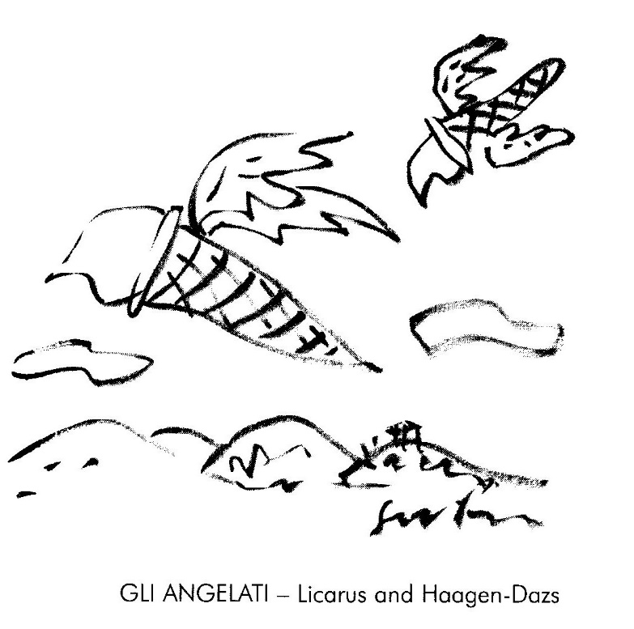

Snail Stripper

for Jenny

Beneath the Agapanthus shrub
There is a Mollusc Slipper Club
That boasts an act to titillate
The jaded snail sophisticate.

To shifting drums and throbbing base
A vamp comes out at sensual pace.
In lurex mantle, sequinned shell
She weaves a concupiscent spell.

Explicit movements not Burlesque
But undulating Arabesque.
She slides across the ﬂickering strobe
And, piece by piece, removes her robe

To climax this erotic act
She makes her lovely foot contract
And slips from underneath her shell:
A hyper-naked jezebell

Not every eye was out on stalks
Nor every snail who gasps and gawks.
A cynic gives a knowing shrug:
‘She’s nothing but a common slug!’

Elitist

Many poems have I Writ
Extolling snails and I’ll admit
I might have rambled on a bit.

But now my conscience tugs,
Would I have done the same for slugs?
They’re both molluscans, both pathetic
But the snail is more aesthetic.

The Sap Rising

The insurrection in the breeze
Is whispered softly to the trees
Who agitate their green-gloved ﬁsts
Like apathetic anarchists.

Chameleons in camouﬂage,
Intent on subtle sabotage,
Advance on dialectic feet
To politicise branch elite.

The propaganda pigeons coo:
“Uhuru...Uhuru...Uhu. . .’
But all in vain. Suburban twigs
Are bourgeois, fascist, kulak pigs!

Quarry Pond Samsara

1.
I come to ﬁsh here all the time,
The ﬁsh are only ﬁve.
I know them, each one, personally
And catch them all alive.

Of course I use ﬁne hooks and bait,
Good line to take the strain;
But since they are inedible
I let them go again.

2.
To eat to suffer is our lot,
It pierces lips and gums
And rips us from our element
Until our saviour comes.

He mercifully slacks the line,
Unhooks and sets us free;
His inﬁnite compassion is
Our sacred mystery

The Amoeba is Immortal

The Universe eternally
Envelops death and life;
Both trouble and tranquillity,
Harmony and strife.

It drifts through lonely nothingness
(With pulse and pulse and glide)
Its glowing, throbbing nucleus
Just itching to divide.

It has but one imperative.
One law in its Torah:
A schizoid urge to generate
Its own diaspora.

Maslow was Wrong

for the Tilani

Along an early morning lane
Between the forest and the sea
A hundred iridescent Webs
Are laid like nets upon the lea.

Roughspun, they look like gossamer rags
Or even gleaming dinner plates.
And at each rim, alert, polite,
A bright, attendant spider waits.

The threads though tacky to the touch
Remain quite empty through the day,
Except for shimmering drops of dew.
A clue? Perhaps the spiders’ prey

Is not small creatures dead or wrapped
But starlight, luminously trapped?

Carpe Diem

for Lionel

A goldﬁsh in a goldﬁsh bowl
Surveys the world outside
And feels completely in control
Of everything he spies.

He thinks: ‘I’m in my element,
My glass a faithful lens
That shows a foggy ﬁrmament
That wobbles and distends.

‘An ever-shifting universe
Of ectoplasmic forms
Beyond all know parameters
Of ﬁnite ﬁshy norms

‘And yet, this mystic interplay
Does serve me with such love
That I am blesséd every day
With manna from above.’

Weather Report

FORE—WARNED

Knowing from television
That the cold front was coming,
The trees on Signal
Hill, blurred in the mist,
Are more mysterious still.

GALE WARNING

The papaya tree
Flaps in the wind, taps windows
And rattles the eaves:

Flags for the deaf and
Morse for the blind, it signals
With snail-tattered leaves.

Pebbles

for Sandra

Impetuous, anarchic sea.
Untamed, implacable and free
Or monstrous calm, no flurried fuss
You seem to us ambiguous,
For Time-trapped humans seldom guess
Your harassed lack of Timelessness.

With currents, backwash, Spring and Neap
Your schedule’s difﬁcult to keep
And Mistress Moon just loves to see
Her serfs enchained by fealty.
But at the strand we can observe
Some evidence of cracking nerve:

A ﬂustered tide that rolls and kneads
Its oceanic Worry-beads.

Snail Mail

In old Japan a border guard
With one wet horsehair wrote,
In microscopic characters,
His wife a poignant note.

He called his favourite carrier-snail
And pinned it to his shell
And said: ‘Oh steadfast Samurai
Depart for home. Go well!’

The message read: ‘Should I survive
Then disregard this brief
But if I die this missive will
Remind you of your grief.’

Plumstead Sky

after Tatamkulu

It is a still and perfect night
No trace of wind nor breeze —
The creaking constellations stop,
Entangled by the trees.

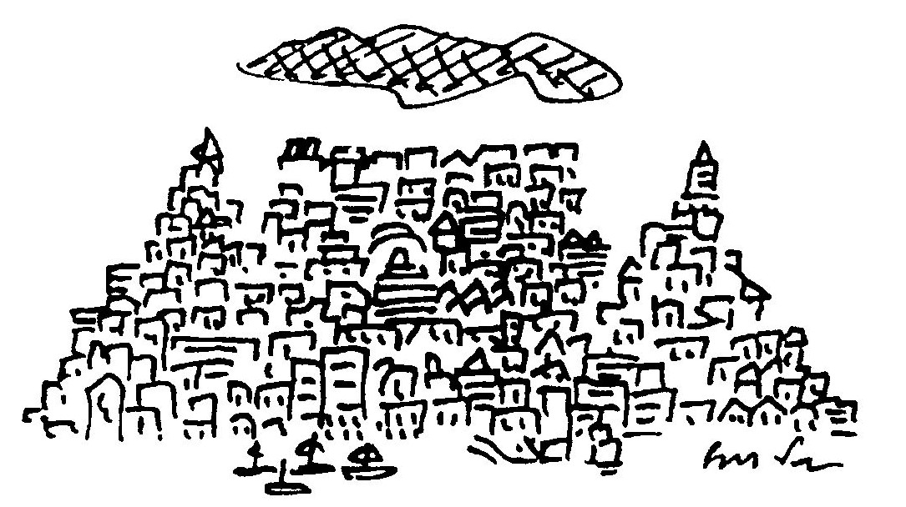

Fugue for Rhythm and Wind

The poplar and plane;
Kinetical trees
That shimmer and shift
Through doppler degrees.

Leaf, light and wind
Weave a contrapuntal ruckus
That immediately brings to mind
Both Mozart and Maracas.

Two Tanka

AUTUMN

God is present in
the stillness of twigs,
the trembling of leaves,
in perception and
the surreptitious
counting of syllables.

FROM THE AIR

Like a length of string
dropped on an unmade bed
the road meanders in the mountains
leaving a sense of
pointlessness and comfort.

The Plover — Plettenberg Bay

for Gus Muller

I think the bird is called a plover
Who seems, frenetically, to hover
Above the shore in search of cover.

But needle eyes espy the feet,
The spindle shanks so deft and neat
That pirouette and sprint the beat

He plies between the sea and land
A crazy crisscross of the sand.
A hurried, frantic saraband.

At earth and water’s interface
With silent rnovie jerky pace
He lifts impatience to a state of grace.

Love Amongst the Middle-Aged

for Nicky after 72775 blissful mornings

Each morn at dawn the slanting light,
Romantic in my failing sight,
Surrounds, like love, her perfect form.
She moves about our nuptial dorm

And murmurs as in deep despair;
‘Whatever is a girl to wear?’
I Watch with tea cup in my grip,
Its rim obscures my trembling lip,

And realise how much I’m blessed:
Awakening from a long night’s rest
To Witness, freed from lust’s blind curse,
My daily striptease in reverse.

Brief Selection: Getting On

From the bus Window
the trees ﬂy by. But the moon,
it travels with us.

*

He wound the clock
of the Universe but failed
to set the alarm.

*

Astigmatism
How wonderful to age:
two moons and a double
plenitude of stars.

*

I know, for sure, one thing that’s true:
The universe is just a clue.

*

just the briefest glimpse,
then all eternity for
interpretation

*

Wooden poles support the vine.
The dead and the living intertwine.

*

My life in action
replay Fifty perfect goals
and me the goalie.

*

Ageing means you can
remember everything
you can imagine.

*

Out of the harbour,
a little effort, a few waves —
and the land is lost.

The Walls of Redwing

Intoning poems at a school
I donned an academic cool
And held the whole of Standard Three
Attentively transﬁxed by me.
The spacious hall had Windows —
Blue gothic fragments of the sky,

And at my feet the children sat
Enrapt, an all-absorbing mat.
I mentioned love. I spoke of death
And resurrection in one breath.
I read from Blake. I read from Frost.
I Waxed profound. The kids got lost.

With thrash of Wings and raucous din,
Two starlings ﬂew from outside in.
Like drunken bats, about the hall
They ricocheted from wall to wall
And bumped and slapped and bumped again
With Wing and beak each Window pane.

The face of every girl and boy
Evolved from torpor into joy
And then, as sudden as before,
They ﬂed (Assassins!) through the door
To toss without aesthetic care
Another burlesque through the air.

Cyclops

The dusk like gauze is falling
The day is fading fast
And homeward I am crawling
In hope that light will last.

As remnant shots of daylight
Are shuttled through night’s loom
I pedal apprehensive
Beneath the waxing gloom.

Myopic in the twilight
I peer from left to right
As cars from all directions
Scud blind towards the night.

Ecologists of the human race
List this amongst your theses:
That Cyclists of the Crepuscule
Are endangered as a species.

Past Applegarth in Radiance

for Lee

My Sunday morning
Genuﬂections
Are made with bending knees
While sun spokes stroke
Across the road
And ﬁre the fallen leaves.

My spinning chainwheel’s
Starred reﬂections
Whirr upward through the trees
And glinting from
My streaming cold:
The snailtrails on my sleeves.

The perfect poet lies in bed,
In vain he tries to sleep,
He counts and counts inside his head
In syllables, not sheep.

His haiku all have seventeen,
His tankas thirty-one.
His prosody has always been
More regular than Donne.

With fourteen lines and seven rhymes
His sonnets are precise —
How cleverly the music chimes,
How literally nice!

Archaic forms he knows them well:
The ode and virelay,
He likes to Write a villanelle
And loves the triolet.

His every pulse is metrical,
Mechanical and neat.
His heart flub-dubs iambical
And never skips a beat.

His ECG scans perfectly
De dum de dum de dum
And measures ineluctably
Each moment’s tedium.

His heart’s a clock inside a box
That ticks each beat and rhyme
And only Death can spring the lock
To break the spell of time.

But Death does not the poem end
(Of this I can’t be surer),
It is, as mystics all contend,
An ultimate caesura.

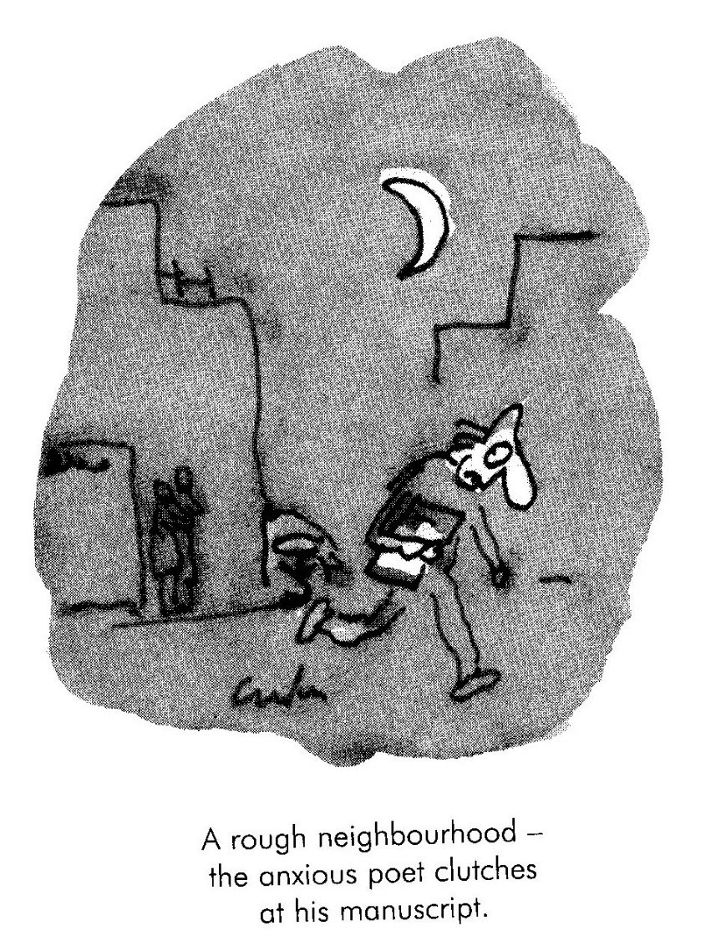

Liveware Blues

Machine! You have not blood nor gland.
Your tongue no man can understand.
What Poem, Sonnet, Song or Ode
Can be expressed in Binary Code?
Pedestrian your rhythms run:
O one, 0 one, 0 one, O one.

We covet your complacent skill.
Those rapid circuits Digital,
Without remorse or grief or pain
Repeat-repeat each task again.
Your functional memory just wipes clean
The slightest trace of Doubt or Dream.

You’re never bored, but can’t regret
Not Wanting what you cannot get.

Arachnidophobia

The poet sighed, laid down his lute
And watched the sun’s declining:
‘The e-mail’s murdered space and time
And put an end to pining.’

‘O nonsense!’ cried the merry youth,
His Pentium aglow:
‘I’d argue but my chat-room calls,
I really have to go,

‘But pain is gone with guilt, remorse
And analog morality.
There’s no impediment to bliss
In virtual reality!’

The poet smiled, a gentle smile,
As tears Welled in his eyes:
‘A final joke: The spider’s web
Is advertised by ﬂies.’

Poet

My poems are the means by which
I send my thoughts to you.
You’]l ﬁnd them sensitive and rich,
Original and true.

They’re erudite and full of wit
With subtle traps and lures
And, quickly While I think of it,
Please d0n’t send me yours!

The Start of Something Big

While ﬁnishing his epic poem,
His editing complete,
He gazed upon the bits of words
That lay about his feet.

He swept up all the syllables
And laid them on his desk.
His name: Matsuo Basho and,
Of course you know the rest.

Who Put the M in Creation?

for Malcolm

He Wrote a small, immortal poem,
It took him several weeks,
And fed it in a shredder bin,
The type that tears and shrieks.

Then, gathering the shreddings up,
He set them all aﬂame —
A Wisp of soot a sad salute
To fortune and to fame.

And then, this Prince of Modesty,
(Has Modesty a realm?)
The ashes in a casket shut
And posted them to NELM.

If Only Scott had a Laptop

Driven by a hunch that
James Joyce was dyslexic,
Herman Charles Engelwald,
poet, translator and
remedial teacher,
ran a computer spell-
check on Finnegans Wake
and produced a novel
of such lucidity
and popular appeal
that the Bloomsbury Press
sold six hundred thousand
copies in sixteen months.

Released by royalties
from the travails of prose,
Engelwald’s current passion
Is to punctuate the
Poems of e e cummings.

With Occam’s Razor Gerard Manley Hopkins Shaves

Those springing rhythms, riding, creaking, Wrecked my rest.
The dapple-dawn—drawn bathroom steams; the mirror mists.
With sweeping, squealing palm I wipe it clean and, fraught
In dreary day’s dominion, meditate my liturgy of lists.
And then, with strokes of contemplation awaken to the thought
— I’ve caught this morning morning’s palimpsest.

Brief Selection: Ars Poetica

A defence against plagiarism;
Ensure your art is boring.

*

Today I took books
to the pulpers but sadly,
they don’t do poetry.

*

Desperate for praise he
quotes reection slips

*
I hereby apply
for funding, sufﬁcient to
ﬁnish this haiku

*

I was going to come to
your reading but something
interesting turned up.

On First Creeping into a Poem by Dylan Thomas

I might be slime and calcite shale,
The common stuff of man and snail,
But yet my consciousness is pure.

One principle I know for sure:
The force that curls my spiral shell
Unwinds the universe as well.

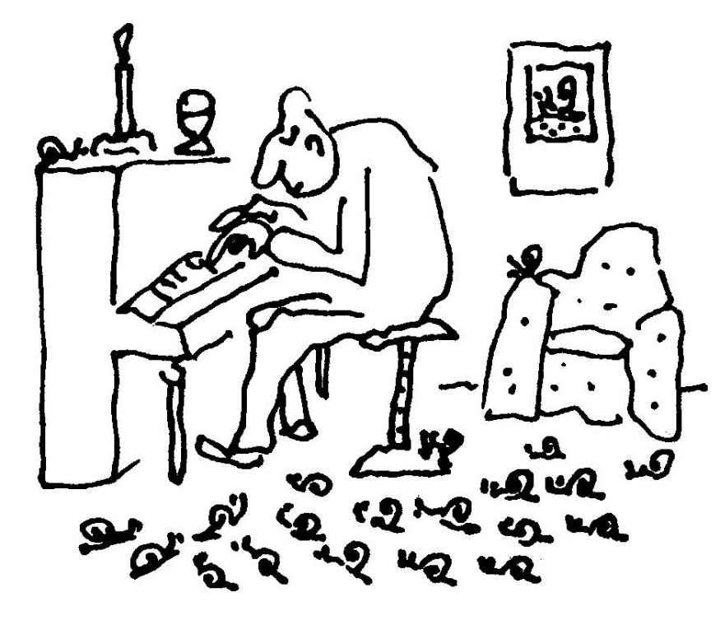

Two Snail Tanka

I

The snail, as twilight
Trims the sky, extends one eye.
A tentatively
Shy one, two, three, four, ﬁve, six,
seven, eight, nine tentacle.

II

Stuck in a trafﬁc jam:
How pedagogical
To see a snail steam
Serene and placidly in
The opposite direction.

Conjunction

Me&ering along the str&
(&ante, stepping, sarab&)
Where littorally sea joins l&
I spied, engraved upon the s&
A perfect, snaildrawn ampers&

Snail Atman

O simple snail upon yon leaf,
Eschewing joy, eschewing grief:

The karmic round of mortal men,
Of birth and death and birth again,
Does not, I think, apply to thee
Who art beyond mortality.

O transcendental monoped
Why, you are neither quick nor dead.

The Limacon GT: Road Test

for Mac

The traction’s great, the rubber grips
The road like pantihose hugs hips
Suspension’s soft. I loved the ride,
An effortless and easy glide.
The headlights swivel and retract
They cannot shatter on impact.
The form is streamlined, sleek and low
Designed for speed and yet, so slow?
The slug, ﬂat out with monstrous power
Does naught point naught naught one ﬁve Ks and hour

Slugavad Gita

or Why the Snail is Slow

Lord Sri Krshna saw a snail
In contemplative trance.
It swayed upon a lotus leaf
In graceful tantric dance.

Krshna watched as time slid by;
The snail seemed unaware
Of the presence of Divinity
Or maybe didn’t care.

Then Krshna spoke: ‘O Svami Snail
Your strange aloofness might
In view of my attendance
Be construed as impolite.

‘But my teachings tell: What seems to be
Is just an outer shell
And you resonate with purity
And vibrate like a bell.

‘But I must hasten on my way
Although you’ll think it odd
That time is of the essence
To an omnipresent God.

‘So I leave you benediction
But I reprimand you too:
Because you did not Hare me
I’ll never Hurry you.’

Resonance

I strolled along the lonely strand
With shells clamped to my ears
I hoped to hear and understand
The Music of the Spheres.

I listened conchientiously
(Il suano blu e serio)
But all I heard, incessantly,
Was just the sea in stereo.

Book Club

My tame domesticated Wife
Tugs slightly at the strings of life
When, once a month, she ﬂies the coop
To join a book discussion group.

No men allowed! This silly rule
I think is chauvinist and cruel.
Who needs,’ I shrug in my defence,
‘Their gossip laced with Lit Pretence?’

But when it is her time to host
It’s then it irritates the most.
Ignored! My fragile ego scarred!
A writer scorned! A poet barred!

I prowl the house, aloof and numb
But furtively, each time, succumb.
Against the door I lay an ear
And don a patronising sneer.

The moral is: What men deride
Is that of which they are outside.

Brief Selection: Snapshots

Opportunity
did knock, but only to ask
for your address

*

A gale Southeaster:
Birds surrender but grass like
Samurai ﬁghts on.

*

Before they left,
the aliens wrote
a brief, explanetary note.

*

Cycling past a kieWiet’s nest,
he stops to check his chain.

*

Eight o’clock —
the cars, how urgently they rush
to reach the trafﬁc jam.

*

For some obscure sin,
Artur Rubinstein returned
as a touch typist.

CLASSIFIEDS

Goldﬁsh coming to Cape Town
seeks bowl in city ﬂat.

Highrise, seafront, apartment block
An eyesore with a perfect view.

Tired of rejection?
Publish your poems
in our classiﬁed section.

*

I believe that God
encrypted the universe
for fear of hackers.

*

It’s the end of the World:
Sales at Christmas and a
begging Santa Claus.

*

On cold crystal nights —
a galaxy of grounded stars.
The city lights.

*

The city lights —
a bed of glowing embers.
We dread the kindling wind.

*

Crossword Clues:
Evacuate the country!
There’s bomb in Thabo Mbeki!

*

Prim with suspicion,
scribbling in the margins,
he reads The Way of Zen.

*

On the death of an old computer:
Ascii to Ascii,
Dos to Dos.

*

The rain, when it pours,
beats through the trees like discreet
Japanese applause.

*

Tired of book and tract
and thesis, I turn to life
for exegesis.

Brief Selection: Foundlings

Matthew said:
Lots of people in
Plumstead, Dad, play pianos
at night. It’s lank sad.

*

From Patricia:
Lost in the hills at the end of the day
we burned the map to light the way.

*

Burns’s Haiku (from Tom O’Shanter)
Like the snow falls
in the river, a moment white —
then gone forever

*

Notice in the Cafda Bookshop:
Your jigsaw puzzle
is welcome
missing pieces or not.

*

Quote from Matthew’s dream:
I’m one hundred and
Ten times more buffable than
A silicone chip.

*

The Dalai Lama quoted in the Cape Argus, 1 January 2000 on the New Millennium:
It’s nothing special.
Day, night, sun and moon will come
Just the normal way

*

From Sera by Giuseppe Ungaretti
…in smoke now I hear
crickets and frogs where grasses
tenderly tremble.

That Sort of Poem

for Don

Mozart swells from the translucent
Wind—up ‘radio in the kitchen.

In the Wind the open window
sways slightly and the catch squeaks.

You alternate browsing drowsily
between The Cloud 0f Unknowing

and an old Len Deighton novel.
The weeks of heat and mountain ﬁres

have passed and a light rain numbs
the suburbs into somnolent,

easy quiet. The departed poet
has left the gift to drift asleep.

Notes to the Poems

SAILING ALONE AROUND THE WORLD
Coincidentally a certain Joshua Slocum did sail his sloop, the
‘Spray’, alone around the World and in 1900 published a book
about it, which has the same title as this poem.

WHO PUT THE M IN CREATION?
NELM National English Literary Museum

FQUNDLING FROM SERA BY GUISEPPE UNGARETTI
… nel fumo oro grilli e rana
dove temere tremona erbe.

