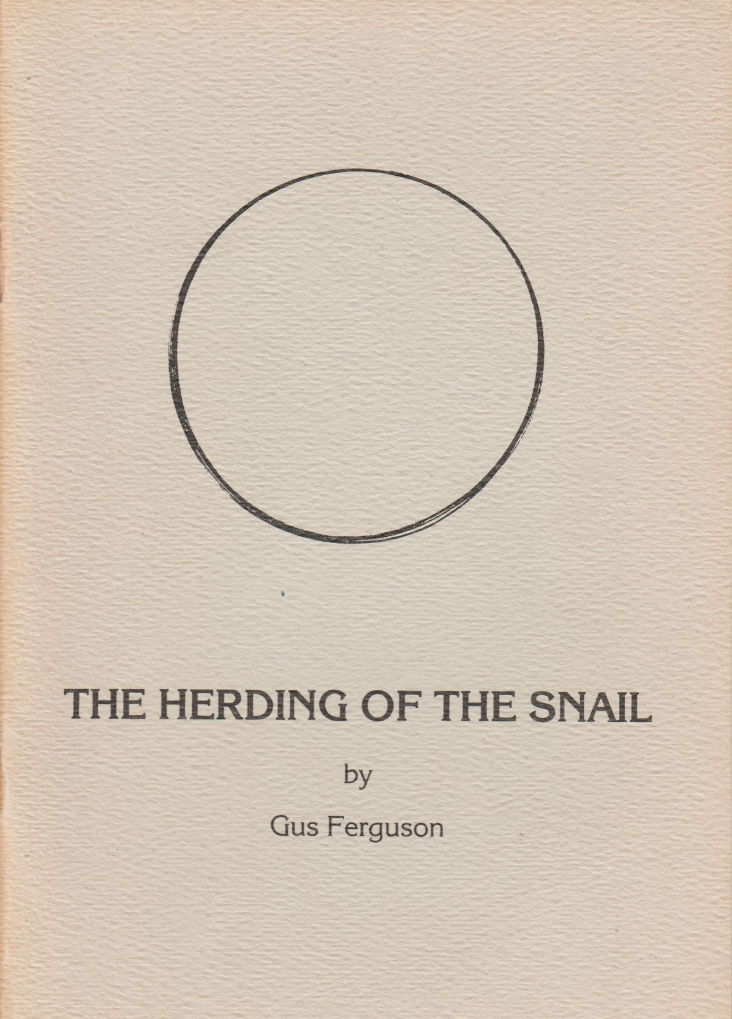

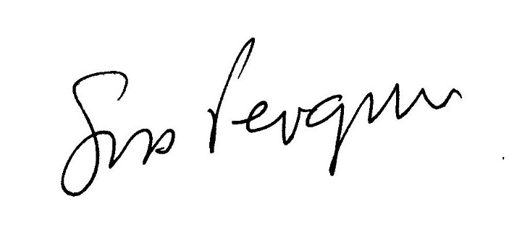
THE HERDING OF THE SNAIL
an adaption in verse by Gus Ferguson

This poem is loosely based on “Bulls” by the 12th century Chinese Zen Master, Kakuan.
lt was written for MOLLLISC MANIA which was performed at the Space Theatre in Cape Town by
Jenny Pichanick and Raphael Gamaroff in June 1978.
lt is dedicated to the memory of Geronimo, the world’s longest known snail.
Copyright Gus Ferguson 1978 (text), 1986 (illustrations).

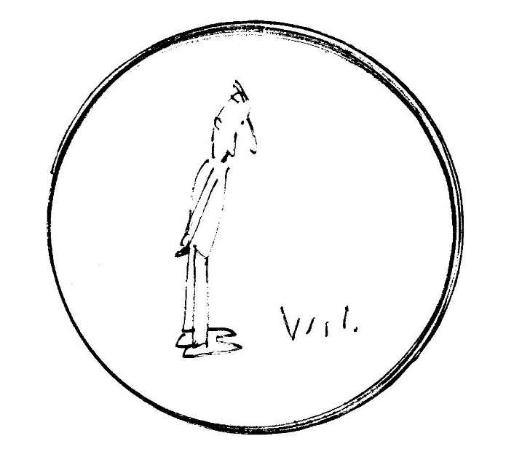
THE SEARCH FOR THE SNAIL

I search and seek to no avail
The shy, elusive garden snail
From dawn to dusk disdaining rest.
(The starlings mock my earnest quest.)

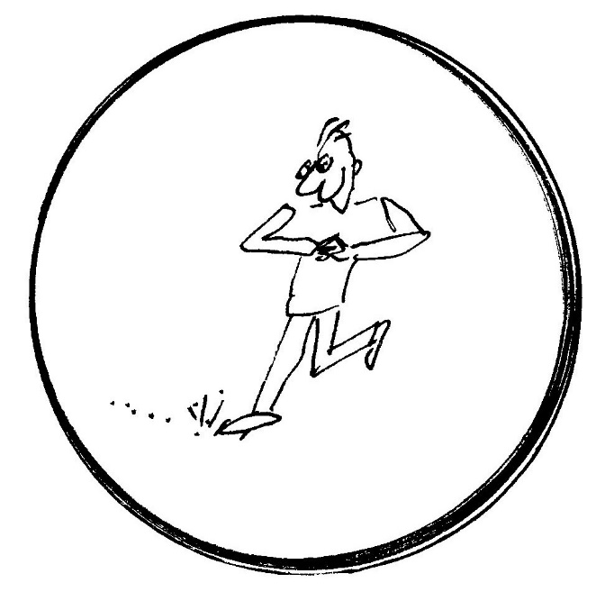
DISCOVERING THE FOOTPRINT

Beside the path the grass is streaked,
As if a tube of Bostik leaked,
l’ve found a spoor, a certain trail
That will disclose the occult snail.

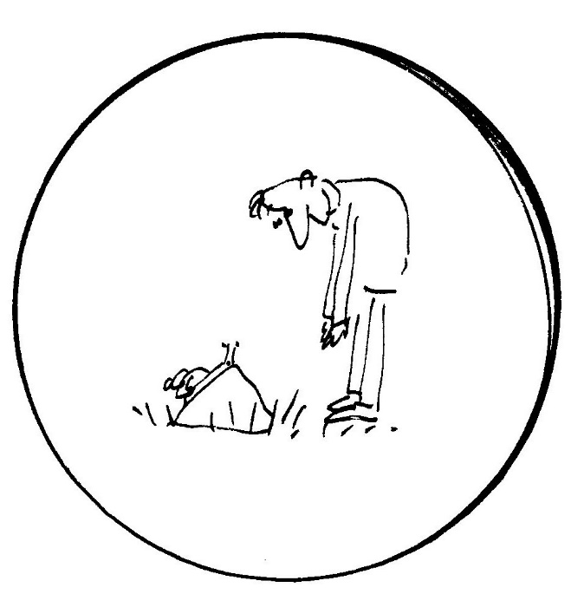
PERCEIVING THE SNAIL

The starlings warble in the eaves
The grass has grown translucent leaves
The snail is seen! A zephyr sighs,
That gorgeous shell, those stalked eyes!

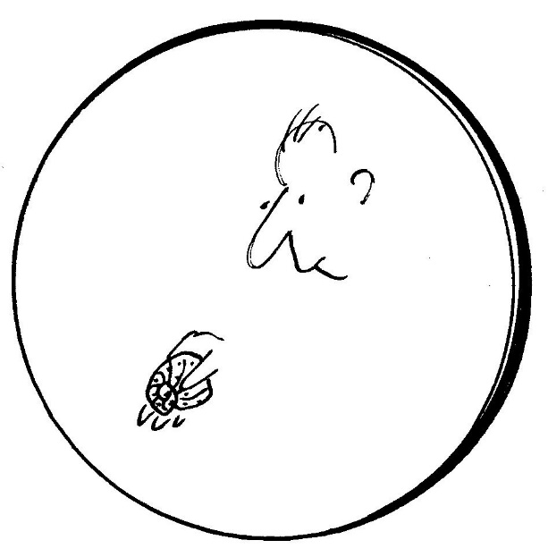
CATCHING THE SNAIL

With trembling finger, nervous thumb,
My heart is thudding like a drum,
In awkward grip l hold him fast,
He can’t escape, he’s caught at last.

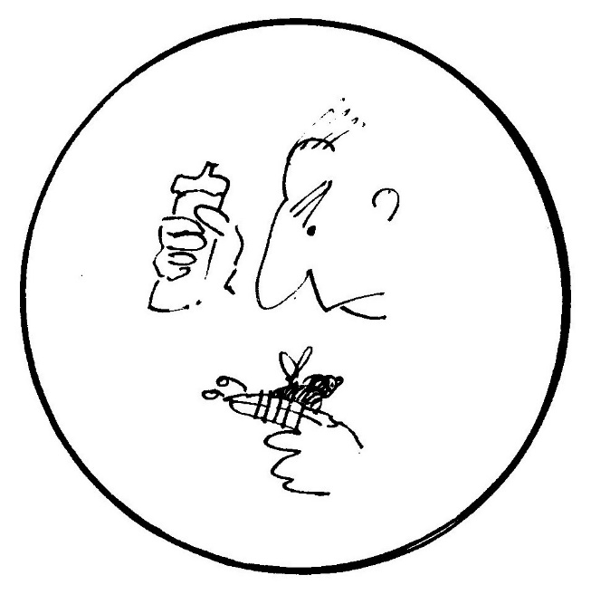
TAMING THE SNAIL

At first a thread and salt l need
To teach my captive Snail to heed
My will, but when l’ve tamed him well
He’ll be constrained just by his shell.

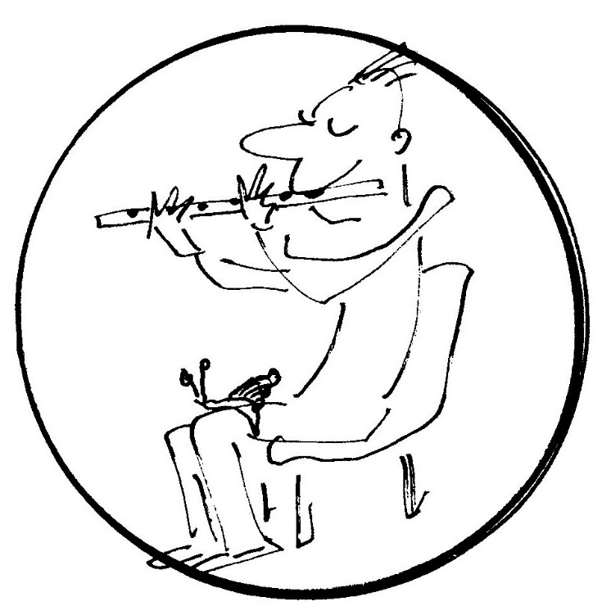
BRINGING THE SNAIL HOME

At night he sits upon my knee
My ﬂute I play in harmony
With sounds around: The wall clock’s chime,
The kitchen cricket chirps in time.

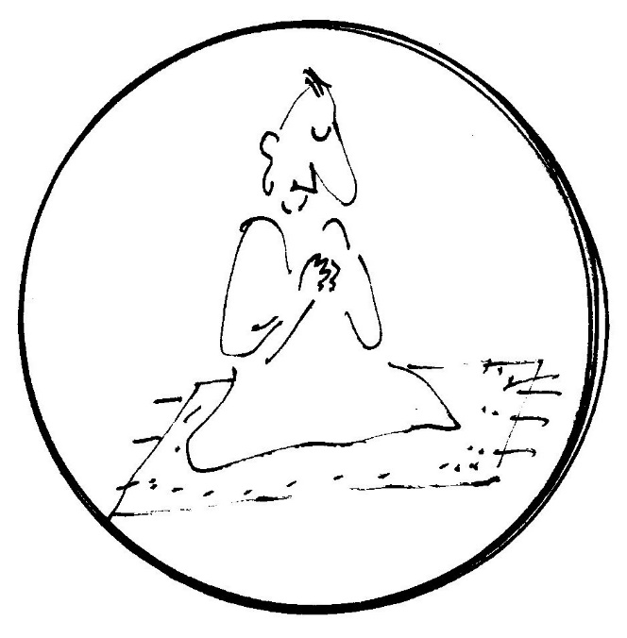
THE SNAIL TRANSCENDED

My loved one tamed, l set him free
No longer needing company
l am serene. Released from pride
l cast the thread and salt aside.

BOTH SNAIL AND SELF TRANSCENDED

The salt and snail and self and string
All merge as One, become No—Thing,
Infinite, clear and heavenly blue.
Desires or needs can’t cloud the view.

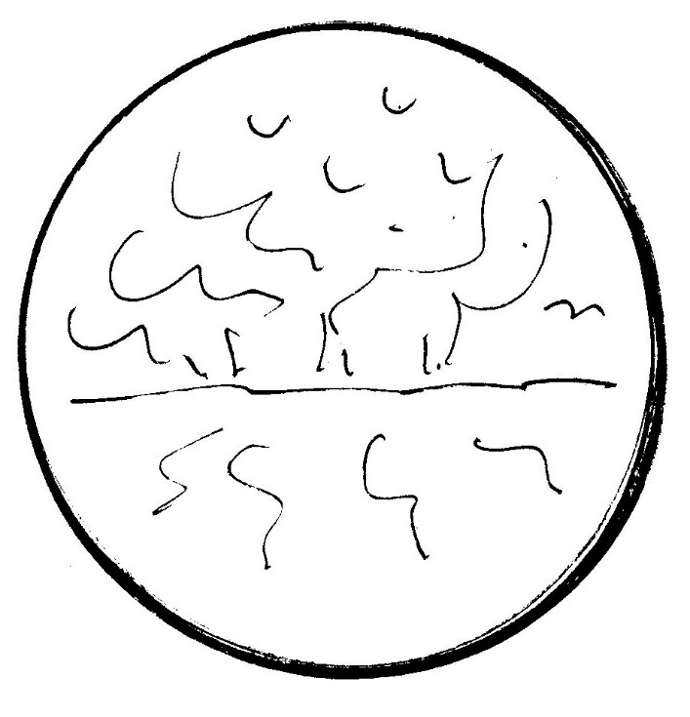
REACHING THE SOURCE

So many steps to reach the Source
A devious, exhausting course.
I should have stopped quite still instead
Where rivers ﬂow and flowers are red.

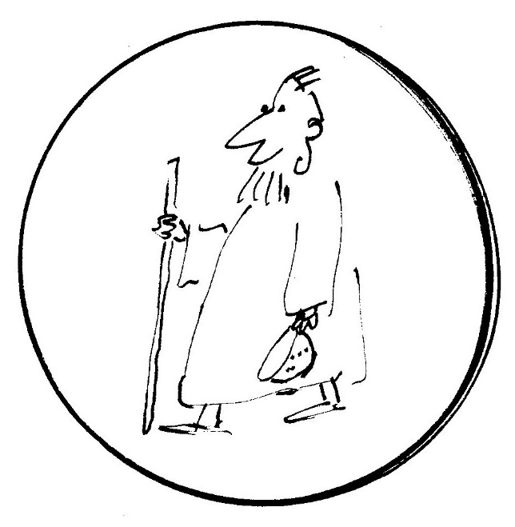
IN THE WORLD

l rise and mingle, simply dressed
Amongst the world where all are blessed
I use no magic, never strive,
Before me trees become alive.

